Tuesday, 28 January, 2003, 03:09 GMT
Victoria Climbie: Chain of neglect
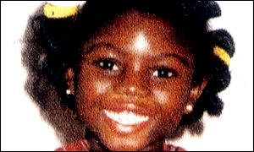
Victoria had 128 injuries
By Sue Littlemore
BBC education and family correspondent
Victoria Climbie was born in November 1991 in the Ivory Coast.
She died in February 2000 in London aged eight. To escape the poverty of Africa, her parents entrusted her to her great aunt who brought her to Europe.
Victoria was tortured to death by that great-aunt, Marie Therese Kouao, and the woman's boyfriend Carl Manning.
But Victoria need not have died.
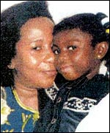
Victoria came from the Ivory Coast
Police, doctors, social workers all had contact with her while she was being abused.
Victoria's parents attended almost every day of the public inquiry into why the child protection system failed so miserably.
At times the details of Victoria's 128 injuries were too much for her mother Berthe to bear.
The inquiry was chaired by the former chief inspector of social services, Lord Laming.
The interrogation of witnesses by barrister, Neil Garnham exposed a picture of incompetence and error at every level.
Medical failures
Two senior doctors failed Victoria.
When consultant paediatrician, Dr Mary Schwartz, saw Victoria at the Central Middlesex Hospital, she decided her cuts were due to the skin disease scabies.
Victoria was sent home to her abusers. Dr Schwartz told the inquiry she assumed social services would investigate further.
I feel devastated and saddened that we failed to protect her

Dr Mary Schwartz
She said: "I feel devastated and saddened that we failed to protect her and I was not more pro-active in doing things."
Two weeks later Victoria was back in hospital - this time the North Middlesex.
Consultant Dr Mary Rossiter felt Victoria was being abused but she confused colleagues by writing "able to discharge" on her notes.
Victoria was again sent home to her abusers.
Dr Rossiter told the inquiry: "I have thought about Victoria on a daily basis... and I feel very distressed that I did not keep up to my own standards."
Cardigan squad
Metropolitan police officers also failed Victoria. Child protection work in the police has had low status.
Teams have been nicknamed "the cardigan squad" or "the baby sitters".
The inquiry heard how PC Karen Jones failed to inspect Victoria's home for fear of catching scabies off the furniture.
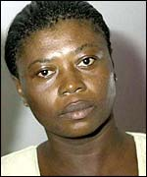
Victoria's mother Berthe found some evidence difficult to bear
She said: "It might not be logical but I did not know anything about scabies."
Lisa Arthurworrey was Victoria's social worker and one of a number from Haringey Council blamed for failing her.
Ms Arthurworrey feels she has been made a scapegoat.
At the inquiry she painted a picture of child protection in Haringey as chaotic, with workers in conflict.
She attacked several colleagues and described supervisions with her boss, Carole Baptiste.
She said: "Ms Baptiste used most of the time to talk about her experiences as a black woman and her relationship with God."
Responsibility
Carole Baptiste became the first person ever to be prosecuted and fined for failing to give evidence to a public inquiry.
When she did eventually cooperate, she criticised her junior, Ms Arthurworrey , but also admitted she had not read Victoria's file properly.
Ms Baptiste asked Victoria's parents to forgive her.
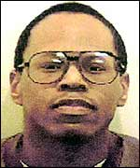
Carl Manning: Jailed for life
Gurbux Singh was the chief executive of Haringey council for 11 years.
The former chairman of the commission for racial equality was in charge while his social workers failed to rescue Victoria.
He told the inquiry he did not feel personally responsible for Victoria's death.
He said he had thought long and hard but he was "not actually sure what else we could have done."
The people who did try to save Victoria were not professionals.
Reform
Esther Ackha is a distant relative of Victoria's great aunt, Marie Therese.
Esther told the inquiry she made two anonymous calls to Brent council reporting fears for Victoria's safety.
Nothing effective was done.
Priscilla Cameron was Victoria's childminder.
It was Priscilla and her daughter, Avril, who had Victoria admitted to the Central Middlesex Hospital - only to get her wounds diagnosed as scabies.
The chairman of the inquiry, Lord Laming, delivered his report to ministers three weeks ago.
He has promised to make recommendations to ensure such a tragedy never happens again.
The hope is there will be effective reform.
The risk is without real change his words become a well-meaning cliché.

