Unit 2 exam structure notes
80 marks:
- 1 hour 30 minutes
- 5 minutes to read through the paper
- 20 minutes per question
- 5 minutes to check through
4 main questions, each with a scenario:
- Physical or mental illness
- Physical or sensory disability
- Learning disability
- Later adulthood
- Early years
Each question split into 4:
- 2 marks
- 4 marks
- 6 marks
- 8 marks
2-mark questions: “Identify” or “State”
- Do not include too much detail

4-mark questions: “Describe” or “Explain”
- Explain or describe 2 things
- One mark for each correct idea
- One mark for each explanation

6-mark questions: “Explain”
Level 3:
- Apply knowledge to the scenario
- Thorough knowledge – minimum 3 different ideas
- Explain each and link to scenario

8 mark questions: “Discuss”
Level 3:
- Links to the scenario
- Different H and SC professionals or settings?
- Judgements and conclusions drawn and justified
- Impact – how will this help?
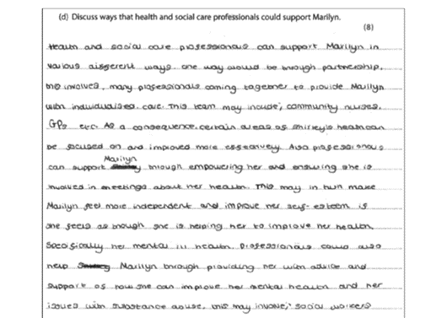
8-mark Sample 1:

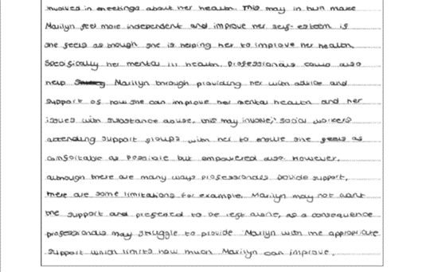

8-mark Sample 2:

8-mark Sample 3:

8-mark Sample 4:

Summary
- Read the question carefully:
  - Look out for Healthcare or Social Care professionals or settings
  - Look out for “other than”
- Focus on the command word – in particular “Identify” or “State” does not need an explanation
- Your answer must link to the scenario and not be too general
- Understand the difference between “Accountability” and “Responsibility”
Accountability:
- A duty to do a good job
- Must be able to give a good reason for their behaviour, decisions, actions
- A good job as defined by the Professional Bodies, National Occupational Standards, Care Certificate etc.
- Accountable to a Professional Body such as NMC, HCPC, GMC, RCN
- Could be checked and monitored by these bodies
Responsibility:
- The tasks you must do as part of your job
- Day-to-day responsibilities (A2):
  - Following policies and procedures
  - Healing and supporting recovery
  - Enabling rehabilitation
  - Providing equipment and adaptations
  - Providing personal care
  - Supporting day-to-day routines
  - Assessment and care planning
- Specific responsibilities (A3):
  - Anti-discriminatory practice
  - Empowering individuals
  - Ensuring safety
  - Information management and communication
  - Being accountable to Professional Bodies

