**Unit 2 Working in Health and Social Care**



Additional Activities for Revision

**Glossary of Key Words**

This glossary contains some key terms that you will need to know – these are the key terms that will come up in your exams. You will need to know what they mean and how to answer these questions!

|  |  |
| --- | --- |
| **Command Word** | **What it is asking you to do** |
| Identify | Very simply state the key facts  If you were asked to “identify 2 professionals who could care for Jane” – then you would simply need to give the names of two professionals |
| Outline | Similar to identify – for example “outline a way in which advocacy could help…” would require you to state “advocacy could help because …” and give one reason |
| Describe | This means to give a FULL account of a topic, giving all relevant information |
| Explain | Make something clear to the person reading it, by giving a detailed description, including relevant data or facts |
| Discuss | Write about a topic in detail – this would include the positive and negative factors and different opinions / perspectives |

Describe tworesponsibilities of healthcare assistants when looking after patients on hospital wards. (4 marks) (A1/A2)

1. .

2) 

How can we challenge discrimination in health and social care settings?

What is discrimination?

Implementing codes of practice and policies that identify and challenge discrimination in specific health and social care settings / adapting services to meet needs – the questions that we are aiming to answer today are:

1. What is a code of practice?
2. What is a policy?
3. What types of codes of practice / policies exist in health and social care settings that are aimed at promoting anti- discriminatory practice?
4. How can services be adapted to meet the needs of different types of service users?
5. What is a policy?

What is a code of practice?

What types of codes of practice / policies exist in health and social care settings that are aimed at promoting anti- discriminatory practice?

How can services be adapted to meet the needs of different types of service users?

**Case Study - Empowerment**

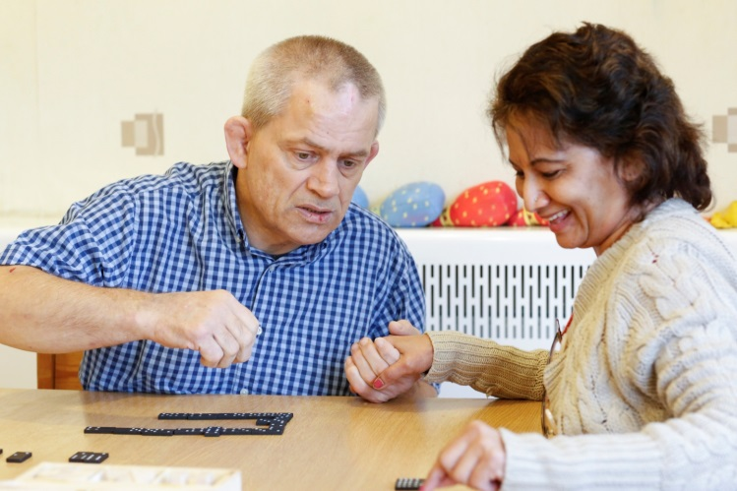

Peter is a 54 year old male with complex learning disabilities. He is living in semi-independent accommodation. He is assigned a support worker, Jane, who visits Peter regularly. Peter gets along well with other residents in the accommodation and appears to be happy living there, but Jane feels that Peter is struggling to cope because his accommodation is not kept very clean. When Jane tried to raise this with Peter, he shouted at her and told her to get out and now is asking for someone else to help him because Jane is ‘annoying him’

1. How could Peter be empowered in this situation? Give examples.
2. What need might Peter have, based on the information in the case study? How could meeting this need be an example of individualised care?
3. How do you think Peter’s self-esteem could be impacted in this situation? How could his self-esteem be improved?

**Safety of Individuals and Staff**

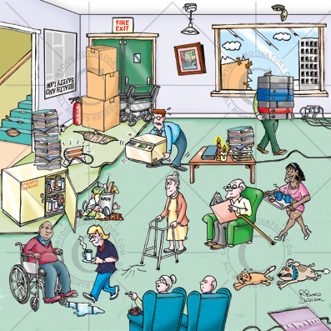

Spot the problem!

How many risks to people’s safety can you find in this picture?

What is the risk? What harm could it cause?

Notes

**Risk Assessments: (A3)**

A risk assessment can be carried out in two ways:

1. It can be used to determine risks of a building or setting – a bit like in the picture above
2. It can be used to determine the level of risk a person may present to themselves or other people

Risk assessments are used in all health and social care settings to identify possible risks, and then to allow for safety measures to be implemented that reduce the possibility of harm occurring from a particular risk.

Have a look at a sample risk assessment Then you are going to pick 5 risks from the picture, and complete a risk assessment for these. Record them in the table on the next page.

Thinking Space

|  |  |  |  |
| --- | --- | --- | --- |
| Risk Identified | Level of risk (low, medium or high) | Who could be harmed (resident / staff / visitors / all of the above) | Control measures |
|  |  |  |  |
|  |  |  |  |
|  |  |  |  |
|  |  |  |  |
|  |  |  |  |

**Risks of Individuals**

People with complex needs can sometimes place themselves at risk of harm, and, if you are working with people like this you need to be aware of the risks they may expose themselves to as well as how to control that risk.

It may not be possible to remove all risks completely, and, ultimately people have the right to take risks if they wish to do so. However, control measures still need to be in place to help keep people safe.

Read through the following case study, and underline any risks that you identify.

Georgina is a support worker who is currently working in a residential setting for young homeless women. As a part of her job, she has to assess the risks that the young women may present and suggest control measures that need to be put into place.

Georgina has just met Abi, Abi is 17 years old and presents with symptoms that could indicate she has an eating disorder. During conversation with Abi, Abi disclosed that at the weekends she likes to go out to raves where she “hooks up” with men. Abi comes from an unstable home environment, where she witnessed her mother behaving in a similar way, and had a variety of different “step dads” between the ages of 5 and 15. One of these “step dads” has kept in touch with Abi, and Abi thinks he is great because he buys her expensive items – like the new iPhone and iPad she has with her. Georgina is concerned that Abi may be exposing herself to multiple risks and completes a risk assessment to reflect this.

|  |  |  |  |
| --- | --- | --- | --- |
| Risk Identified | Level of risk (low, medium or high) | Who could be harmed (resident / staff / visitors / all of the above) | Control measures |
|  |  |  |  |
|  |  |  |  |
|  |  |  |  |
|  |  |  |  |
|  |  |  |  |

**Safeguarding**

All health and social care providers will have a safeguarding policy, this will tell you what you need to do in the event of a service user disclosing abuse to you. It will also provide information on measures you might have to put in place to safeguard those you work with. For example – ensuring that you do not share confidential information about service users with people outside of the service.

Think space – Why should you not share service user information with people outside of the service?

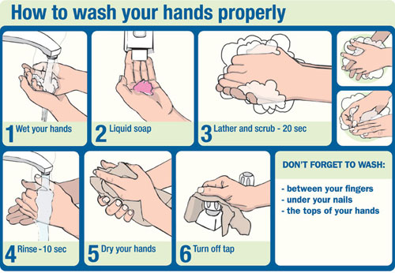**Preventing illness**

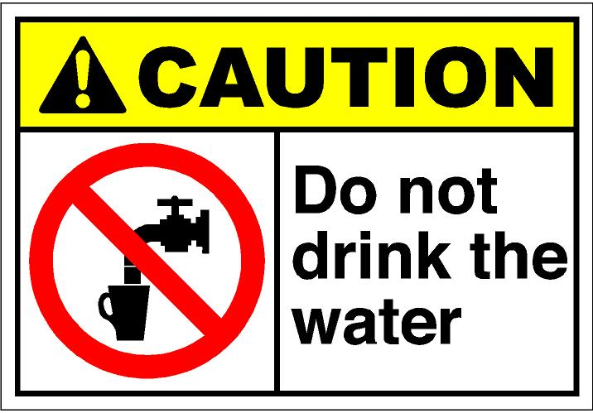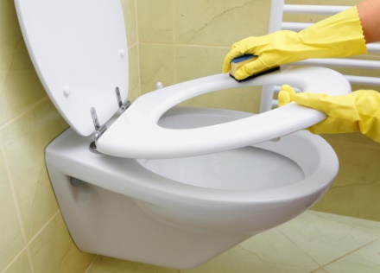

Look at the images Think about why these actions are important – how can they help prevent illness? Make some notes

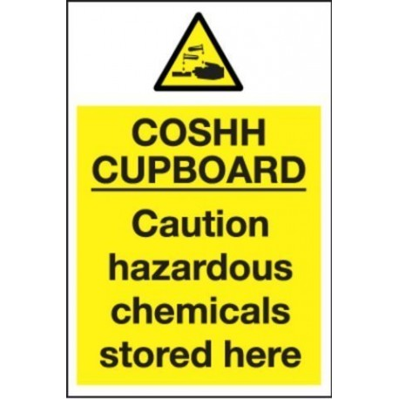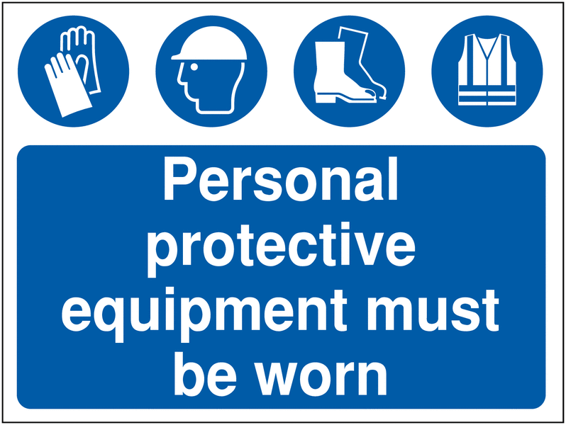

**Reporting Accidents and Incidents**

There are illnesses, diseases and accidents that health care providers MUST report – these are known as **notifiable** deaths, illness or injuries and are covered by the RIDDOR regulations – RIDDOR stands for Reporting of Injuries, Diseases and Dangerous Occurrences Regulations (2013)

What should be reported?

Why should these things be reported?

Who are reports made to, and how are they made?

Provision of first aid facilities:

All health and social care services need to be able to deliver first aid, and should have first aid kits on site as well as a trained first aider at all times.

Why is this?

What could happen if there were no first aid facilities?

**Information Management and Communication**

The Data Protection Act (1998)

Summary of Key points of Data Protection Act (1998)

**Exam Practice**

This question is looking at responsibilities that health and social care workers have towards service users – this is all the topics that we have covered under A3. How much do you know?

Explain the responsibilities that people who work in health and social care organisations have towards service users with visual impairments. (6 Marks)

**Monitoring those who work in health and social care services**

Brainstorm your ideas – Who is responsible for monitoring people who work in the health and social care industry?

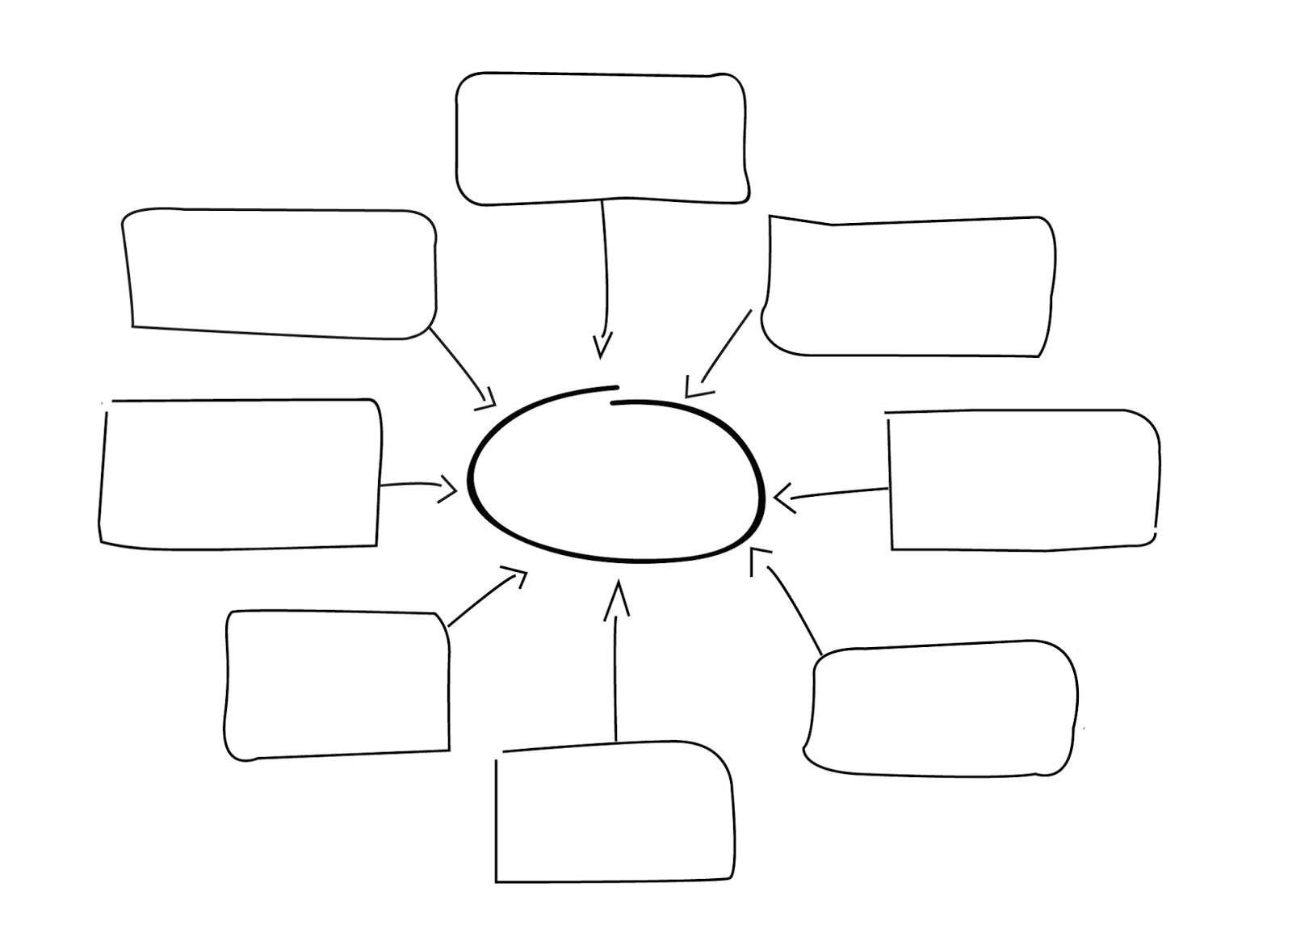 Why should people who work in health and social care services be monitored?

Notes

**Exam Practice**

Joe is a 56 year old man who has recently had his children taken into foster care. He lost his job which led to him drinking, which then resulted in him neglecting his children. Joe has now stopped drinking and is undergoing a parenting assessment to determine whether or not he can provide the care his children need so that the children can either be returned to him or a more suitable home can be found. The children are aged 10 and 12.

Discuss how advocacy services could help to represent the children. (8 marks)

……………………………………………………………………………………………………………………………………………….

……………………………………………………………………………………………………………………………………………….

……………………………………………………………………………………………………………………………………………….

……………………………………………………………………………………………………………………………………………….

……………………………………………………………………………………………………………………………………………….

……………………………………………………………………………………………………………………………………………….

……………………………………………………………………………………………………………………………………………….

……………………………………………………………………………………………………………………………………………….

……………………………………………………………………………………………………………………………………………….

……………………………………………………………………………………………………………………………………………….

……………………………………………………………………………………………………………………………………………….

……………………………………………………………………………………………………………………………………………….

……………………………………………………………………………………………………………………………………………….

……………………………………………………………………………………………………………………………………………….

……………………………………………………………………………………………………………………………………………….

……………………………………………………………………………………………………………………………………………….

……………………………………………………………………………………………………………………………………………….

……………………………………………………………………………………………………………………………………………….

**Specific Needs - PHYSICAL ill health**

How many different types of PHYSICAL health needs can you identify?



Case Study:

Mr Khan is an 80 year old man who lives on his own following the death of this wife two years ago. He was born in Pakistan and moved to live in the UK over 35 years ago. He has been a healthy and active member of the local Asian community. Mr Khan’s family live close by and keep in daily contact with him.

Mr Khan fell in his garden and fractured on of his hips. He has been recovering in hospital for three weeks and the discharge care manager at the local hospital hopes a return home is possible once a multi-disciplinary team assessment has taken place. However, Mr Khan’s son is concerned that his father is becoming anxious and confused about returning home so he has volunteered to act as an advocate for this father during the multi-disciplinary team meetings.

1. Identify two health and social care professionals who could become involved in Mr Khan’s assessment (2 Marks)

………………………………………………………………………………………………………………………………………………

………………………………………………………………………………………………………………………………………………

………………………………………………………………………………………………………………………………………………

………………………………………………………………………………………………………………………………………………

1. Describe two benefits of multi-disciplinary teamwork for Mr Khan’s care (4 marks)

………………………………………………………………………………………………………………………………………………

………………………………………………………………………………………………………………………………………………

………………………………………………………………………………………………………………………………………………

………………………………………………………………………………………………………………………………………………

………………………………………………………………………………………………………………………………………………

………………………………………………………………………………………………………………………………………………

………………………………………………………………………………………………………………………………………………

………………………………………………………………………………………………………………………………………………

………………………………………………………………………………………………………………………………………………

………………………………………………………………………………………………………………………………………………

1. Explain two of Mr Khan’s needs that should be assessed before he is discharged from hospital (6 marks)

………………………………………………………………………………………………………………………………………………

………………………………………………………………………………………………………………………………………………

………………………………………………………………………………………………………………………………………………

………………………………………………………………………………………………………………………………………………

………………………………………………………………………………………………………………………………………………

………………………………………………………………………………………………………………………………………………

………………………………………………………………………………………………………………………………………………

………………………………………………………………………………………………………………………………………………

………………………………………………………………………………………………………………………………………………

………………………………………………………………………………………………………………………………………………

………………………………………………………………………………………………………………………………………………

………………………………………………………………………………………………………………………………………………

1. Discuss the implications of Mr Khan’s son becoming involved in multi-disciplinary team meetings as an advocate for his father (8 marks)

………………………………………………………………………………………………………………………………………………

………………………………………………………………………………………………………………………………………………

………………………………………………………………………………………………………………………………………………

………………………………………………………………………………………………………………………………………………

………………………………………………………………………………………………………………………………………………

………………………………………………………………………………………………………………………………………………

………………………………………………………………………………………………………………………………………………

………………………………………………………………………………………………………………………………………………

………………………………………………………………………………………………………………………………………………

………………………………………………………………………………………………………………………………………………

………………………………………………………………………………………………………………………………………………

………………………………………………………………………………………………………………………………………………

………………………………………………………………………………………………………………………………………………

………………………………………………………………………………………………………………………………………………

………………………………………………………………………………………………………………………………………………

………………………………………………………………………………………………………………………………………………

………………………………………………………………………………………………………………………………………………

………………………………………………………………………………………………………………………………………………

………………………………………………………………………………………………………………………………………………

………………………………………………………………………………………………………………………………………………

………………………………………………………………………………………………………………………………………………

………………………………………………………………………………………………………………………………………………

………………………………………………………………………………………………………………………………………………

………………………………………………………………………………………………………………………………………………

**Early Years and Later Adulthood**

Case Study: Early Years

You have been appointed to work as a healthcare assistant in the neonatal unit at Oak Trees Hospital.

The unit has a procedure in place that states what you should wear when changing the babies, such as disposable gloves and an apron. Other guidelines give information about how to disinfect surfaces and how to dispose of used nappies.

You enjoy you work and learn by observing more experienced staff. However, you have noticed that some members of staff do not wash their hands after they have finished changing nappies.

1. Outline one personal risk if you do not wash your hands following nappy changing (2 marks)

……………………………………………………………………………………………………………………………………………….

……………………………………………………………………………………………………………………………………………….

……………………………………………………………………………………………………………………………………………….

……………………………………………………………………………………………………………………………………………….

1. Describe two key objectives that Oak Trees Hospital’s health and safety policy should address (4 marks)

……………………………………………………………………………………………………………………………………………….

……………………………………………………………………………………………………………………………………………….

……………………………………………………………………………………………………………………………………………….

……………………………………………………………………………………………………………………………………………….

……………………………………………………………………………………………………………………………………………….

……………………………………………………………………………………………………………………………………………….

……………………………………………………………………………………………………………………………………………….

……………………………………………………………………………………………………………………………………………….

1. One management strategy to reduce poor practice amongst staff is to update and create new policies.

Explain two other management strategies that could be used by Oak Trees Hospital to reduce poor staff practice (6 Marks)

……………………………………………………………………………………………………………………………………………….

……………………………………………………………………………………………………………………………………………….

……………………………………………………………………………………………………………………………………………….

……………………………………………………………………………………………………………………………………………….

……………………………………………………………………………………………………………………………………………….

……………………………………………………………………………………………………………………………………………….

……………………………………………………………………………………………………………………………………………….

……………………………………………………………………………………………………………………………………………….

……………………………………………………………………………………………………………………………………………….

……………………………………………………………………………………………………………………………………………….

……………………………………………………………………………………………………………………………………………….

……………………………………………………………………………………………………………………………………………….

1. Discuss how poor working practices can affect service users and their families that they work with. (8 marks)

……………………………………………………………………………………………………………………………………………….

……………………………………………………………………………………………………………………………………………….

……………………………………………………………………………………………………………………………………………….

……………………………………………………………………………………………………………………………………………….

……………………………………………………………………………………………………………………………………………….

……………………………………………………………………………………………………………………………………………….

……………………………………………………………………………………………………………………………………………….

……………………………………………………………………………………………………………………………………………….

……………………………………………………………………………………………………………………………………………….

……………………………………………………………………………………………………………………………………………….

……………………………………………………………………………………………………………………………………………….

……………………………………………………………………………………………………………………………………………….

……………………………………………………………………………………………………………………………………………….

……………………………………………………………………………………………………………………………………………….

Discuss the importance of service regulation in health and social care (8 marks)

……………………………………………………………………………………………………………………………………………….

……………………………………………………………………………………………………………………………………………….

……………………………………………………………………………………………………………………………………………….

……………………………………………………………………………………………………………………………………………….

……………………………………………………………………………………………………………………………………………….

……………………………………………………………………………………………………………………………………………….

……………………………………………………………………………………………………………………………………………….

……………………………………………………………………………………………………………………………………………….

……………………………………………………………………………………………………………………………………………….

……………………………………………………………………………………………………………………………………………….

……………………………………………………………………………………………………………………………………………….

……………………………………………………………………………………………………………………………………………….

……………………………………………………………………………………………………………………………………………….

……………………………………………………………………………………………………………………………………………….

……………………………………………………………………………………………………………………………………………….

……………………………………………………………………………………………………………………………………………….

……………………………………………………………………………………………………………………………………………….

……………………………………………………………………………………………………………………………………………….

……………………………………………………………………………………………………………………………………………….

……………………………………………………………………………………………………………………………………………….

……………………………………………………………………………………………………………………………………………….

……………………………………………………………………………………………………………………………………………….