Unit 2: Working in Health & Social Care
Teacher: Mrs. Collins
REVISION BOOKLET

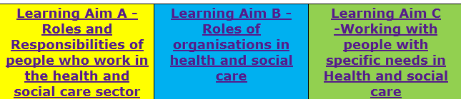

Learning Aim A - Roles and Responsibilities of people who work in the health and social care sector
- A1 The roles of people who work in health and social care settings
- A2 The responsibilities of people who work in health and social care settings
- A3 Specific responsibilities of people who work in health and social care settings
- A4 Multidisciplinary working in the health and social care sector
- A5 Monitoring the work of people in health and social care settings
Learning Aim B - Roles of organisations in health and social care
- B1 The roles of organisations in providing health and social care services
- B2 Issues that affect access to services
- B3 Ways organisations represent interests of service users
- B4 The roles of organisations that regulate and inspect health and social care services
- B5 Responsibilities of organisations towards people who work in health and social care settings
Learning Aim C - Working with people with specific needs in Health and social care
- C1 People with specific needs
- C2 Working practices

A1: The roles of people who work in health and social care settings

Using the links to help you, write in your books
1. What do they do?
2. Who do they work with?
3. Where do they work?

Roles
- GPs - https://nationalcareersservice.direct.gov.uk/job-profiles/gp
- Nurses- https://nationalcareersservice.direct.gov.uk/job-profiles/gp
- Midwives - https://nationalcareersservice.direct.gov.uk/job-profiles/midwife
- Healthcare assistant- https://nationalcareersservice.direct.gov.uk/job-profiles/healthcare-assistant
- Social workers - https://nationalcareersservice.direct.gov.uk/job-profiles/social-worker
- Occupational therapist- https://nationalcareersservice.direct.gov.uk/job-profiles/occupational-therapist
- Youth Worker- https://nationalcareersservice.direct.gov.uk/job-profiles/youth-worker
- Care worker- https://nationalcareersservice.direct.gov.uk/job-profiles/care-worker
- Support worker- https://nationalcareersservice.direct.gov.uk/job-profiles/residential-support-worker
You tube links
- https://youtu.be/YzkMSIKk944
- https://youtu.be/sH2_eoBM_3c
- https://youtu.be/z5oBDzTSSGw
- https://youtu.be/QKukNzye_78
- https://youtu.be/x3qkXz9WGbc
- https://youtu.be/4M5wtPvpveo
- https://youtu.be/K9QeH0PSjY4
- https://youtu.be/BsKoG8jabQ4
- https://youtu.be/zrbUbK-fKLc
Text book page 80- 85
Revision guide page 56-59

A2: The responsibilities of people who work in health and social care settings

You-tube links:
- https://youtu.be/E_VV4De7gc8
- https://youtu.be/lZloQC1MV1M
- https://youtu.be/lZloQC1MV1M

Other links:
- https://www.nhs.uk/conditions/social-care-and-support/care-plans

Task: For each of the following explain how it will help a service user.

- Following policies and procedures in place in the health and social care setting in which they work

- Healing and supporting recovery for people who are ill

- Enabling rehabilitation

- Providing equipment and adaptations to support people to be more independent

- Providing personal care, to include washing, feeding, toileting

- Supporting routines of service users, to include day-to-day family life, education, employment, leisure activities

- Assessment and care and support planning, involving service users and their families. See-

Text book page 86-94
Revision guide page 60-62

A3: Specific responsibilities of people who work in health and social care settings
Watch the videos.
https://youtu.be/mH54EM8ggmw & https://youtu.be/ggR9l2dFmmU
Make notes:
- How do the people in each video feel?
- Try to pick out examples of where people are fulfilling their responsibilities and breaking them.

- Use the text book or revision guide to make notes on each of the following:

- Being accountable to professional bodies

- Empowering individuals

- Ensuring safety

- Promoting anti-discriminatory practice

- Information management and communication
Text book page 94-109
Revision guide page 62-72

A4: Multidisciplinary working in the health and social care sector
Watch the video.
https://youtu.be/mAZ2xhR84mA
Make notes:
- How does this help the women in the case study?
- Complete notes on multidisciplinary working
Text book page 109 - 110
Revision guide page 73 – 74
Text book page 109 - 110
Revision guide page 73 – 74
A5: Monitoring the work of people in health and social care settings
Internal Monitoring
1. Watch the following video. Discuss the impact of service user involvement.
- https://youtu.be/51QNdfRZLJw
Read p110 in text book on line management

External monitoring
Whistleblowing
Read and watch the video clips on whistleblowing. Discuss the implications of whistleblowing
- https://www.channel4.com/news/nhs-whistleblowers-are-they-really-being-protected-now
For further information on Criminal investigations watch the clips:
- Victoria Climbe- https://youtu.be/pwckGJy9OhQ
- Jessica Chapman & Holly Wells - http://news.bbc.co.uk/1/hi/england/2180946.stm
- Baby P- http://www.bbc.co.uk/news/uk-11626806

- https://youtu.be/nhLURjB99D0
- https://www.telegraph.co.uk/news/uknews/baby-p/4978770/Baby-P-inquiry-Child-protection-issues-not-given-priority-says-Lord-Laming.html
- https://www.independent.co.uk/life-style/health-and-families/health-news/timeline-the-mid-staffordshire-nhs-trust-scandal-8482726.html
- https://youtu.be/uBhYu65HefE
Research-
- Every Child Matters
- Children's Act 2004
- Bichard Report
- DBS
- Laming Review
- The Mid Staffordshire NHS Trust

LEARNING AIM B
B1: The roles of organisations in providing health and social care services
Research & make revision notes on the following:
- Video clip: http://media.dh.gov.uk/uploads/infographic/Full%20Size%20HTML/index.html
Ways services are provided by:
- the public sector: NHS Foundation Trusts, to include hospitals, mental health services and community health services adult social care children’s services GP practices
- the voluntary sector
- The private sector.

Settings where health and social care services are provided to meet different needs to Include:
- Hospitals
- Day care units
- Hospice care
- Residential care
- Domiciliary care
- The workplace.

Text book page 112 - 119
Revision guide page 77 – 83

B2: Issues that affect access to services
- Read the section on different types of referral. Describe and give an example of each type of referral.

- Read the section on barriers to access. Describe and give an example of each type of barrier.

- Read the section on assessing care needs. Explain:
- How you are assessed?
- What eligibility criteria means?
Text book page 119 -121
Revision guide page 84
Watch the video clips
- http://resources.hwb.wales.gov.uk/VTC/2012-13/22032013/hsc/eng/unit_1/u1-a-and-b/u1a-and-b4.htm
- http://resources.hwb.wales.gov.uk/VTC/2012-13/22032013/hsc/eng/unit_1/u1-a-and-b/u1-a-and-b1.htm
- https://www.nhs.uk/conditions/social-care-and-support/carers-assessment/

Discuss the effects of a carer's assessment.

B3: Ways organisations represent interests of service users
Advocacy
Watch video and explain what advocacy is:
- https://youtu.be/NnOk2tTz468
Complaints policies
Watch video and explain how complaints should be dealt with:
- https://youtu.be/CHelGIv4sdg
Whistleblowing policies
Watch video and explain what whistleblowing is:
- https://youtu.be/sIC7mp07Irg

B4: The roles of organisations that regulate and inspect health and social care services
Research: Organisations that regulate or inspect health and social care services.
- Care Quality Commission (CQC)
- National Institute for Health and Care Excellence (NICE)
- Public Health England (PHE)
- Ofsted
Research: Organisations that regulate professions in health and social care services.
- Nursing and Midwifery Council (NMC)
- Royal College of Nursing (RCN)
- Health and Care Professions Council (HCPC)
- General Medical Council (GMC).
Useful video clips:
- http://www.cqc.org.uk/
- https://www.nice.org.uk/about
Text book page 123 -125 129-132
Revision guide page 87-88 91
B5: Responsibilities of organisations towards people who work in health and social care settings
You need to understand:
- how to implement the organisation’s codes of practice
- how National Occupational Standards (NOS) are met
- the importance of continuing professional development (CPD)
How individuals are safeguarded through being able to:
- have internal/external complaints dealt with properly
- take part in whistleblowing
- have membership of trades unions/professional associations
- Follow protocols of regulatory bodies.
Video clip: https://youtu.be/lPazmLm5igw
Text book page 132 -134
Revision guide page 92-94
Learning Aim C
C1: People with specific needs
Watch clips & make notes on the following:
- Ill health – physical
- Ill health – mental
- Supporting someone with severe learning disability – [video on right hand side of website]
- Physical disabilities
- Sensory disabilities
- Specific age - early years
- Specific age - later adulthood

Useful video clips:
- https://youtu.be/-a7REdsSvSI
- https://youtu.be/Yz03r7bMPjA
- https://www.theguardian.com/commentisfree/video/2016/mar/30/were-being-forced-to-fix-our-own-mental-health-its-not-working-video
- https://www.nhs.uk/livewell/childrenwithalearningdisability/pages/whatislearningdisability.aspx
- https://youtu.be/xFB0tczJW_8
- https://youtu.be/CL8GMxRW_5Y
- https://youtu.be/PLPEcu6523Q
- https://youtu.be/LU0dQXJ-YQM
- https://youtu.be/z_3cC8NiMiI
- https://youtu.be/cmI6E11xClo
- https://youtu.be/loksPQ7Q8Tm

Text book page 134 -137
Revision guide page 95-100

C2: Working practices
The 6 Cs Health and social care may change over time with new policies and governments, but the need to look after patients with dignity and compassion always remains consistent. The 6Cs of nursing stand for the professional commitment to always deliver excellent care. Each value is equal, not one is more important than the other. They focus on putting the person being cared for at the heart of the care they are given.
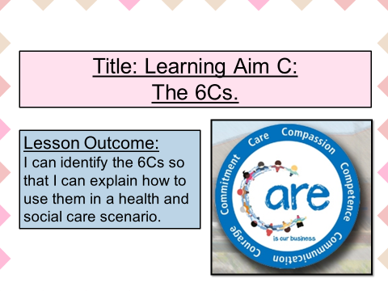
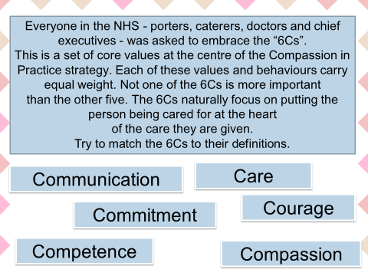
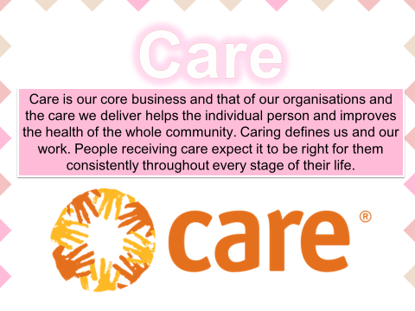
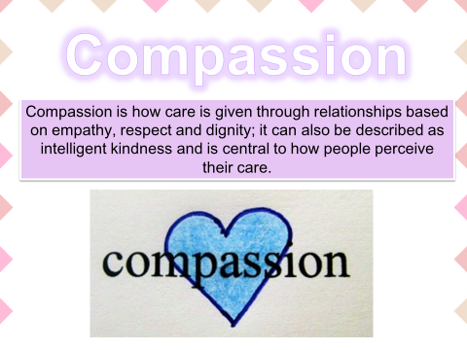
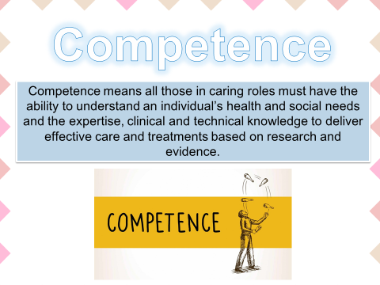
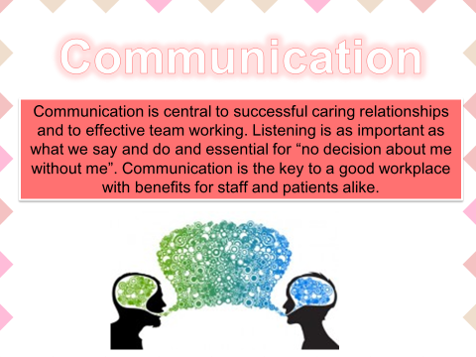
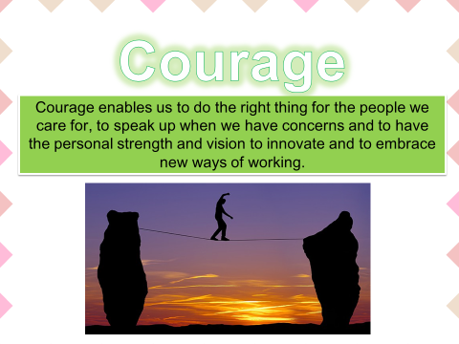
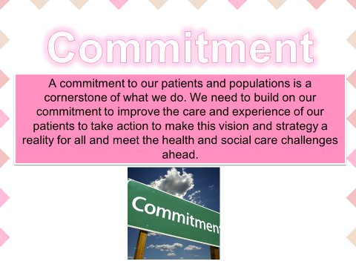
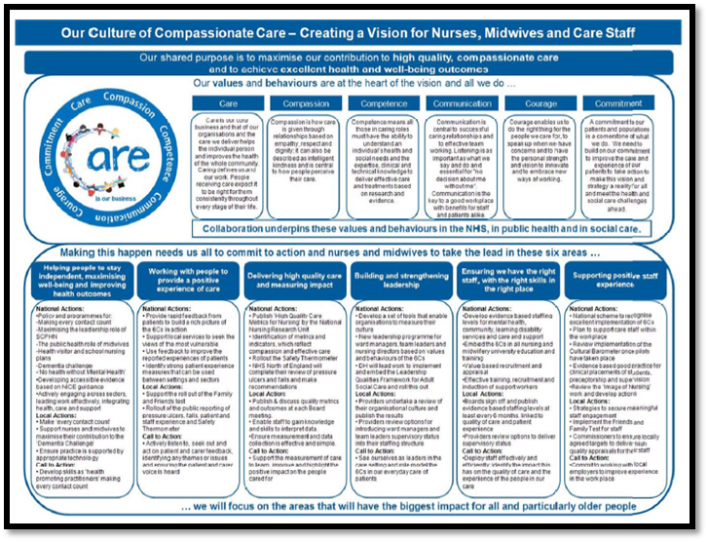

Useful video links:
- http://int.search.myway.com/search/video.jhtml?n=78486EF6&p2=%5ECAM%5Exdm107%5ETTAB02%5Egb&pg=video&pn=1&ptb=DF5CA0FF-2D1C-444A-B198-D1FAC0D5DA70&qs=&searchfor=the+6+cs+in+healthcare&si=34975715463&ss=sub&st=tab&tpr=sbt&trs=wtt
- http://int.search.myway.com/search/video.jhtml?n=78486EF6&p2=%5ECAM%5Exdm107%5ETTAB02%5Egb&pg=video&pn=1&ptb=DF5CA0FF-2D1C-444A-B198-D1FAC0D5DA70&qs=&searchfor=the+6+cs+in+healthcare&si=34975715463&ss=sub&st=tab&tpr=sbt&trs=wtt
- http://int.search.myway.com/search/video.jhtml?n=78486EF6&p2=%5ECAM%5Exdm107%5ETTAB02%5Egb&pg=video&pn=1&ptb=DF5CA0FF-2D1C-444A-B198 D1FAC0D5DA70&qs=&searchfor=the+6+cs+in+healthcare&si=34975715463&ss=sub&st=tab&tpr=sbt&trs=wtt

Check your knowledge:
Apply 6Cs to the following case studies:
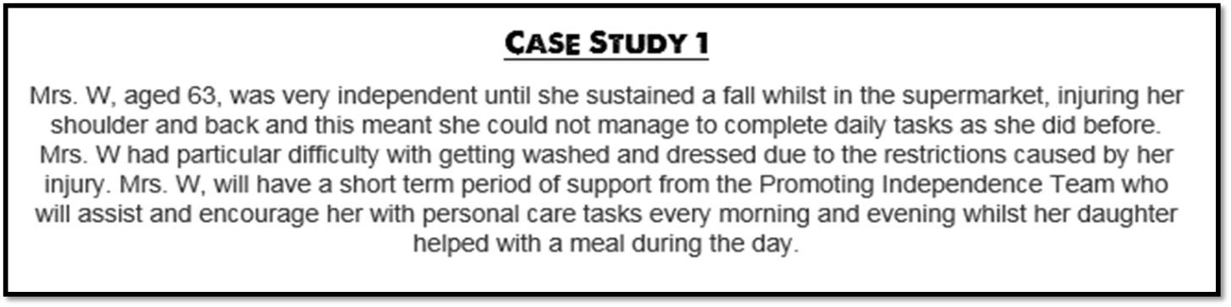

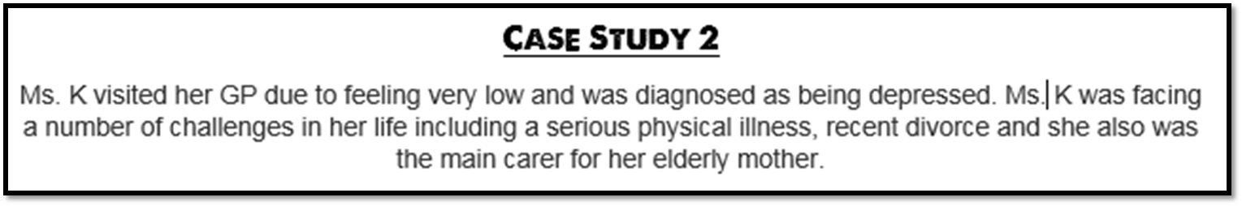

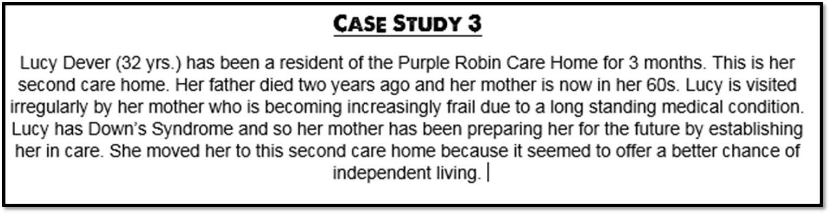

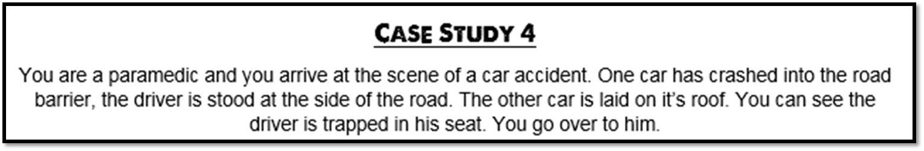

Assessment Practice:
Peter
Peter is 19. He has a range of health and care needs. He is grossly overweight, has high blood pressure and suffers from bronchitis. He was bullied at school and left with few qualifications. He has never worked. His self-esteem is low and he has recently been diagnosed with clinical depression.
- Identify two of the health and care professionals who may be involved in Peter’s care [2]
- Describe the key skills that the two professionals need to effectively support him in living an independent life [4]
- Explain why a multi-disciplinary team is likely to be involved in Peter’s care [6]
- Discuss the importance of good communication between members of a multidisciplinary team and the possible consequences of poor communication between professionals [8]

Aziz
Aziz was born in Pakistan, and came to England in the 1960s. He is a devout Muslim and has a large caring family. However, he now needs some additional help. He has chronic bronchitis, he does not have very good appetite and he is beginning to lose his balance when walking into town.
- Identify two health professionals who might be involved in Aziz’s care [2]
- Describe the role of the two professionals [4]
- Explain how the care provision may need to adapted to meet Azizs needs [6]
- Discuss how Aziz’s maybe supported in planning his future [8]

Muriel
Muriel is 40 years old and visually impaired. Her sight is deteriorating, and her doctors have predicted that she will be totally blind within two years. Muriel feels alone and feels lonely. Muriel had an emergency admission to hospital to have her appendix removed but will be soon going home.
- Identify one voluntary organisation an one statutory service that could support Muriel in maintaining an independent life at home [2]
- Describe two barriers the Muriel, and other people who are visually impaired may face when going to hospital [4]
- Explain which care provision may be most helpful in supporting Muriel to remain independent [6]
- Discuss how the nurses who provide care during Muriel’s stay in hospital are monitored to ensure they provide a professional service [8]
Brian
Brian is morbidly obese. Following an appointment with his GP, he was referred to a consultant surgeon at his local hospital. The surgeon recommended that Brian has surgery to help him lose weight. When Brian is admitted to hospital, a nurse asks him questions about his health and wellbeing and ensures that the necessary risk assessment is in place. The nurse records this information in his records before admitting him onto the ward. After his operation, Brian must spend two days in hospital as part of his recovery. During this time, nursing staff provide him with necessary medication and monitor his progress. Brian is also looked after by healthcare assistants. Following his discharge from hospital, Brian will have to attend an out-patient clinic where medical staff continue to monitor his progress.

- Identify two factors that a risk assessment might highlight when Brian is admitted to hospital [2]
- Describe two responsibilities of healthcare assistants when looking after patients on hospital wards [4]
- Explain how the nurses who provide Brian with care during his stay in hospital are monitored to ensure that they maintain professional standards [6]
- Discuss ways that health and social care staff could empower Brian to continue to improve his health when he is discharged from hospital [8]

Debbie
Debbie has a moderate learning disability. She receives a personal budget from her local council. She has a care manager who helps her use her budget to buy support so that she can live in her own flat, carry out her day-to-day routine, and plan for the future. The care manager sometimes acts as Debbie’s advocate. Debbie has just got a part-time job at her local supermarket. She also attends her local college on a part-time basis. She needs to travel to work and college on the bus. Debbie’s boyfriend, Dexter, also has a moderate learning disability. He has recently asked her to marry him.
- Identify two ways that a support worker might help Debbie get to her new job [2]
- Describe how Debbie would use an advocate[4]
- Describe one challenge that Debbie’s care manager might face when acting as her advocate [6]
- Explain how the college could prevent discrimination towards people such as Debbie who have learning disabilities [6]
- Discuss how Debbie and Dexter might be supported in planning for their future [8]

Conan
Conan is 30 and he has a serious hearing impairment. In order to maintain his independence, Conan has a hearing dog. This was provided for him by the charity ‘Hearing Dogs for Deaf People’. Conan’s hearing dog has been trained to alert him to household sounds and signals, such as when his mobile phone rings or if his smoke alarm is activated. The effect of Conan’s hearing impairment causes him to become depressed from time to time. However, he has continued with his job with no absence from work. At this stage, Conan is not sure what he can do to overcome his depression and feels that he may need more support.
- Apart from providing them with a hearing dog, identify two other ways that people with hearing impairments might be supported [2]
- Describe two barriers that people such as Conan might face when attending a GP surgery [4]
- Explain how skills used by health and social care professionals enable Conan to manage the effects of his hearing impairment [6]
- Discuss how personal information about Conan might be managed by professionals who assess his hearing needs [4]

Regina
Regina is 85. She lives in sheltered housing which has been adapted to meet her needs but she finds it difficult to care for herself and her home without support. When she was 80, Regina needed a hip replacement. She had the operation in her local hospital. While she is frail, her cognitive skills are very good and she participates in a range of activities, including playing internet chess, going to the opera and keeping a diary. You are one of her team of support workers. You work for a local, private-sector organisation that provides services and support to older people like Regina. You have five years’ experience in your role and you hope to be promoted to the role of team leader in the near future.

- Identify two health needs that a frail, older person like Regina might have [2]
- Describe two responsibilities that the organisation you work for has towards you [4]
- Explain the reasons why health and social care services are provided in different settings [6]
- Discuss the responsibilities you have when supporting a client such as Regina [8]

