Revision Tasks. Unit 2: Working in Health and Social Care
1] Needs and services available
A] Explain who may need care services
B] What those needs may be.
C] Identify the roles and responsibilities of three health care professionals that may support those needs.
D] Identify what services may be available.

2] Case study
Jo has multiple sclerosis. He uses a wheel chair both at home and when he goes out. Jo has a very caring family who are determined that they should look after him at home. He needs help with washing and dressing he cannot feed himself any longer and is incontinent.
Check your knowledge
1. Identify the range of care professionals who might support Jo.
2. Briefly describe the contribution that each care professional you have identified may
make to Jo`s care and comfort.

3] Research the Code of PRACTICE for Healthcare Support Workers and Adult Social Care Workers in England and outline some of its key points.

4] Research the Code of CONDUCT for Healthcare Support Workers and Adult Social Care Workers in England and outline some of its key points.

5] Policies and procedures
• Describe what they are?
• Explain why we have them?

6]
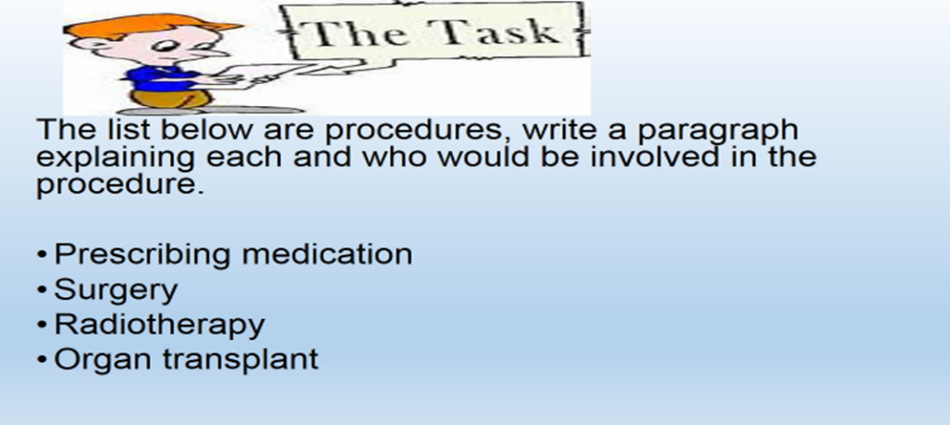
7] Task: Write a brief statement for each
• Health and safety policy
• Equality and Diversity policy
• Medication policy
• Safeguarding policy
• Disclosing and barring policy
• Death of a resident policy
• Complaints policy

8] Specialist Agencies
Investigate the role of specialist organisations/agency and individuals can access them. Such as:
- Age UK
- Mind
- Young minds
- The Royal Institute for blind people [RNIB]
- Alzheimer’s Society.
Write a short report on one such organisation/agency.
Report on its: Aims; Objectives and key activities of the organisation.
9] Rehabilitation
- Identify what rehabilitation is
- Explain what the purpose is for rehabilitation.
- Who may be in need of rehabilitation and why?
- What sort of rehabilitation is there?

10] Complimentary therapies
Describe what complimentary therapies are?
Explain 3 different types on complimentary therapies.
When may an individual use them and what may be the benefits?
Do you think they work?

11] Write a paragraph explaining each and how they may be put into practice.
- Prevent discriminatory practice
- Empower service users
- Ensure Safety
- Maintain communication
- How they are monitored and by whom

12] Specialist Agencies
Investigate the role of specialist organisations/agency and individuals can access them. Such as:
- Age UK
- Mind
- Young minds
- The Royal Institute for blind people [RNIB]
- Alzheimer’s Society.
Write a short report on one such organisation/agency.
Report on its: Aims; Objectives and key activities of the organisation.
13] Holistic Approaches: The holistic approach [also known as the whole person approach] takes account of a person’s wider needs [physical, intellectual, emotional, social, cultural and spiritual] and seeks to meet these needs to promote health and wellbeing.
- What are the `Advantages and Disadvantages`?
- Describe a holistic approach that may be used to support someone who has bipolar disorder. Aspects to consider:
- Social and cultural needs as well as medical needs
The professionals who would be part of the multidisciplinary team that would support someone with bipolar disorder

