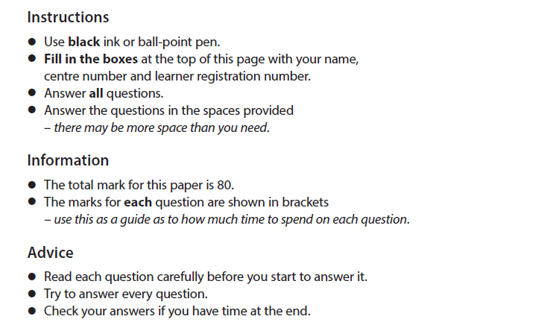
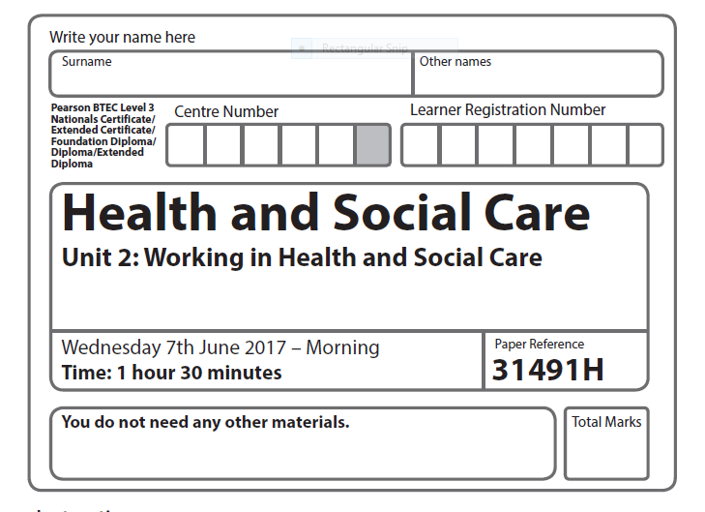
For 8-mark questions, you MUST show evidence of a plan.
40
U6 KA2
PEEL
P - Make a Point
E – Explain and expand the point
E – Give an Example
L – Link to impact
Upper Sixth Key Assessment 2

40

Case Study Scenario 1: Age-related needs
Hal is 70. He was recently diagnosed with a brain tumour which his neurosurgeon told him is inoperable and that he had about six months to live.
Before his diagnosis, Hal was healthy except for failing eyesight. He would prefer to remain at home until he dies, in familiar surroundings. He has support from Marie Curie, a charity which provides care and support for people like Hal who have a terminal illness.
The Marie Curie nurse who supports Hal asks him about his needs and preferences, for example whether he wants members of his family to be involved in his care. She also advises Hal about palliative care. This is care which helps people to manage their pain levels.
Hal’s condition gets worse and he talks to his Marie Curie nurse about going into a hospice where he can receive constant care. He dies on the day he is admitted to the hospice.

a) Identify two reasons why Hal might prefer to receive care at home.
[2 marks]
…………………………………………………………………………………………………………………………………………………………………………………………………………………………………………………………………………………………………………………………………………………………………………………………………………………………………………………………………………
b) Describe two ways that the Marie Curie nurse will help Hal to manage his pain.
[4 marks]
………………………………………………………………………………………………………………………………………………………………………………………………………………………………………………………………………………………………………………………………………………………………………………………………………………………………………………………………………………………………………………………………………………………………………………………………………………………………………………………………………………………………………………………………………………………………………………………………………………………………………………………………………………………………………………………………………………………………………………………………………………………………………………………………………
c) Explain why services such as hospice care might be provided in a variety of settings.
[6 marks]
…………………………………………………………………………………………………………………………………………………………………………………………………………………………………………………………………………………………………………………………………………………………………………………………………………………………………………………………………………………………………………………………………………………………………………………………………………………………………………………………………………………………………………………………………………………………………………………………………………………………………………………………………………………………………………………………………………………………………………………………………………………………………………………………………………………………………………………………………………………………………………………………
………………………………………………………………………………………………………………………………………………………………………………………………………………………………………………………………………………………………………………………………………………………
d) Discuss the responsibilities of healthcare workers when supporting people like Hal who have a terminal illness.
[8 marks]
…………………………………………………………………………………………………………………………………………………………………………………………………………………………………………………………………………………………………………………………………………………………………………………………………………………………………………………………………………………………………………………………………………………………………………………………………………………………………………………………………………………………………………………………………………………………………………………………………………………………………………………………………………………………………………………………………………………………………………………………………………………………………………………………………………………………………………………………………………………………………………………………
………………………………………………………………………………………………………………………………………………………………………………………………………………………………………………………………………………………………………………………………………………………
…………………………………………………………………………………………………………………………………………………………………………………………………………………………………………………………………………………………………………………………………………………………………………………………………………………………………………………………………………………………………………………………………………………………………………………………………………………………………………………………………………………………………………………………………………………………………………………………………………………………………………………………………………………………………………………………………………………………………………………………………………………………………………………………………………………………………………………………………………………………………………………………
………………………………………………………………………………………………………………………………………………………………………………………………………………………………………………………………………………………………………………………………………………………
……………………………………………………………………………………………………………………………………………………………………………………………………………………………………

Case Study Scenario 2: Physical/sensory disabilities
Lars is 25. He was involved in an accident while rock climbing. After he received emergency medical care in a hospital, an orthopaedic surgeon (a doctor who treats injuries to bones and muscles) told Lars he had broken his spine.
Lars now uses a wheelchair. He is able to lift himself in and out of his wheelchair and he uses it to get from one place to another, including from home to work.
He lives near a tram stop and the trams are accessible to people who use wheelchairs. He works in an office which is adapted to include accessible ramps, lifts, office furniture and canteen facilities.
Before his accident, Lars was active in a range of sports. He maintains this interest and now participates in different types of sports, including basketball, tennis and archery.
While Lars is not happy about having to spend a lot of his time in his wheelchair, he has adapted successfully and continues to lead a full and meaningful life.

a) Apart from the orthopaedic surgeon, identify two healthcare workers who would have been involved in providing care for Lars after his accident.
[2 marks]
…………………………………………………………………………………………………………………………………………………………………………………………………………………………………………………………………………………………………………………………………………………………………………………………………………………………………………………………………………
b) Describe two ways that healthcare workers would have enabled Lars to recover from his accident.
[4 marks]
………………………………………………………………………………………………………………………………………………………………………………………………………………………………………………………………………………………………………………………………………………………………………………………………………………………………………………………………………………………………………………………………………………………………………………………………………………………………………………………………………………………………………………………………………………………………………………………………………………………………………………………………………………………………………………………………………………………………………………………………………………………………………………………………………
c) Explain how hospitals, such as the one where Lars was treated after his accident, are inspected.
[6 marks]
…………………………………………………………………………………………………………………………………………………………………………………………………………………………………………………………………………………………………………………………………………………………………………………………………………………………………………………………………………………………………………………………………………………………………………………………………………………………………………………………………………………………………………………………………………………………………………………………………………………………………………………………………………………………………………………………………………………………………………………………………………………………………………………………………………………………………………………………………………………………………………………………
………………………………………………………………………………………………………………………………………………………………………………………………………………………………………………………………………………………………………………………………………………………
d) Discuss ways that people like Lars, who develop a physical disability, are enabled to come to terms with their condition.
[8 marks]
…………………………………………………………………………………………………………………………………………………………………………………………………………………………………………………………………………………………………………………………………………………………………………………………………………………………………………………………………………………………………………………………………………………………………………………………………………………………………………………………………………………………………………………………………………………………………………………………………………………………………………………………………………………………………………………………………………………………………………………………………………………………………………………………………………………………………………………………………………………………………………………………
………………………………………………………………………………………………………………………………………………………………………………………………………………………………………………………………………………………………………………………………………………………
…………………………………………………………………………………………………………………………………………………………………………………………………………………………………………………………………………………………………………………………………………………………………………………………………………………………………………………………………………………………………………………………………………………………………………………………………………………………………………………………………………………………………………………………………………………………………………………………………………………………………………………………………………………………………………………………………………………………………………………………………………………………………………………………………………………………………………………………………………………………………………………………
………………………………………………………………………………………………………………………………………………………………………………………………………………………………………………………………………………………………………………………………………………………
……………………………………………………………………………………………………………………………………………………………………………………………………………………………………

