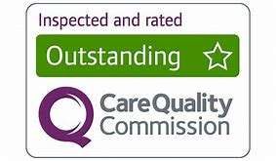
30.  Well done you have been rated outstanding by CQC | 29.  Assess the importance of multi-agency working from a staff and service user perspective. | 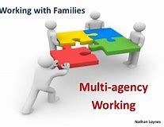  28.  Describe multi-agency working, including agencies that may be involved. | 27.  Ian has had surgery due to obesity and heart problems. Explain the role of the Health Care Assistant in his recovery. | 26.  Discuss good and bad practice in the promotion of dignity in care.
21.  Outline 3 policies and procedures that protect service users in care. | 22.  Explain the role of professional body responsible for HSC settings and/or staff. | 23.  Identify 2 Health professionals that may be involved in her care. | 24.  Discuss the role of a Doula. | 25.  Explain how children in care can be empowered.
20.  Explain how domiciliary carers can protect themselves while at work. | 19.  Assess domiciliary care with residential care. | 18.  Susan is hearing impaired, explain how her local health clinic promote anti-discriminatory practise? | 17.  Describe the law helps to protect the rights of people with disabilities | 16.  Discuss the types and effects of discrimination that may be faced by Lilly and Ray.
11.  Outline the 6 C’s | 12.  State the duties of a doctor. | 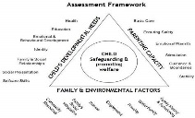  13.  Discuss what this framework is used for and which professional may use it. | 14.  Ray has learning difficulties identify 2 social care professionals who could support him. | 15.  Lily is being assessed by a support worker to see if she can live independently. Assess potential risks that may arise.
10.  Outline the Nursing Code. | 9.  Explain whether this patient needs an occupational therapist or physiotherapist. | 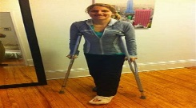  8.  Explain whether this patient needs an occupational therapist or physiotherapist. | 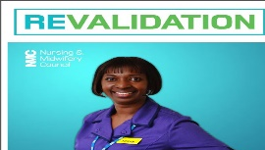  7.  Discuss revalidation and how it improves standards in an organisation. | 6.  State 4 health professionals
1.  You are waiting for some results, miss a go. | 2.  Which laws and policies is this breaching? | 3.  Your GP needs to further investigate what do they do now? | 4.  Your patient is confused and can’t remember name 2 conditions that this could be. | 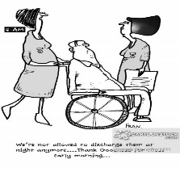  5.  Discuss why an assessment of this patient’s home needs to be undertaken before they can go home.

