BTEC Health & Social Care Unit 14 – Physiological Disorders and their care
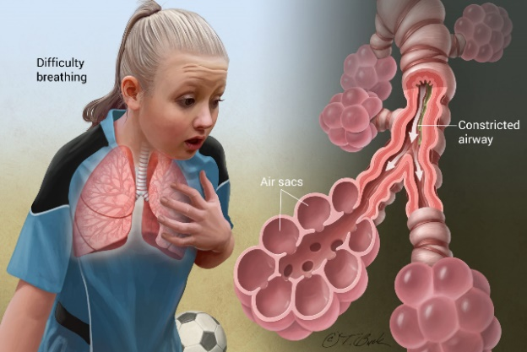
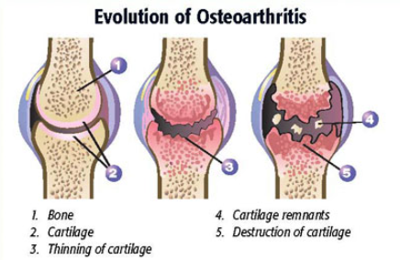

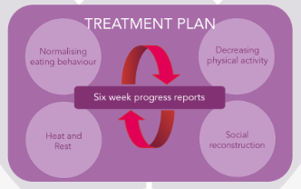

Unit 14
Physiological Disorders and their care
Introductory booklet

Assignment 1: January 14th – March 1st
Assignment 2: March 4th - May 8th

Learning Aim A; Investigate the causes and effects of physiological disorders
Unit Content:
A1. Types of physiological disorders and effects on body systems and functions
- Endocrine System Disorders e.g. diabetes, hypothyroidism and hyperthyroidism
- Nervous System Disorders e.g. Parkinson’s disease, Alzheimer’s disease
- Musculo-skeletal System Disorder e.g. rheumatoid arthritis, osteoporosis
- Respiratory System Disorders e.g. asthma, chronic obstructive pulmonary disease
- Circulatory System Disorders e.g. coronary heart disease, leukaemia
- Cancer e.g. bowel, prostate
Impact of disorders on service user’s physical, mental, social and emotional health
A2. Causes of physiological disorders
- Inherited traits e.g. sickle cell anaemia
- Lifestyle choices e.g. smoking cigarettes, alcohol
- Diet e.g. obesity, dietary deficiency
- Environmental e.g. housing conditions, air pollution
A3. Signs and symptoms of physiological disorders
- Observable signs of physiological disorders e.g. rash, swelling
- Symptoms experienced by the individual e.g. pain, disorientated
Learning aim B: Examine the investigation and diagnosis of physiological disorders
B1. Investigative procedures for physiological disorders
- General measurements that may be undertaken, e.g. blood pressure, body temperature.
- Investigations as appropriate for each individual, e.g. medical history, blood tests.
B2. Diagnostic procedures for physiological disorders
- Procedures based on specific signs and symptoms, e.g. lumbar puncture, biopsy
- Importance of recognising non-specific or confusing symptoms, e.g. myalgic encephalomyelitis (ME).
Learning aim C: Examine treatment and support for service users with physiological disorders
C1. Provision of treatment and support
- Medication, e.g. anti-inflammatory drugs.
- Surgery, e.g. surgical procedures for cancer.
- Rehabilitation programmes, e.g. physiotherapy.
- Complementary therapies, e.g. aromatherapy, acupuncture.
- Advice on lifestyle changes, e.g. smoking cessation.

C2 Types of carers and care settings
Carers:
- professional carers, e.g. GPs, nurses
- informal carers, e.g. friends, family
- private and voluntary carers, e.g. Age UK, private care agencies.
Care settings:
- service user’s own home
- residential care home
- GP surgery or health centre
- hospital care
- rehabilitation settings

Assignment 1 overview

You will choose TWO physiological body system disorders to research and write your assignment on:
For each disorder you will discuss:
- What causes the disorder
- What symptoms a person will experience
- How it is diagnosed, and which tests may be involved
- How it is treated – medication, surgery etc.
- Who will support their treatment and which settings they work in.

Learning aim D: Develop a treatment plan for service users with physiological disorders to meet their needs
D1. Care methods and strategies
- Assessment of care needs, e.g. primary, secondary or tertiary care.
- Reviewing care needs, e.g. making changes as required.
- Validity and reliability of the sources of information on possible treatments.
D2 Treatment planning processes
- Cycle of planning.
- Individual needs, including culture, gender, age, religion, disability.
- Purpose and aim of care for individual.
- Outcomes to be achieved.
- Actions to be taken.
- Overcoming potential barriers.
- Professional responsibilities.
- Advantages and disadvantages of different types of treatment, e.g. benefit to service users, cost to health and social care services.
- Scheduling, including times and locations where treatment will take place.
- Timescales for achievement.

Assignment 2 overview

You will choose ONE case study person with a physiological condition. Someone who you know well and can speak to about their condition and treatment.

You will write a treatment plan for that person which includes:
- A care needs assessment
- The aims of the treatment plan
- The treatments and care they will receive and who will deliver them
- How the plan will improve their health and well-being

Pass Criteria | Merit Criteria | Distinction Criteria
Learning aim A: Investigate the causes and effects of physiological disorders
A.P1 Explain the causes, signs and symptoms of different types of physiological disorders on service users. | A.M1 Analyse the changes in the body systems and functions, resulting from different types of physiological disorders on service users | A.D1 Evaluate the impact of physiological disorders on the health and well-being of service users
Learning aim B: Examine the investigation and diagnosis of physiological disorders
B.P2 Compare investigative and diagnostic procedures for different physiological disorders. | B.M2 Assess the importance of specific procedures in confirming the diagnosis of physiological disorders. | BC.D2 Justify the potential benefits of different investigations and treatment options for service users diagnosed with physiological disorders.
Learning aim C: Examine treatment and support for service users with physiological disorders
C.P3 Explain the treatment and support available for service users with different physiological disorders. | C.M3 Assess the provision of treatment, support and types of care for service users with different physiological disorders.
C.P4 Compare the types of carers and care settings for service users with different physiological disorders.
Learning aim D: Develop a treatment plan for service users with physiological disorders to meet their needs |  | D.D3 Justify the recommendations in the plan in relation to the needs of the service user and advantages and disadvantages of treatment options.
D.P5 Assess care needs of a selected service user with a physiological disorder. | D.M4 Plan treatment to meet the needs of a selected service user with a physiological disorder, reviewing as appropriate to improve outcomes.
D.P6 Plan treatment to meet the needs of a selected service user with a physiological disorder.
D.P7 Explain how the plan would improve the health and wellbeing of a selected service user.

Key Terminologies – these need to be correctly and accurately used in your work…
Physiological disorders
Endocrine system disorders
Nervous system disorders
Musculo-skeletal system disorders
Respiratory system disorders
Circulatory system disorders

Holy Cross BTEC Assessment Policy

The Harvard reference system

Most courses ask students to reference using the Harvard system.
There are TWO parts to this system:
  - You write your quote out, and in brackets, put the author name, date and page.
  - Then you provide a list of books you have referenced from at the end of your written work in the Bibliography.

Here is an example…
You have read about Tuckman’s Sequential Theory by Bruce Tuckman. It is on pages 19 to 20 of the course BTEC textbook. This is what you would put in your written work:

“The first stage forming phase, refers to people meeting for the first time and sharing information’’.

Stretch, Whitehouse 2010 (p19)
(Author name Year of publication Page number)

This is what you put in the Bibliography…

Stretch, Whitehouse | 2010 | BTEC Level 3 Health & Social care Book 1 | Pearson Education Limited
Author’s surname & initials | Date of publication | Full title of the book | Name of the publisher

You will find the year of publication and the name of the publisher in the front of the book.
This website has a useful tool to help you with referencing: http://www.neilstoolbox.com/bibliography-creator/

Constructing a Bibliography
This must be presented in alphabetical order. We use the Harvard Referencing System, which uses the following order: author surname, initial, date, title of publication, place of publication, publisher.

EXAMPLE
Author surname | Initial/s | Date | Title of publication | Place of publication | Publisher
E.G. Mill | J S | 1985 | On Liberty (1859) ed. Himmelfarb | London | Penguin Classics

Webliography

Present this in alphabetical order.
The following recommendation includes all the essential elements required in the citation of a website:

Page title | URL (page, not site) | Date accessed
British Sports – Disability Sports | http://www.britishsports.com/disabilitysports.htm | (downloaded 7 July 2007)

