Holy Cross Sixth Form College
Health & Social Care

Lower Sixth BTEC Level 3 National
Subsidiary Diploma Handbook
2018-2019
Welcome to Health and Social care at Holy Cross!

Over the coming two years, you will be studying the BTEC National SUBSIDIARY DIPLOMA in Health and Social Care.

This course will suit you if you see your future in working with people. The course covers topics related to the health and well-being of individuals and the wider community. It is equivalent in size to one A Level.

For the Subsidiary Diploma you can be awarded:

Grade | A level equivalent
Distinction* | A*
Distinction | A
Merit | C
Pass | E

What units will I study?

Lower sixth: |  | Credits
Unit 1: | Developing effective communication in health and social care | 10
Unit 2: | Equality, diversity and rights in health and social care | 10
Unit 4: | Development through the life stages | 10
Upper sixth:

Unit 3: | Health, Safety and Security in Health and Social Care | 10
Unit 5: | Anatomy and Physiology for Health and Social Care | 10
Unit 14: | Physiological Disorders and their Care | 10
ALL units are coursework based and assessed by your subject tutor.

Unit Summaries
Unit 1: Developing Effective Communication in Health and Social Care
Aim and purpose
This unit aims to enable learners to understand effective communication, the barriers that may exist and ways to overcome these. The unit will give learners the opportunity to gain the interpersonal skills needed to embark on a career within the health or social care sectors.
Learning outcomes
On completion of this unit a learner should:
1 Understand effective communication and interpersonal interaction in health and social care
2 Understand factors that influence communication and interpersonal interaction in health and social care environments
3 Understand ways to overcome barriers in a health and social care environment
4 Be able to communicate and interact effectively in a health and social care environment.

Unit 2: Equality, Diversity and Rights in Health and Social Care
Aim and purpose
This unit aims to develop learners’ understanding of concepts related to equality, diversity and rights in health and social care. Learners will be able to gain knowledge of discriminatory practice and means of combatting this. They will also develop understanding of national initiatives that promote anti-discriminatory practice in health and social care settings.
Learning outcomes
On completion of this unit a learner should:
1 Understand concepts of equality, diversity and rights in relation to health and social care
2 Know discriminatory practices in health and social care
3 Understand how national initiatives promote anti-discriminatory practice
4 Know how anti-discriminatory practice is promoted in health and social care settings.

Unit 4: Development through the Life Stages
Aim and purpose
This unit aims to enable learners to gain knowledge and understanding of the different stages throughout the human lifespan. Learners will be able to develop an understanding of both the physical and psychological changes of ageing and be able to apply theories of ageing to health and social care provision.
Learning outcomes
On completion of this unit a learner should:
1 Know stages of growth and development throughout the human lifespan
2 Understand potential effects of life factors and events on the development of the individual
3 Understand physical and psychological changes of ageing.

What support will I receive?
Staff are always available by email or in the Health office:
Mrs Claire Prescott cap@holycross.ac.uk (Head of Department)
Mrs Kate Porter kep@holycross.ac.uk

Weekly support sessions
Tuesday 12.25 in IT7 All welcome
Monday 4pm in HS1 – by invitation only!

Health at Holy Cross website: www.hcchealth1.com
All class resources, assignment briefs and the deadlines calendar are available on our department website, you will need to use this to catch up on missed lessons:

Course textbooks
Min of 5hrs independent work
BTEC Level 3 National Health and Social Care: Student Book 1 (Level 3 BTEC National Health and Social Care) Paperback – 19 Aug 2010
by Mr Neil Moonie (Author), Carolyn Aldworth (Author), Marilyn Billingham (Author), Hilary Talman (Author), & 2 more
£23.67
Course expectations

Arrive on time to all lessons
Bring your file and equipment to every lesson
Keep a well organised file with ALL resources
Work hard in EVERY lesson
Respect others at all times
Use your free time in college to work on assignments and revision
Check emails regularly
Use the support sessions to achieve your BEST
Write ALL work in your OWN WORDS
Submit work which is the best of your ability
Meet ALL deadlines

Work experience
It is a vital part of your Health and Social Care course that you gain experience of working in the sector. Appropriate settings include:
● Residential / Nursing Care homes
● Day-care centres
● Children’s nurseries
● Hospitals
● GP surgeries
● Surestart Children’s centres
● Special educational needs schools.

Use the Careers Moodle page to start your search for a place relevant to your Career goals:
https://moodle.holycross.ac.uk/course/view.php?id=7#workexperience

Turnitin UK
All assignments must be submitted on Turnitin UK.
Turnitin checks work for plagiarism. It will be checked against published work and against other work submitted for the assignment.
Turnitin also helps to save the environment … all work will be submitted and assessed electronically.
Turnitin Setting up Account Instructions
Please follow the stages below in order to set up your Turnitin account.
Stage | Instruction | Tick
1 | Go onto your college e‐mails.
2 | You will have an e‐mail from TurnitinUK No Reply.
3 | Go into the e‐mail and click on the website address link.
4 | Enter your college e‐mail address and the password contained in the e‐mail.
5 | You will then be asked to change your password (this should be your surname followed by your date of birth e.g. Smith231099)
6 | Read the user agreement and select ‘I agree’.
7 | You will now be signed in to Turnitin UK and should have the class BTEC Health and Social Care, Instructor: Mrs. C Prescott appearing on your screen.

Submitting Work on Turnitin UK
- Log in to Turnitin UK (www.turnitinuk.com). Remember to use your college e‐mail address.
- Click on the correct course. The instructor name should be the same name as the teacher who has set you the assignment.
- Go to the correct assignment and click Submit.
- The Submission Title should be the assignment title (see assignment brief).
- Choose the file location of your assignment and click upload.
- Follow the instructions provided. An electronic receipt will be sent to your college e‐mail address.

OneDrive
Losing work will not be accepted as an excuse for missing a deadline and the loss of work cannot be a reason for requesting an extension. Therefore, we recommend the use of One Drive. You will automatically have an account set up through your college e‐mail system.

Instructions on how to use OneDrive
- Open up a word document as normal.
- Click ‘Save As’ click ‘One Drive – Holy Cross College’
- Click on ‘OneDrive –Holy Cross College’ and Windows box will appear where you can save (or create) files. (Once you have used a folder a couple of times it will appear for you to save in).
- To then access your work:
  - Open Word click ‘File’ ‘Open’ and then you will have the option to open any of your OneDrive documents.
  - OR, open up your e‐mails. Go to the top left hand corner and click on this icon:
You will then have the option to open your OneDrive and you will be able to
access all files saved in your OneDrive.
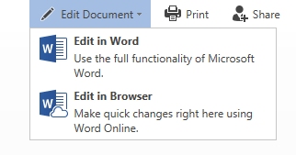
- When opening files direct from your OneDrive to edit your document. Click on ‘edit document’. You will have two options: (1) Edit in Word. This will open your document in Microsoft Word. You will then edit and save your document as you would when normally using Word. (2) Edit in Browser. This will allow you to edit work on Word Online and will save as you type. It does not have all the functions of the full Microsoft Word Software.

- You can access your OneDrive from any computer device connected to the internet. Type in ‘outlook.com/holycross.ac.uk’ you will then be required to enter your college e‐ mail address and password. Alternatively, you can download the OneDrive APP (ios and Android versions are available).
Unfortunately, you cannot upload directly from your OneDrive to Turnitin. Therefore, when you are ready to upload your work to Turnitin you will need to save your work on to the college computer or your desktop. This can be done by either downloading the document from your OneDrive or using the ‘Save As’ function in Word.
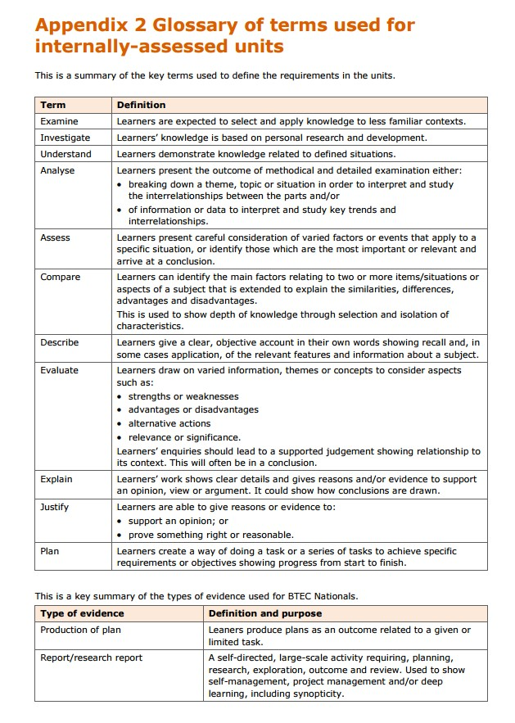

The Harvard reference system
Most courses ask students to reference using the Harvard system.
There are TWO parts to this system:
  - You write your quote out, and in brackets, put the author name, date and page.
  - Then you provide a list of books you have referenced from at the end of your written work in the Bibliography.

Here is an example…
You have read about Tuckman’s Sequential Theory by Bruce Tuckman. It is on pages 19 to 20 of the course BTEC textbook. This is what you would put in your written work:

“The first stage forming phase, refers to people meeting for the first time and sharing information’’.

Stretch, Whitehouse 2010 (p19)
(Author name Year of publication Page number)

This is what you put in the Bibliography…

Stretch, Whitehouse | 2010 | BTEC Level 3 Health & Social care Book 1 | Pearson Education Limited
Author’s surname & initials | Date of publication | Full title of the book | Name of the publisher

You will find the year of publication and the name of the publisher in the front of the book.
This website has a useful tool to help you with referencing: http://www.neilstoolbox.com/bibliography-creator/

Constructing a Bibliography
This must be presented in alphabetical order. We use the Harvard Referencing System, which uses the following order: author surname, initial, date, title of publication, place of publication, publisher.

EXAMPLE
Author surname | Initial/s | Date | Title of publication | Place of publication | Publisher
E.G. Mill | J S | 1985 | On Liberty (1859) ed. Himmelfarb | London | Penguin Classics

Webliography

Present this in alphabetical order.
The following recommendation includes all the essential elements required in the citation of a website:

Page title | URL (page, not site) | Date accessed
British Sports – Disability Sports | http://www.britishsports.com/disabilitysports.htm | (downloaded 7 July 2007)

Holy Cross BTEC Assessment Policy

Health and Social Care Learning Contract

Student
- I have read and understand this Health and Social Care Induction booklet.
- I have read and understood the Holy Cross College BTEC policy.
- I understand the requirements of the course.
- I will meet the course expectations to the best of my ability.

Student Name: …………………………………………………………………………………………………

Student Signature: …………………………………………………………………………………………………

Date:
.……………………………..

Parents/Carers
- I/We have read and understood this Health and Social Care handbook.
- I/We have read and understood the Holy Cross College BTEC policy.
- I/We will try to ensure that my child meets the course expectations and requirements.

Parent/Carer Name(s): ………………………………………………………………………………………………

Parent/Carer Signature: ………………………………………………………………………………………………

Date: .……………………………..

