The Statutory Sector – Health Care Services
Health care in this sector is provided by the National Health Service (NHS), which provides services in the hospital and in the community.
Services under the NHS include primary, secondary and tertiary care.
Primary Care Services: this is the first stage of treatment when you are ill – provided by family doctors, dentists, pharmacists, optometrists and ophthalmic medical practitioners, together with district nurses and health visitors. It describes health care that is provided by professionals who work in the community and who can be contacted directly by the public. They are called primary health care workers because they are most people’s first or primary port of call when they are concerned about some aspects of their health.
Secondary care: this is the second stage of treatment when you are ill and is usually provided by a hospital. This includes treatment provided for inpatients, day cases, outpatients and patients who attend wards for treatment such as dialysis. Secondary care is known as acute healthcare and can be either elective care or emergency care. Elective care means planned specialist medical care or surgery, usually following referral from a primary or community health professional such as a GP. Accident and emergency cases are the obvious exceptions to this.
Tertiary care: this is the third and highly specialised stage of treatment, usually provided in a specialist hospital centre or hospice.
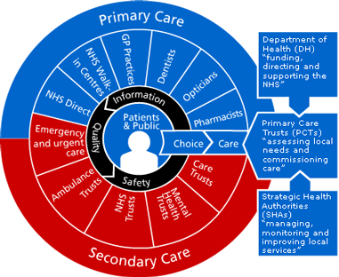

http://www.nhs.uk/NHSEngland/thenhs/about/Pages/nhsstructure.aspx

