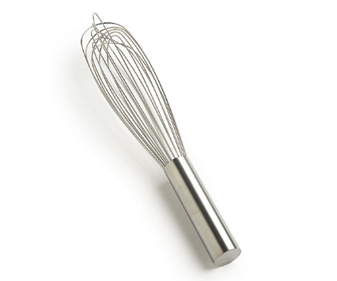
Policy Analogy
A useful analogy to remember the differences between policy, procedures, standards and guidelines is the Sweet Indulgence Cake company analogy. This company makes expensive cakes and has a Whisk policy.

Policy: All cakes must be made using company issued whisks to ensure end-product consistency and staff safety.
This gives the company the flexibility to change the whisk if new technology or safety issues arise. Note the aim of the policy is end-product consistency.

Standard: 10” balloon stainless steel whisk with 11 wires. This provides plenty of whisking power, while leaving no fiddly gaps, so it's really easy to clean. Only large plastic bowls to be used with the whisk. Hand whisks are to be used for repetitive jobs less than 1 hour only.
These are the technical specifications that make sense for that workplace.

Guideline: When whipping cream, it should form soft peaks as air in incorporated into it. You should use double cream or whipping cream only.
Only a suggestion or recommendation and may not apply in all cases.

Procedure:
1. You will need: double cream, large plastic bowl, balloon whisk.
Golden rule: whisk slowly otherwise you will make butter!
2. Begin whisking the cream in the bowl.
3. As soon as it starts to thicken SLOW DOWN! Stop whisking and use a large spoon to fold the cream and it will continue to firm up.
4. Whip cream until it has doubled in volume and forms a stiff peak.
5. Can be kept in the refrigerator for up to 48 hours. Can also be frozen in a sealable plastic bag for up to 2 weeks.
The procedure describes the process for using the whisk to get the best results and be successful.
Following this procedure with the correct whisk, and following the guidelines where appropriate, will ensure the member of staff complies with the Whisk policy.

