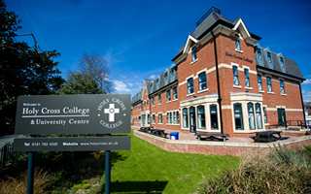
Holy Cross Hospital

Part 6 – Specific Responsibilities of People working in H&SC

People working in health and care settings are required to work to high professional standards. They are required to follow agreed policies and procedures and actively promote the health and wellbeing of those in their care.
TASK: What do you think we expect of you in your role as a student nurse?
Hint – think back to Unit 5!

The Care Sector Consortium (1992) established a care value base, which covers the aspects listed above. These are found in the code of practice of all health and care professions.
Use the table provided and highlight the words which link the themes between the 6Cs and the Principles of nursing. Then link these to the words in the Care Value base.

TASK: Complete the table below, adding in any missing details to the white boxes:

Abbreviation | What this stands for | What this does
GMC |  | Sets and monitors standards of behaviour for doctors
Abbreviation | What this stands for | What this does
 | Nursing & Midwifery Council
HCPC |  | Sets and monitors standards of behaviour for social workers and for a range of other health professions such as…

Promoting anti-discriminatory practice
Anti-discriminatory practice is a core value and principle that guides the work of health and care professionals.
The legislation that this is based on is ____________________________
Anti-discriminatory practice aims to ensure that the needs of service users are met, regardless of any protected characteristics and that any prejudice by staff or other service users are appropriately challenged.
TASK: There are 9 protected characteristics. What do you think these are?

The Human Rights Act (1998) applies to all parts of the United Kingdom (England, Scotland, Wales and Northern Ireland). It guarantees rights to people cared for by ‘public authorities’ to be treated with fairness, dignity and respect.
The Human Rights Act guarantees the following rights to individuals:
The Human Rights Act 1998 guarantees an individual the right to… | What does this actually mean?
Life
Access to an education
Freedom from torture and inhuman or degrading treatment or punishment
Peaceful enjoyment of possessions and protection of property
Freedom from slavery, servitude and forced or compulsory labour
Marry and found a family
Freedom of expression
Liberty and security of person
Freedom of thought, conscience and religion
Respect for a private and family life, home and correspondence
TASK: Complete the questions below, applying principles of fairness, dignity and respect to the case studies of our service users.
- Public authorities can include:

____________________________________________________________________________________________________________________________________________________________________________________________________________________________________

2. How do you think you would treat our service users with fairness, dignity and respect in your role as a student nurse? Consider the holistic needs of our service users as outlined in booklet 1.

Service user | How I would demonstrate fairness, dignity and respect
Carlos
Salome
Service user | How I would demonstrate fairness, dignity and respect
Fay
Drake
Baby Jack

Adapting health and social care provision for different types of service users
Despite the legislation that underpins the policies, procedures and codes of practice governing professional practice and the care provided in health and care settings, the world is not free from prejudice and discrimination.
Prejudice:

Discrimination:

Think higher: If we have legislation that aims to prevent discriminatory practice, why do you think that unfair treatment is a daily experience for some people within society?
______________________________________________________________________________________________________________________
______________________________________________________________________________________________________________________
______________________________________________________________________________________________________________________

Eye on the exam (Sample assessment material paper)
Debbie has a moderate learning disability. She receives a personal budget from her local council. She has a care manager who helps her use her budget to buy support so that she can live in her own flat, carry out her day-to-day routine, and plan for the future. The care manager sometimes acts as Debbie’s advocate.
Debbie has just got a part-time job at her local supermarket. She also attends her local college on a part-time basis. She needs to travel to work and college on the bus.
Debbie’s boyfriend, Dexter, also has a moderate learning disability. He has recently asked her to marry him.

Explain how the college could prevent discrimination towards people such as Debbie who have learning disabilities.
(6 marks)
__________________________________________________________________________________________________________________
______________________________________________________________________________________________________________________________________________________________________________________________________________________________________________________________________________________________________________________________________________________
__________________________________________________________________________________________________________________
__________________________________________________________________________________________________________________

TASK 1: Walking around College, can you identify anything that may be an adaptation to meet the needs of people with specific needs?

TASK 2: Considering your service users, how do you think that health and care provision could be adapted to meet their needs?

Complete the table below with your thoughts.

Service user | How health and care provision could be adapted to meet service user needs
Carlos
Salome
Fay
Drake
Service user | How health and care provision could be adapted to meet service user needs
Baby Jack
Empowering Individuals
The importance of fostering and supporting the empowerment of service users can often be overlooked.
Empowerment:

TASK: How do you think you could help to empower service users in your role as a trainee nurse?

Empowering Service Users
READING TASK: Empowering individuals
- Read the information below and answer the questions within each section. There are four questions and one think higher in total.

Promoting individualised care
Empowerment enables service users to understand the choices that they can make about their care, to contribute to the decision-making and to take control of their lives.

In health and care settings, particularly when service users are feeling unwell or anxious, there can be a tendency to allow service providers to take over and for the service user to just ‘do as they are told’.

In most situations, practitioners are required to gain their client’s consent before carrying out a care procedure, a treatment or making arrangements for a client’s care.
Q1: What could the outcome be if a service provider does not allow their service user to be active in decision making?
________________________________________________________________________________________________________________________________________________________________________
Q2: How could the empowerment of individuals and inclusion in decision making promote individualised care?
________________________________________________________________________________________________________________________________________________________________________

Promoting and supporting individuals’ rights to dignity and independence
Empowering service users means that they are more likely to be treated as individuals. Their needs and preferences will be known and respectfully considered.

Q3: If a person’s needs and preferences are known and considered with respect, what is likely to be the effect on the individual? Hint: consider Unit 1!
____________________________________________________________________________________________________________________

Providing active support consistent with the beliefs, cultures and preferences of service users
Health and care provision in a multi-cultural society must address the specific needs of people from diverse backgrounds.
A professional carer must be aware of individual differences and ensure, through discussion and planning, that the importance of these needs to the service user are fully respected and are not ignored.
Here at Holy Cross College Hospital, we are committed to the following, to provide active support for our service users:
- Translators will be provided if a service user does not speak English as a first language.
- We provide a multi-cultural appreciation week, which we encourage all of our colleagues and service users to get involved in, each year.

Q4: Why is it important in your role, to recognise the multi-cultural society in which we live?
____________________________________________________________________________________________________________________________________________________________________________________
Think Higher: What else could Holy Cross College Hospital do to support our service users? Try to think of at least two additional things.
1._______________________________________________________________________________________________________________________2._________________________________________________________________________________________________________________________________________________________________________________________________________________________________________________
Supporting individuals to express their needs and preferences
Not all of our service users will have the confidence or personal skills to participate fully in their care. Some may need specific support to participate in meetings or to enable them to explain their preferences.
Support mechanism | Provide an example of a service user that this could benefit and why
Translators and interpreters
Signers
Advocates
Family and friends

Promoting the rights, choices and wellbeing of individuals and balancing their rights with those of other service users and staff
It will not always be straightforward to provide a service user with the care or treatment of their choice, even when their preferences are clear and apparently reasonable.
Using the mind-map below, jot down conflicts that could arise when considering the balance of service user rights with other service users and staff members.

Potential Conflicts

Dealing with conflict in health and social care settings
Challenging behaviour can be defined as any behaviour that puts the service user or anybody else in the setting at risk, or that significantly affects their quality of life.
What types of challenging behaviour may arise in health and social care settings?

What skills would you need when dealing with conflict?

Video task – Challenging behaviour
Whilst watching the video about an episode of challenging behaviour in a health care setting, answer the following questions:
- What did the health care professional do incorrectly in the first video?
____________________________________________________________________________________________________________________________________________________________________________________________________________________________________
_________________________________________________________
- How might you have managed this situation differently?
____________________________________________________________________________________________________________________________________________________________________________________________________________________________________
_________________________________________________________
Think Higher: Why is a multi-disciplinary team important in managing challenging behaviour?

What skills would you need when dealing with conflict?

If it seems that a situation could lead to violence, wherever possible:
- Make sure that you know where the doors or other exit points are
- Remove anything that could be used as a weapon
- Allow the aggressor personal space, do not stand too close to them
- Summon help as soon as possible, by using a panic alarm, shouting for help or by phoning the police or security.

We also have a lone workers’ policy available to you. This includes guidance and procedures aimed at ensuring that people working on their own are safe. This policy is in place primarily to protect you, but also to protect our service users.
What care setting might this policy be most applicable to and why?

What skills would you need when dealing with conflict?

Video Activity - https://youtu.be/dPupXa-PXHA
The Health and Safety at Work Act (1974) governs the requirements of employers and employees to ensure that they maintain a safe working environment for all.
Whilst watching the video, answer the following questions:
- Who does this apply to?
___________________________________________________________________________________________________________________________________________________________________________
- Who is ultimately responsible for health and safety at work?
_________________________________________________________
- What is a hazard?
__________________________________________________________________________________________________________________
- What is a risk?
__________________________________________________________________________________________________________________
- What is a risk assessment?
__________________________________________________________________________________________________________________

- What do you think you need to do in order to promote good health and safety at work?

As your employer, when we carry out risk assessments, we examine all the procedures and activities that take place in our organisation and assess the level of risk involved. In our care home, for example, this will range from risks associated with routine care procedures to organising social events and taking service users on outings / trips.
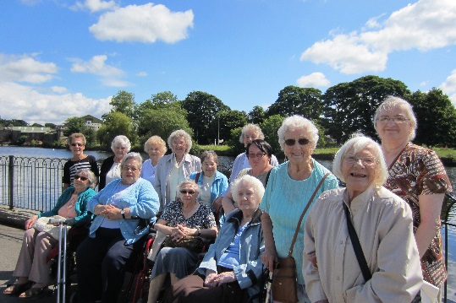

The responsibility for completing a risk assessment is given to a senior member of staff, for example, your supervisor. An example of this is Jo, who is our senior care assistant, who is responsible for assessing the risks associated with the bathing of any new residents.
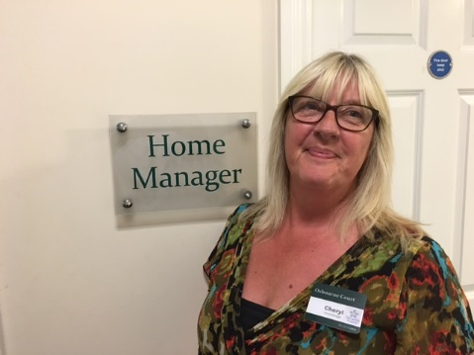
Our care home manager, Cheryl, has the responsibility of ensuring that Jo has the correct training required to carry out this task.

Step by step: Carrying out a risk assessment (5 steps)
- Identify the hazards at the setting, or in carrying out an activity.
- Identify those at risk, including service users, staff, volunteers and other visitors.
- Evaluate the level of risk – usually rated on a scale of 1 to 4, with 1 being the lowest level of risk.
- Identify ways to limit the risk – this will include specific actions to minimise risk.
- Review measures taken to minimise the risk.

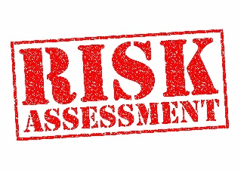
Risk assessment task: Working in small groups, complete the following risk assessment for the risk of frail, elderly service users falling on the stairs. Are you able to agree on the level of risk and measures that should be taken?

Use the following tables to calculate your risk rating.
The risk rating for a particular activity can be helpfully expressed numerically by multiplying the rating for the likelihood of risk by the severity of the likely injury that could arise.
Risk rating = likelihood of risk x severity of injury
Likelihood of risk | Score |  | Severity of injury | Score
Most unlikely to happen | 1 |  | If it did happen, the harm would be minimal and could be dealt with by an untrained person eg applying a plaster | 1
Unlikely to happen | 2 |  | Slight injuries, eg catching a cold or needing a few stitches | 2
Likely to happen | 3 |  | Serious injuries (physical or psychological) which could take months or years to heal | 3
Very likely to happen | 4 |  | Could be permanent disability or even death | 4

The first row has been completed as an example.
Potential hazard | Who is at risk | Existing measures to minimise risk | Risk rating | Preventative measures | Responsibilities (identify the job role)
Slipping on a piece of rubbish left on stairs | Service users, staff, volunteers, cleaners | Cleaners on site to maintain rubbish collection | 6 | All staff to be briefed on checking stairs for rubbish | Senior care assistant, care assistants
Potential hazard | Who is at risk | Existing measures to minimise risk | Risk rating | Preventative measures | Responsibilities (identify the job role)
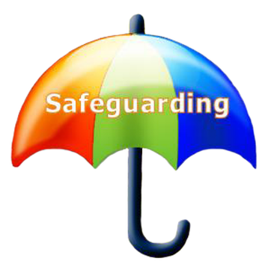
Safeguarding
If a child or a vulnerable adult shares information with you that raises concerns about their personal safety, or they disclose that they are being abused, you should follow the setting’s safeguarding policies.
What does safeguarding mean?
Safeguarding involves a setting having policies in place to ensure that children and vulnerable adults are protected from harm, abuse and neglect and that their health and wellbeing is promoted.

As an employee or volunteer, you must listen carefully to the service user and avoid asking questions. Let the service user tell you their story in their own way and in their own words. In this instance, you will have to explain to the service user that the information will need to be shared with somebody more senior.
What is the name of the role that is responsible for investigating the claim or accusation?
___________________________________________________________
What will you be asked to provide?
___________________________________________________________

Protecting service users, staff and volunteers from infection
Working in a care environment requires all staff and volunteers to ensure that they maintain a clean and hygienic working environment and minimise the likelihood of passing on infection. In order to keep yourself and others safe from infection, you must ensure that you are familiar with the setting’s policies and procedures in place to minimise any risk.

On the mind-map below, expand on the points with regards to what actions you can take to prevent infection.
Think Higher: Add additional main points of your own to this mind-map.

Minimising the spread of infection
Washing hands
Sharp articles e.g. needles
Linen
Equipment

Control and disposal of substances harmful to health - https://youtu.be/7788C0p8NQQ
To protect all service users, staff and visitors from harm and infection, you must ensure that hazardous waste is disposed of properly.
What is the definition of hazardous waste?

What things might be classified as hazardous waste?

What skills would you need when dealing with conflict?

The Control of Substances Hazardous to Health (COSHH) Regulations (2002) provide guidance for the safe disposal of hazardous waste.
In care settings, different coloured bags are often used to ensure the safe and efficient disposal of hazardous waste.
TASK: See if you can match up the example type of waste with the appropriate method of disposal:
Clinical waste, e.g. used bandages, plasters or other dressings
Yellow bag: waste is burned in controlled settings
Needles and syringes
Body fluids, e.g. urine, vomit and blood
Soiled linen
Yellow ‘sharps’ box which is sealed: waste is burned in controlled settings
Flushed down a sluice drain: area must then be cleaned and disinfected
Red laundry bag: laundered at the appropriate temperature
Blue bag: returned to the Central Sterilisation Services (CSSD) for sterilising and reuse
Recyclable equipment and instruments

Reporting and recording of accidents and incidents
There are particular illnesses, diseases and serious accidents that health and care providers must officially report. These are covered in the Reporting of Injuries, Diseases and Dangerous Occurrences Regulations (RIDDOR) (2013).
What types of illnesses and incidents have to be reported?

However, less serious accidents and incidents must also be recorded e.g. slips, trips and falls, regardless of whether or not there is an injury. Here at Holy Cross College Hospital, we, along with other providers, use an accident form to report the details of all accidents and incidents, which are then recorded in the accident book. These reports are required by law and are checked when care settings are inspected. They can also be used in court, particularly if the injured person is attempting to claim compensation for injury or if there is an accusation of criminal negligence.

HOLY CROSS COLLEGE HOSPITAL ACCIDENT FORM
About the person completing the form:
Full name: ____________________________________________
Job title: ____________________________________________
Signature: ____________________________________________
About any witnesses:
Full name: ____________________________________________
Job title: ____________________________________________
Signature: ____________________________________________
About the injured person:
Name: ____________________________________________
Home address: ____________________________________________
____________________________________________
Postcode: ____________________________________________
Telephone no: ____________________________________________
Date of birth: ________________________ Age: _______________
Gender: ____________________________________________
About the accident:
Date & time of accident: ______/________/20______________:__________hrs
Location of accident: ____________________________________________
Injury (e.g. fracture): ____________________________________________
Part of the body injured: ____________________________________________
About the type of accident:
Describe the accident using factual information:
What happened? (tick if applies)
- Equipment failure | - Inhaled gas/fumes
- Slip on wet surface | - Electric shock
- Tripped over object | - Asphyxiation
- Fell | - Assault
- Exposure to fire | - Struck by moving object
- Injured while moving something
- Trapped by something collapsing
- Other

About prevention of recurrence:
Can you identify any way the accident could have been prevented?

Date form completed: Review Date
Eye on the exam…
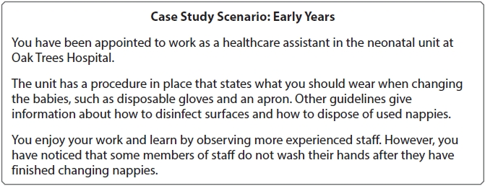

Describe two key objectives that Oak trees Hospital's health and safety policy should address.
(Total for question = 4 marks)
1 Risk assessments completed.
2 Accidents and near misses reported.

This answer scored two marks. Rewrite the answer to gain full-marks.
- ____________________________________________________________________________________________________________________________________________
- __________________________________________________________________________________________________________________________

Provision of first-aid facilities
The provision of first aid in health and care settings is governed by the Health and Safety (First-Aid) Regulations (1981). From September 2016, all early years foundation stage practitioners (EYFS) will be required to complete paediatric first aid within the first three months of their start date.

Complaints procedures
Our organisation, along with other care providers is required to have a complaints procedure and these are checked during any inspection. If a service user or a member of staff complains, they have a right to:
- Have their complaint dealt with swiftly and efficiently
- Have a proper and careful investigation of their concerns
- Know the outcome of those investigations
- Have a judicial review of the facts, if they think the action or the decision is unlawful
- Receive compensation if they have been harmed either physically or psychologically as a result of the situation about which they are complaining.
TASK: What would you do if a service user made a complaint to you about another member of staff?
____________________________________________________________________________________________________________________________________________________________________________________________________________________________________________________________________________________________________________________________________________________
Think Higher: What would be the impact on the service user if their complaint was not handled to their satisfaction?
____________________________________________________________________________________________________________________________________________________________________________________________________________________________________________________________________________________________________________________________________________________

Information management and communication
Health and care organisations hold a wide range of diverse information about service users.
TASK: What kinds of information might be held?

Information

General Data Protection Regulation (GDPR)
The GDPR is a piece of European legislation that sets out clear guidelines on the use, storing and processing of personal data of citizens within the European Union (EU).
The Data Protection Act (2018) is the UK’s implementation of this legislation. Both the GDPR and Data Protection Act came into force in the UK on 25 May 2018.
VIDEO TASK: Watching the two videos below, write what the GDPR is in your own words.

https://youtu.be/6fITStJ-4Es (03:25 - Top 5 things to consider for your GDPR preparation)
https://youtu.be/6IRE3CjqS0M (3:01 - CNBC International – Why everyone is freaking out over four letters)

Think Higher: How do you think this legislation might affect health and social care?
____________________________________________________________________________________________________________________________________________________________________________________________________________________________________________
The legislation covers information stored electronically on computers, mobile phones and social media sites, along with paper-based personal information. It is against the law to have photographs of service users without their permission.
The rules do not apply to:
- The processing of personal data of deceased people;
- The processing of data by an individual for purely personal reasons or for activities carried out in your own home, providing that there is not a connection to a professional or business activity.

The Data Protection Act (2018) and GDPR (2018) have 7 key principles:
Data must…
Be collected and used honestly and fairly
Be used only for the reasons for which it has been given
Be limited to what is necessary for the purpose – no ‘spare’ data
Be accurate and up to date
Not be kept for longer than is necessary
Be kept safe and secure
Be maintained by a ‘controller’, who is responsible and accountable for complying with this legislation

TASK: See if you can complete the following paragraphs with regards to the collection, storage and use of data.

Recording and storage of data
The Act covers the policies, procedures and systems for:
- Storing information – confidential information should be stored in _____________ filing cabinets in ___________ rooms. Information held _____________________ should be protected by a secure password.
- Accessing information – members of staff who are allowed access to this information should be clearly _____________________. Staff should ______________ have access to personal information that they do not need to know. Where information is stored electronically, only the relevant staff should have personal access passwords.
- Sharing information – information should only be shared with other professionals who have a __________ and a __________ to know it.
Legal and workplace requirements
- The principles and requirements of the legislation and the requirement for confidentiality are within the _______________ and _________________ of all health and social care settings. They are also embedded in the __________ of _______________ of the professional bodies that ___________________ health and care staff, such as the General Medical Council (GMC), Nursing and Midwifery Council (NMC) and the Health and Care Professions Council (HCPC).
- All employees and volunteers in organisations have a ____________________ to ensure that the confidentiality of service users’ information is __________________. They also have a duty to actively promote respect for confidentiality throughout the setting. If they spot ___________________ in the procedures, they should feel confident to suggest improvements in the systems and arrangements. This is necessary to ensure the safety and _______________ of service users and to respect their right to the confidentiality of personal information.
Confidentiality, safeguarding and legal disclosure
- All personal records must be kept safely and securely and used only for the purpose that they are intended for. They must not be available to people who do not have a ____________ professional need to know the details.
- If a child or a vulnerable adult ________________ to any member of staff or volunteer that they are at personal __________ or that they are the subject of ______________, the setting’s ____________________ policies should be followed.
- In this situation, you will need to explain to the service user that their disclosure will be shared with a _____________ member of staff who will support them. The ______________________ _______________ at the setting will then take over responsibility for dealing with the concerns.

Accountability to professional organisations
The standards of professional practice expected of professionals working in health and care settings are regulated and monitored by a range of professional bodies including:
- ……………………………………………………………………………………………………………..
- ……………………………………………………………………………………………………………..
- ……………………………………………………………………………………………………………..
Specific regulations vary according to your profession; however, each professional organisation monitors the:
- Level and content of the initial training and education of members within their profession
- Ongoing professional development, up-to-date training and further training
What is this training known as?

- Standards of professional practice in everyday work
- Standards of personal conduct, both at work and in leisure time.

TASK: See if you can match up the description with the relevant title.
Care Certificate
These are published for members and must be followed. If a member is accused of failing to meet standards set, this is investigated and, in extreme circumstances, the member can be removed from the professional register and barred from practice.
Revalidation procedures
Members are required to complete regular CPD in order to remain on the register. Requirements will always include evidence that members have current and up-to-date understanding of safeguarding regulations.
This is not a legal requirement. It provides a set of standards that health and social care workers should follow in daily working life. This was introduced in 2015 for newly appointed health and social care workers who are not members of the regulated professional bodies (e.g. NMC).
Codes of professional conduct

Eye on the exam…January 2018
Case Study Scenario: Physical / Sensory Disability
Melanie is 16 years old. She lives with her parents and her sister. Melanie was born with a hearing impairment and she uses two hearing aids.
Melanie’s hearing impairment was only diagnosed when she was five years old. She has a noticeable specific language impairment and finds it difficult to communicate with strangers.
Melanie attends the local comprehensive school. Sometimes she finds it hard to understand her teachers and other students. Melanie feels very isolated and she is becoming anxious about her future.
Following a recent audiological appointment, Melanie has said that she would like to have some additional support with her health and social care needs.

3(b) Describe how health and social care professionals should communicate within the team, without compromising Melanie’s right to confidentiality.
(4 marks)
………………………………………………………………………………………………………………………………………………………………………………………………………………………………………………
………………………………………………………………………………………………………………………………………………………………………………………………………………………………………………
………………………………………………………………………………………………………………………………………………………………………………………………………………………………………………
………………………………………………………………………………………………………………………………………………………………………………………………………………………………………………
………………………………………………………………………………………………………………………………………………………………………………………………………………………………………………
………………………………………………………………………………………………………………………………………………………………………………………………………………………………………………
TASK: What mark do you think this response achieved?

Using the mark scheme above, rewrite this answer to create a model response.

3(c) People working in health and social care organisations have responsibilities to prevent discriminatory practices in caring for Melanie.
Explain these responsibilities.
(6 marks)
………………………………………………………………………………………………………………………………………………………………………………………………………………………………………………
………………………………………………………………………………………………………………………………………………………………………………………………………………………………………………
………………………………………………………………………………………………………………………………………………………………………………………………………………………………………………
………………………………………………………………………………………………………………………………………………………………………………………………………………………………………………
………………………………………………………………………………………………………………………………………………………………………………………………………………………………………………
………………………………………………………………………………………………………………………………………………………………………………………………………………………………………………
………………………………………………………………………………………………………………………………………………………………………………………………………………………………………………
………………………………………………………………………………………………………………………………………………………………………………………………………………………………………………
………………………………………………………………………………………………………………………………………………………………………………………………………………………………………………

