**Holy Cross College Hospital**

**A2: The responsibilities of people who work in the Health and Social Care sector**

* Textbook pages 86-94
* Revision guide pages 60-62

**Tasks of a care assistant: working with older people; residential and domiciliary**

Physical needs

Intellectual needs

Emotional needs

Social needs

We don’t want to be a burden ☹

We get confused filling in forms

I can’t wash my own hair ☹

Although there is a wide range of roles within health and social care, all people who work in the sector have the same day-to-day responsibilities.

What responsibilities do you think ALL Health and Social Care staff have that are the same?

Think Higher - Why are these important?

**Day-to-day responsibilities:**

1. Following policies and procedures
2. Healing and supporting recovery for people who are ill
3. Enabling rehabilitation
4. Providing equipment and adaptations to support people in being more independent
5. Providing personal care
6. Supporting day-to-day routines of service users
7. Assessment and care and support planning

**1. Following policies and procedures**

All Health and Social Care organisations have guidelines that describe the working procedures that should be followed to ensure that the care provided meets service users’ needs.

**Policies** and **procedures** aim to ensure that all staff and volunteers work within the law and to the highest professional standards.

|  |  |  |
| --- | --- | --- |
|  | **Policy** | **Procedure** |
| My definition |  |  |
| Textbook definition |  |  |

**Policies**

|  |  |  |
| --- | --- | --- |
| **Case Study** | **Settings involved** | **Policies which will apply** |
| Carlos |  |  |
| Fay |  |  |
| Salome |  |  |
| Drake |  |  |
| Baby Jack |  |  |

On a work placement, why is it important you are aware of the placement’s policies and procedures?

1) Who is protected by a Code of Practice?

2) List the dangers or negatives, if Codes of Practices are NOT maintained?

3) What is the purpose of a policy?

4) Give 5 examples of policies in care.

5) What is the purpose of regulating bodies?

6) What is the purpose of procedures?

7) What is safeguarding?

8) Why does a whistle-blowers policy exist?

**2. Healing and supporting recovery for people who are ill**

There is a wide range of different treatments and care procedures to support the recovery of people who are ill.

Support to make better life style choices

Rehabilitation and return home plan



**Ill Service User**

Accessing support from specialist agencies in the community

Diagnosis and Treatment plan

The precise support will depend on the service user’s condition and their wider personal and social needs.

**Treatments and Care procedures**

**Prescribing medication**

Traditionally the doctor’s role, some nurses and midwives can undergo additional training to become a Nurse Prescriber – they can prescribe a limited range of medication. They usually have a specialism.

Dentists, chiropodists, physiotherapists can all prescribe in certain circumstances.

Who can write a prescription?

Use this website to answer the questions:

<https://www.nhs.uk/chq/Pages/1629.aspx?CategoryID=68>

1. Which roles are Independent Prescribers and what can they prescribe for?

2. Which roles are Supplementary Prescribers and how can they prescribe?

**Surgery**

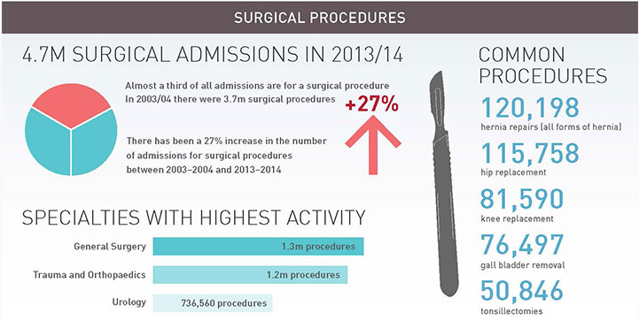May be needed to recover from an illness or other physical disorder.

Examples of surgical procedures:

Most common surgical procedures in the UK:

Think Higher - Which patient groups require most of these procedures?

**Recovering from Surgery**

After discharge from hospital it is Health and Social Care workers in the community who support patients.

Following surgery, Allied Health Professionals will work with the patient whilst in hospital as an in-patient and most commonly, when they’ve been discharged. They will have out-patient appointments or even home visits to ensure the fullest recovery and return to independence is achieved. For example…

|  |  |
| --- | --- |
| **Physiotherapist** | Role after a knee replacement…… |
| **Occupational Therapist** | Role after knee surgery, following discharge…. |
| **Dietician** | Role after gastric band surgery…. |
| **Podiatrist** | Role after a bunionectomy……. |
| **Speech and Language therapist** | Role after brain tumour removal, causing some aphasia… |

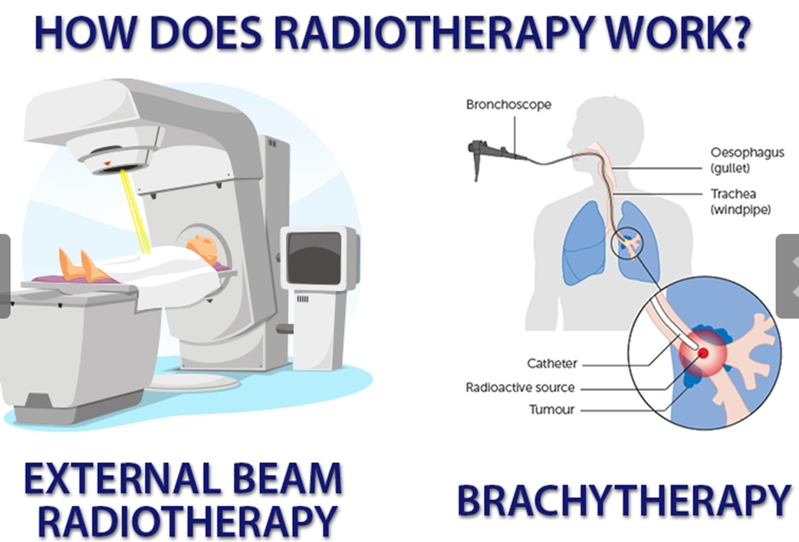**Radiotherapy**

Treatment using high energy radiation. It is planned by skilled radiotherapists, working alongside radiographers and specialist nurses. Radiotherapy is most often used to treat ________ but is also used to treat non-cancerous tumours and other conditions such as thyroid disorders and some blood disorders.

Who will the patient need support from when the treatment is completed?

Common side effects of radiotherapy are:

**Organ Transplant**

Purpose is to replace a damaged or absent organ.

There are two types:

|  |  |
| --- | --- |
| Allograft |  |
| Autograft |  |

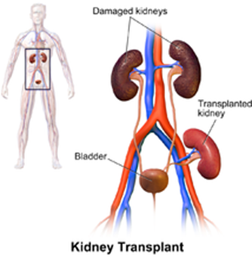 

Which organs can be transplanted?

What are the most commonly transplanted organs?

Who will support the patient during and after their transplant?

What can a living donor donate?

**Support for lifestyle changes**

Sometimes the best treatment for a patient can be to change their pattern of daily routine and habits that are damaging to their health; this can be very challenging.

|  |  |  |
| --- | --- | --- |
|  |  |  |
| Self-help support groups  E.g. smoking cessation | Counselling to support behaviour changes | Hypnotherapy or mindfulness practices |

What habits may need to be changed?

What types of support can help implement and sustain these changes?

Healthcare professionals such as GPs, practice nurses and district nurses can assist individuals to set up self-help groups e.g. by allowing them to meet in a room in the GP practice. Lifestyle changes may be needed alongside other medical intervention.

Can you think of any examples?

**Accessing support from specialist agencies**

Healthcare professionals can inform their service users of specialist agencies for specific illnesses and disorders.

For example:

* Age UK
* Mind
* Young Mind
* The Royal National Institute of Blind People (RNIB)
* Alzheimer’s Society
* National Society for the Prevention of Child Cruelty

For each of these organisations, research the following:

|  |  |  |  |
| --- | --- | --- | --- |
| **Organisations** | **Aims and Objectives** | **Key activities** | **Main service user group** |
| Age UK |  |  |  |
| Mind |  |  |  |
| Young Minds |  |  |  |
| The Royal National Institute of Blind People (RNIB) |  |  |  |
| Alzheimer’s Society |  |  |  |
| National Society for the Prevention of Child Cruelty |  |  |  |

**Think Higher:**

How are the above organisations funded?

**Recap:**

List as many types of policies as you can remember, then check against the list you made on page 3 of this booklet.

**Task**

Joan is 44 years old; she made an emergency appointment with the GP for her mother, Mary, who is 75 years old and lives with Joan. Mary has recently been diagnosed with dementia and, yesterday, placed her hand in very hot water causing it to become scalded. Joan said that her mother was unclear why she had put her hand in the water in order to ‘check it.’ Joan is very supportive and wants her mother to continue to live with her, however, she is struggling to ‘keep an eye on her’ all the time because she must go to work. The GP looked at Mary’s hand and covered it with a dressing; he advised Mary to take paracetamol or ibuprofen for the pain and then asked Joan if they had any at home. He advised Joan and Mary that some kind of home care may be needed; the GP offered to make a referral to social services to ask for a care needs assessment and Joan and Mary agreed.

1. Identify Joan and Mary’s needs

Joan:

Mary:

2. Describe how the GP fulfilled his professional responsibilities? (including supporting treatment and recovery).

3. Explain how the GP fulfilling his responsibilities could lead to improved health and wellbeing for both Joan and Mary.

**3. Enabling rehabilitation**

The purpose of a rehabilitation programme is to enable a person…

Can you think of any examples where rehabilitation programmes may be needed?

**Key terms:**

|  |  |
| --- | --- |
| Rehabilitation |  |
| Psychotherapy |  |

Which conditions may require psychotherapy?

Rehabilitation may also include **Complementary therapies**. They are not considered conventional medicine and may not be available on the ____.

What would be considered to be complementary therapies?

**Conventional medical treatment** is also known as orthodox treatment. All conventional therapies such as chemo or radiotherapy have to go through rigorous testing by law to prove that are safe AND they work.

What does the term alternative therapies mean?

**Exam questions:**

1. Heather is an elderly woman who lives alone and has not left her house since she had a burglary.

Which health and care professionals could support her in living a more fulfilling life?

What strategies could they use?

2. Noah is 8 years old; he was diagnosed with Type 1 diabetes after becoming temporarily blind and being admitted to hospital. Noah has now been discharged and requires daily insulin injections at home and at school; the temporary blindness, hospitalisation and the regular regime of injections has been very distressing for Noah and he is having nightmares about becoming blind again.

Identify one care worker that could support Noah in his rehabilitation and explain their role in promoting his health and wellbeing.

Using the website [www.diabetes.co.uk](http://www.diabetes.co.uk) find a complementary therapy for diabetes that could be useful for Noah’s rehabilitation.

**Complementary therapies** are not medical and may not treat physical symptoms of disease (e.g. art or music therapy.)

Why do you think medical professionals recommend the use of some complementary therapies?

Go back to [www.diabetes.co.uk](http://www.diabetes.co.uk) to have a look at the benefits of some complementary therapies for diabetes if you need help.

**4. Providing equipment and adaptations to support people in being more independent**

There is a vast array of equipment available to support people to remain independent when carrying out their routine daily activities; needs are usually assessed by a _______________ or __________________________. Other healthcare professionals, such as doctors and nurses, may refer a service user to a physiotherapist or occupational therapist for assessment. Care assistants, support workers and health care assistants often provide ongoing support in using equipment effectively and adaptations to increase a service user’s independence.

What are the names and who would use the different equipment below?

|  |  |  |
| --- | --- | --- |
|  |  |  |
|  |  |  |
|  |  |  |
|  |  | Tetrapod (4) or tripod (3) |
|  |  |  |
|  |  |  |

Adaptations to assist with toileting can save a huge amount of embarrassment and ensure service user dignity. Name the equipment in the pictures below and imagine being disabled yourself… and requiring intimate personal care.

|  |  |  |
| --- | --- | --- |
|  |  |  |
|  |  |  |

Use this website and others to research other equipment available.

<https://www.independentliving.co.uk/independent-living-products/>

|  |  |  |
| --- | --- | --- |
| **Equipment to Increase Mobility** (allows people to be more physically active) | **Appliances that Support Daily Living Activities** | **Technology and Other Resources that Support Educational Achievement** |
|  |  |  |

**Notes:**

**Key terms:**

|  |  |
| --- | --- |
| Assistive technology |  |

**Task:** Investigate the range of adaptive equipment available to support someone with:

* Arthritis in their hands and fingers
* Who uses a wheelchair
* Has a degenerative eye condition and is partially sighted

<http://www.inclusive.co.uk/>

**Exam Question:**

Caleb is a 14-year-old who attends his local residential special needs school; Caleb has a physical disability and requires a wheelchair, he also has autism and, as a result, writes very slowly and takes a long time to answer questions. Caleb sometimes becomes frustrated when people try to rush him.

The special school employs an occupational therapist.

Explain the responsibilities the occupational therapist has towards Caleb (6 marks)

**Think higher…**

Justify the role of the occupational therapist in the special school? (6 marks)

**5. Providing Personal Care- Including Washing, Toileting and Feeding**

There are clearly important reasons, in terms of physical wellbeing, why people should be clean, eat well and be able to use the toilet when necessary. Dealing with personal care has a big impact on a service users self-esteem and general confidence so the whole process should be empowering and reassuring, being guided by the individual themselves. Choices, discussions, preferences and building a rapport are essential and it’s important not to ‘over-care’ and take over, making assumptions about what the person needs help with.

Read through Doris’ case study below.

Use a highlighter to pick out some examples of **good practice** when providing personal care.

Then use a DIFFERENT highlighter to pick out some examples of **poor practice** when providing personal care.

**Doris’ case study:**

Doris is 88 years old; she has swelling in her legs which seriously reduces her mobility and ability to carry out some personal care tasks. Doris has help from private domiciliary care assistants who come and see her in the morning, at lunch time and in the evening. Doris has a good relationship with the carer Emma; Emma has been visiting Doris for 18 months. Emma has a key, however she always uses the door buzzer to let Doris know that she is about to let herself in otherwise it can take Doris by surprise when Emma walks into the bedroom. In the morning, Emma first checks Doris’ care file to see if the evening carer has left any notes and sees that Doris had mentioned her daughter would be picking her up in the morning and she would need to be ready fairly quickly. The care file is very important as it contains information about Doris’ routine, compression tights (for her swollen legs) and dietary information such as her allergy to strawberries and shellfish.

Emma asks Doris if she would like to use the toilet and brings a commode over to Doris’ bed, once Doris is positioned on the commode Emma leaves the room to allow her to relieve herself. Doris calls Emma in to help her wipe and then to bring a basin of warm water to wash her hands. Emma has a cheerful disposition and makes an effort to ask Doris how she has slept and chat about her plans for the day with her daughter. Emma asks Doris what she would like to wear and lays out Doris’ clothes. Doris needs help to get her underwear and skirt on but Emma knows that Doris can put on her shirt and button it up easily so Emma goes downstairs to prepare breakfast. Emma then updates Doris’ care file with the morning routine, chatting to Doris while she has her breakfast.

The next day, Emma is off ill and an agency care assistant arrives to see Doris; she uses the door buzzer and then lets herself in. The care assistant then goes straight upstairs and gets the commode ready for Doris - she helps Doris to be seated and then stays in the room to make sure she doesn’t fall off. The care assistant then asks Doris what she would like to wear and helps her into her underwear, skirt and shirt and does her buttons for her. Doris says she can do it herself but the care assistant says ‘don’t worry I’m here to help.’ The care assistant makes Doris’ breakfast and then says she has to dash because she has three more visits to complete.

**Think higher:** How might the poor practice in the case study impact on Doris’ emotional health?

**Key terms:**

|  |  |
| --- | --- |
| Domiciliary care |  |
| Halal foods |  |
| Kosher foods |  |
| Gluten |  |
| Lactose |  |

**Task:**

How might a service users’ religious and cultural identity affect the way personal care is provided?

**6. Supporting Routines of Service Users in the Context of their day-to-day Family Life, Education, Employment and Leisure Activities**

**Emotional**

**Physical**

**Spiritual**

**Social**

**PIES**



**Holistic Health**

**& well-being**

**Intellectual**

Although many health and care staff have expert knowledge and high-level skills in particular areas; they will also try to address the wider personal needs that may emerge while working with their service users.

**Case study:**

Danny is 19 years old and has a learning disability. He lives in supported housing with 3 other young adults (all with varying needs;) care is provided by support workers who work on a shift rotation. Danny has expressed a wish to get a job and his support workers have discussed with him some potential options; they have encouraged Danny to email a local employability scheme and have a look at some college courses nearby. Danny was accepted on a BTEC accountancy course and the support workers planned some practice bus trips to and from the college in the week leading up to his start date. They also used lots of encouragement to reassure Danny and build his confidence; they also contacted the educational psychologist associated with the college and ensured that Danny had a support plan in place with his tutors. The educational psychologist also recommended that Danny do some social skills work before the course start date so the support workers used the communication support sheets provided by the psychologist to practice some typical conversations and social situations.

Support workers also prompted Danny to mention his new course to his parents when they visited and chatted about their plans to ensure Danny has a safe transition into his college course; Danny’s mum said she’d like to meet him after his first day and the support worker made a note to wait at the bus stop outside of college to make sure Danny remembers.

**Task:**

How have the support workers supported Danny’s routines?

**Task:**

What would be the consequences of the support workers not supporting Danny in his search for a job?

What is an informal carer? (key exam terminology)

**Task:**

What kind of support could be put into place (and by whom) for each of these situations?

Remember to consider all of the professional care workers as well as those providing informal care (this is care and support provided by relatives and friends, normally unpaid, and in addition to the care provided by professional health and care workers).

Katherine lives in a residential care home for elderly people; she is Catholic and would like to attend mass on Sunday mornings.

Stephen attends a local special needs school. He is struggling with anger management issues and the educational psychologist has suggested that he may benefit from taking part in sporting activities.

Max has become partially deaf due to an infection. He has expressed to his audiologist that he’s worried about getting to and from work now that he can’t hear clearly when he crosses the road or gets the train.

**Exam Practice question:**

Explain what is meant by and give examples of holistic health and well-being? [10 marks]

**7. Assessment and Care and Support Planning, Involving Service Users and their Families**

Health and care professionals are likely to take a similar approach to planning and evaluating care. Often referred to as the care planning cycle.

**The Care Planning Cycle:**

The process is cyclical and interventions/changes may be introduced at any point in the process; this might be in response to changes in the client’s health or ________ circumstances, the resources that are available, the specific expertise of the staff or changing levels of support from informal carers.

Care plans always have a review date for evaluation and changes.

**Care Plan example**

**Jane Smith**

A care plan is a document that gets reviewed roughly every month and outlines the care requirements that your relative will be receiving. It is broken down into several key sections. You will be notified by email whenever a change to the care plan is made.

**Mobility**

Last Updated 15 Aug 2013

**Now:**Jane suffered a fall and broke her hip prior to coming into the home.  She has lost confidence and is worried about falling again. She is fully recovered from her hip joint repair and is fully mobilised. She uses one walking stick. On some days she finds it difficult to initiate walking which she finds very frustrating.

**Objective:**To maintain Jane’s mobility. To avoid trip hazards.

**Residents’ Support Choices:** Ensure that there are no trip hazards in Jane’s bedroom. Offer to accompany Jane on days when her walking is difficult.

**Medication**

Last Updated 15 Aug 2013

**Now:** Jane has Parkinson’s Disease which makes it difficult for her to swallow tablets. Most of her medication is therefore given in syrup or soluble form. On days when she is agitated she may refuse her medication. In these instances, it is best to withdraw and try again.

**Objective:** For Jane to receive the maximum therapeutic effect from her prescribed medication.

**Residents’ Support Choices:** RGN to administer all of Jane’s prescribed medication. If refused, withdraw and try again later. Monitor for therapeutic or side effects and report to GP.

**Body Temperature**

Last Updated 15 Aug 2013

**Now:** Jane has no problems in this area. She is able to make her needs known and is able to request changes in her physical environment.

**Objective:** To maintain a stable body temperature and to ensure that Jane is comfortable at all times.

**Residents’ Support Choices:** Provide Jane with a warm and well-ventilated environment. Ask Jane if she is comfortable and encourage her to request any changes she may require.

It can be very effective to write care plans in a service user-centred way, as if in the persons own voice. The example below shows the difference in approach:

***Intervention:***

Monitor side-effects of medication

***Service user-centred intervention:***

1. I will tell my Gill my Care Co-ordinator if I have any side-effects from the medication, such as vomiting, shaking, headaches, nausea, or stiffness in my joints. When I see Gill, she will ask me about this.

2. Gill will write down any side-effects in my notes and talk to the doctor about them with me.

3. Gill and I will fill in a rating scale to help manage any side-effects

**Complex Care Plans**

Care Plans often include other agencies, but there are some situations in which it is particularly important to have clear information, and to explain in more detail what all the responsibilities are, particularly where the person:

✓ Has a learning disability

✓ Has substance misuse problems

✓ Misuses alcohol

✓ Has safeguarding issues

✓ Is a vulnerable adult

✓ Has cognitive problems

✓ Is a child

**Exam Link:**

Describe two responsibilities of care assistants who work in residential homes for older people (4 marks)

Carol is 74 years old and lives in a residential care home for older people; the care manager has met with Carol and her family to agree upon a care plan that staff can follow while Carol is at the home.

Discuss the effectiveness of using a care plan to ensure that Carol has the care she needs from the care practitioners who support her (8 marks)

Revise the SIX stages of care planning – create yourself a revision resource to help you learn the care plan process.

Activity

Sheet 2.4

**Case study: Mr Brimble**

*Learning aim A2/A4*

**Mr Brimble**

Mr Brimble is 73 years old and has severe osteoarthritis. He also has diabetes and is insulin-dependent. He has poor mobility, cannot climb stairs or stand for long, meaning that he cannot meet his own personal care needs. His bathroom and bedroom are upstairs so for a while now Mr Brimble has been sleeping on the sofa, washing in the kitchen sink and using a commode – all downstairs. Because of his lack of mobility, shopping, cooking and cleaning, his cottage is a problem for him. The home is now being neglected, with signs of damp upstairs, clutter accumulating everywhere, and evidence of mice droppings in the kitchen. However, Mr Brimble is adamant that he wants to stay in his own home as he has lived there for most of his life.

Mr Brimble has been visited by the community health nurse (CHN) as he is unable to administer his own insulin, which he needs daily, because of his failing eyesight. The CHN has become concerned about the general deterioration of Mr Brimble’s health during the last few months, and the impact it is having on his ability to care for himself, and the conditions in which he has been living. A neighbour provides some support but she works and has a young family to care for and cannot help long-term. Mr Brimble has a son, John, but he lives 50 miles away and due to his own work and family commitments cannot visit on a regular basis.

The CHN has made a referral to the local social services department because it is clear that Mr Brimble requires an ‘assessment of need’ with the view to developing a support plan for him, so that he can stay in his own home without being at risk.

On the following page there is a care/support plan template.   
Use the information in this case study to identify Mr Brimble’s needs and fill out the care plan. Use more pages if you need them.

Then give a brief justification below for your answers in relation to each of the Mr Brimble’s assessed needs and the care you suggested to meet those needs.

**Care planning template: Mr Brimble**

|  |  |  |  |  |
| --- | --- | --- | --- | --- |
| **Service user need** | **Desired ‘outcome’** | **Care planning ‘action’** | **Service provider ‘responsibility’** | **When and why**  **‘review/evaluate’** |
|  |  |  |  |  |
|  |  |  |  |  |
|  |  |  |  |  |
|  |  |  |  |  |
|  |  |  |  |  |
|  |  |  |  |  |

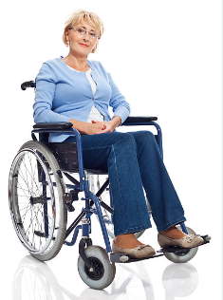

**Question: What might the tasks a domiciliary carer may be asked to do, daily?**

**Question: What might the informal carer be able to do and how would this work?**

**Question: What services may be put in place in the interim period and what appointments with professionals or Allied Professionals might she need?**

**Question: Who might be involved in a care plan initial meeting and why?**

**Case Study**

Zuzanna is 57 and was a busy teacher with grown up children, enjoying hobbies like gardening and going on walking holidays with her husband.

A car accident, which unfortunately killed her husband, damaged her internal organs and causing her to require a stoma bag. She also had a broken pelvis and a crack in her spine which required surgery to pin it together safely.

She spent 5 weeks in hospital and was discharged home with a care plan in place. Her neighbour can help out and she will receive sick pay for six months.

**Command Words in Exam Questions**

|  |  |
| --- | --- |
| **Describe** | Give a clear, objective account in your own words showing recall, and in some cases application, of the relevant features and information about a subject.  **Example:** ‘Describe work practices in relation to…’. |
| **Discuss** | Consider different aspects of a topic, how they interrelate and the extent to which they are important.  **Example:** ‘Discuss how **both** the organisations responsibilities **and** the individual staffs responsibilities…’. |
| **Evaluate** | Draw on varied information, themes or concepts to consider aspects such as strengths or weaknesses, advantages or disadvantages, alternative actions, and relevance or significance.  **Example:** ‘Evaluate possible explanations for the development of…’.  Associate the word evaluate with POSTIVE< NEGATIVE< CONCLUSION |
| **Explain** | Show you understand the origins, functions and objectives of a subject and its suitability for purpose. Give reasons to support an opinion, view or argument, with clear details.  **Example:** ‘Explain two possible features of the development of…’.  Top tip; Associate the word explain, with the word BECAUSE… |
| **Identify** | Indicate the main features or purpose of something, and/or are able to discern and understand facts or qualities.  **Example**: ‘Identify the services that might be available to…’. |
| **Justify** | Give reasons or evidence to support an opinion or prove something right or reasonable.  **Example:** ‘Justify how overcoming…’. |
| **Outline** | Provide a summary or overview or a brief description of something.  **Example:** ‘Outline ways in which X might affect if the care worker….’ |
| **To what extent** | Show clear details and give reasons and/or evidence to support an opinion, view or argument. It could show how conclusions are drawn (arrived at).  **Example:** ‘To what extent might recent…’. |
| **Which** | Specify one or more items from a definite set.  **Example:** ‘Which regulation…’. |