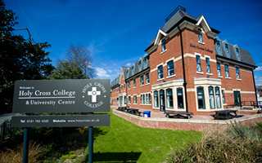
Holy Cross Hospital

Part 4 – Professionals in the Health Sector

There are a wide range of professions within the health and social care sector.

Profession | Support Service User

Doctors

There are lots of different types of doctors who specialise in different areas.

Doctor name | Specialism

General Practitioners (GP)
A GP is the primary point of contact when a person is unwell. A GP provides ongoing Health Care for people in the community.
This includes
- Caring for people who are unwell including simple surgical procedures
- Preventative care and health education
Responsibility | Help the Service User
General Practitioners (GP) Responsibilities
What is meant by preventative care and health education?

________________________________________________________________________________________________________________________________________________________________________
Why might this be important for the service user?
________________________________________________________________________________________________________________________________________________________________________

GP Main Responsibilities

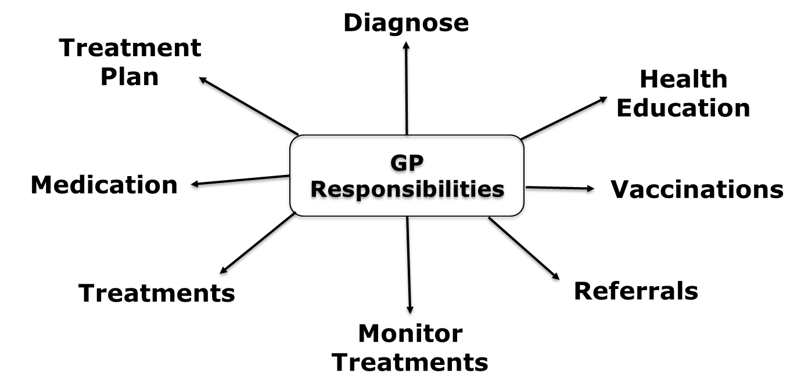

Think Higher
A GP is responsible for referring patients to other services. What services might a GP refer a patient to? What is it called when multiple services are involved in persons care?
_____________________________________________________________________________________________________________________________________________________________________
Why would it be important for a GP to refer a patient to these services?
____________________________________________________________________________________________________________________________________________________________________________________________________________________________

Hospital Doctors
There are three levels of the hospital doctors
- Junior Doctors
- Registrars
- Consultants
Hospital Doctors - Specialisms
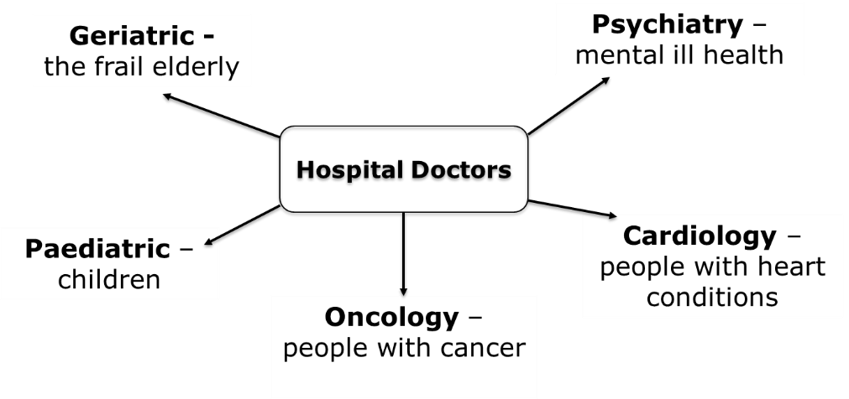
Midwives
Play a central role supporting women through all the stages of pregnancy providing antenatal and postnatal care
Antenatal Care

Postnatal Care

Nurses
There are a number of different types of nurses who specialise in different areas
Types of Nurses and what they specialise in…..

Nurse Type | Role and responsibilities
School Nurses

Adult Nurses

Mental Health

Health Visitors

Paediatric Nurses

Practice Nurses

Learning Disability Nurses

Neonatal Nurses

District Nurses

Healthcare Assistants
Often known as nursing assistant or auxiliary nurses. They work under the guidance of qualified healthcare professionals such as midwives and nurses.
They work in many healthcare settings including GP practices, hospitals and nursing homes.
Duties include:- Taking patients temperature and pulse, making beds, washing and dressing patients, serving and assisting with meals.
Occupational Therapists
Work with people of all ages who struggle with practical routines of daily life. This may be due to a disability, physical or psychological illness, an accident or old age.
Specific activities will be agreed with patient to help them overcome barriers to independent living. Work in patients home, GP practices, nursing homes, prisons, social services and hospitals.
Social Workers
Help and support people of all ages through difficult times in their lives.
Ensure vulnerable people are safeguarded and help them to live independently. Including children, people with disabilities, mental health problems and the frail elderly.
Child Services

Adult Services

Social Workers
Adult Services:- Older people, adults with disabilities, adults with mental health problems. Support them living independently and in residential care, work closely with families and carers.
Child Services:- Provide support for children and their families. Ensure child is safe and protected from abuse. Implement special measures for children at risk. In extreme circumstances this may include removing the child their home. Manage fostering and adoption processes. Work in children's residential settings and support young people leaving residential care.

 | Adult Services | Child Services
Physical
Intellectual
Emotional
Social

Youth Workers
Work with people ages 11-25. Support young people reach their full potential. Work in a range of settings and are employed by the council or religious organisations or voluntary organisations.
Settings

Typical Activities:-
- Delivering programmes relating to young people’s concerns including smoking, drinking, drugs, relationships and dealing with violence.
- Residential activities
- Sports teams
- Managing community projects
- Supporting parents for child’s healthy development
How will the activities of a youth worker help young people? Think P.I.E.S.

Care Assistants
Provide practical help and support for people who have difficulties with daily activities. Care assistants work in a wide range of settings including shelter accommodation, residential homes and day care centres.
What age groups do care assistants work with?
_______________________________________________________________________________________________________________________________________________________________
What type of support do they provide?

________________________________________________________________________________________________________________________________________________________________________________________________________________________
What will the support provided help the service user? Think P.I.E.S.
________________________________________________________________________________________________________________________________________________________________________________________________________________________

Care Managers
Key leadership role within residential care settings and are responsible for:-
- Adults with learning difficulties
- Older people in residential and care homes
- People in supported housing
- People receiving hospice care
Responsibilities include appointing and managing staff, managing budgets and ensuring the quality of care meets the required standards.
Support Workers
This role is closely linked to a healthcare or nursing assistant
discussed earlier.
Support workers work under the supervision of professional such as physiotherapists, occupational therapists and social workers.
Once a needed has been identified the support worker will work closely with the patient and their family to implement the plan.
They may provide support with parenting skills, financial management and domestic skills.

Case Study 1 - Carlos

Carlos is 19 and is studying at a university in Manchester. His parents and friends are very concerned about the amount of weight he has lost over the past year. Carlos is unwilling to talk about the situation.
During a lecture, Carlos collapses and is taken to the health centre on the university campus where he is seen by a nurse. She asks him about his weight loss and he discusses the reasons for it with her. His height is 175 cm. He weighs 50kg and his body mass index (BMI) is 16.3.
Carlos attends an appointment with his GP, who refers him to a specialist service for people with eating disorders. The service also provides support to enable people like Carlos to manage their mental health.
During conversations with specialist staff at the service, Carlos reveals that the reason for his weight loss is linked to his fear about telling other people that he is gay.

TASK 1:
Identify the professionals that would make up the Multidisciplinary team for this case study.

Case Study 2 - Salome

Salome has a profound learning disability. This means that, according to the Department for Health, she has a significantly reduced ability to
- understand new or complex information
- learn new skills
- cope independently.
Some people are born with a learning disability. Other people develop learning disabilities as a result of an accident or illness during childhood or later life.
Salome finds it very difficult to communicate. She has additional sensory needs, physical disabilities and mental ill health. Some of her behaviour is challenging. She sometimes makes her preferences known through her behaviour and her reactions.
Salome needs a wide range of support. This includes help with day-to-day needs, including dressing and toileting. She currently lives with her family and has trained specialist carers. These carers also enable her family to have respite.
Her carers are trying to find ways to enable Salome to be involved in decisions about her needs. They are working on different ways of communicating with her, based on techniques developed by the learning disability charity Mencap in their ‘Involve Me’ project.
TASK 1:
Identify the professionals that would make up the Multidisciplinary team for this case study.

Case Study 3 - Fay

Fay is 40 and she has been diagnosed with multiple sclerosis. She has two young daughters. When they were first told about Fay’s diagnosis, they were very upset. Recently, however, they have been helping Fay with some of her day-to-day routines.
Multiple sclerosis has a range of symptoms. These include extreme tiredness (fatigue), numbness and tingling, not being able to see clearly, problems with mobility and balance, and muscle weakness.
Fay is finding the Multiple Sclerosis Society a great support. It has given her information about symptoms, how she can manage her condition and how her family can support her.
Fay’s home will be adapted and, in time, she will need respite care.
Following her care assessment, Fay will have a support worker for five afternoons a week.
TASK 1:
Identify the professionals that would make up the Multidisciplinary team for this case study.

Case Study 4 – Drake

Drake is 80. He was diagnosed with Alzheimer’s, a type of dementia, when he was 75 and he is now at a late stage of the disease. He has an appointment every six months with his gerontologist, a doctor who specialises in illnesses in older people.
Because he is becoming increasingly weak, Drake is almost totally dependent on other people for care. He is currently living in a nursing home.
He has very little memory and is usually unable to recognise familiar objects or surroundings. From time to time, he does recognise people he knows, but usually he does not know who they are. This upsets members of his family.
Drake does not understand what is happening to him. At times, he becomes very angry, especially when he is receiving personal care.
Drake may live for up to another five years, but this depends on how his dementia develops.
TASK 1:
Identify the professionals that would make up the Multidisciplinary team for this case study.

Case Study 5 – Baby Jack

You are working as a trainee nurse on a local hospital ward. The children on the ward are aged from 0 to 6 years. The children’s ward has been poorly equipped and understaffed. Baby Jack is one of the children on the ward, who has late-onset sepsis. A few weeks ago, a nurse miscalculated the dose of a drug needed to reduce baby Jack’s blood pressure. She gave him 10 times the dose he needed and he became seriously ill.
You think that this hospital ward has not been providing effective care for the babies, young children and their families.
TASK 1:
Identify the professionals that would make up the Multidisciplinary team for this case study.

