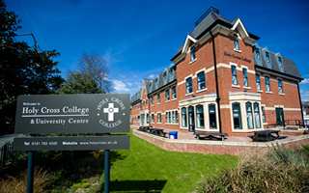
Holy Cross College
Hospital

Part 2 – Settings and Sectors

The settings in which health and care services are provided vary enormously. Settings range from care provided in a person’s own home, to hospital departments providing highly technical and specialist treatment.

Hospitals

Hospitals provide both inpatient and outpatient services.

Inpatient services:
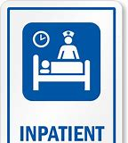

Outpatient services:
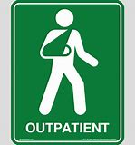

If you need to be referred to a hospital for treatment, you will usually be referred by your GP. Patients have the right to choose which hospital they wish to attend and which consultant they would like to see.
TASK: Mind-map below different hospital departments that you may be aware of.

Hospital Departments

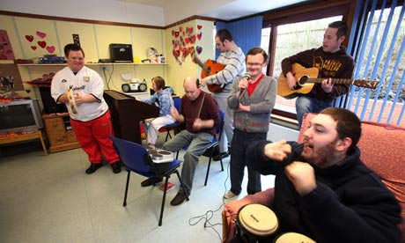
Day care centres / units
These are usually provided for specific client groups.
Which client groups may attend day care centres / units?

The day care centre unit provision is designed to be a friendly, stimulating and supportive environment for people who would usually be socially isolated. For example, they could provide educational facilities and support to help people progress into employment.

Hospice Care
RESEARCH TASK: Research a local hospice (e.g. Bury Hospice). Find out the answers to the following:
- Name of the hospice: _____________________________________

- What is the aim of the hospice?
_________________________________________________________________________________________________________________________________________________________________________________
- Describe the care provided by the hospice for service users.
________________________________________________________________________________________________________________________________________________________________________________
______________________________________________________________________________________________________________________
- Is there any additional support provided for the service user’s family?
_________________________________________________________________________________________________________________________________________________________________________________
______________________________________________________________________________________________________________________
Any other information:

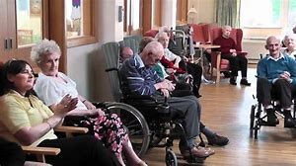

Residential Care
This refers to the long-term care of adults and children needing 24-hour care, which cannot be provided adequately or appropriately in their own home.
There are two types of care home:
- Residential Care Home

____________________________________________________________________________________________________________
- Nursing Home
____________________________________________________________________________________________________________
______________________________________________________
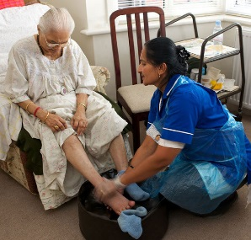
Domiciliary Care
Sometimes referred to as home care, domiciliary care is provided in a client’s home. It may be short-term, for example following a patient’s discharge from hospital, or could be longer-term if the service user has a more complex need (e.g. a disability).
Support can vary from one visit per day, to 24-hour care, providing support with domestic tasks as well as intimate personal care. This is provided in the person’s home so that they can live as independently as possible.

Domiciliary services may include…

The workplace
Occupational health (OH) services aim to keep a workforce fit and healthy so that they are able to carry out the duties of which they are employed, or to assist employees in regaining fitness after illness / injury.
Services can often include access to a nurse, doctor or other healthcare professionals, including counsellors or physiotherapists.

RESEARCH TASK: Go to the website below and complete the following questions.
http://www.nhshealthatwork.co.uk/what-is-oh.asp j
Research task questions:

- What types of support are provided to service users?
____________________________________________________________________________________________________________________________________________________________________________________________________________________________________________
- In what ways might this benefit the employer of the service users?
____________________________________________________________________________________________________________________________________________________________________________________________________________________________________________
- In what ways might this benefit the NHS?
____________________________________________________________________________________________________________________________________________________________________________________________________________________________________________

Eye on the exam - Task
Explain the reason why health and social care services are provided in different settings.
(6 marks)

Complete a plan to outline what you would include in your answer.
Once you have done this, please write an answer to this question, using your plan.

Plan:

Answer: ______________________________________________________________________________________________________________________________________________________________________________________________________________________________________________________________________________________________________________________________________________________________________________________________________________________________________________________________________________________________________________________________________________________________________________________________________________
___________________________________________________________
___________________________________________________________
___________________________________________________________

