Health and Social Care
2

Unit 2:

Promoting Good Health

Introduction

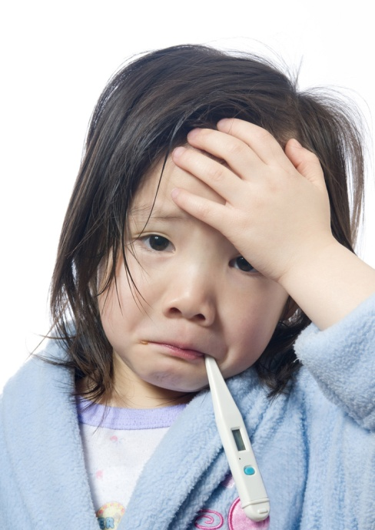

Student Information Pack and Work Book

Student Name:

The Introduction

The following handout will look at the Introduction in more detail.

The Introduction can be split into several smaller sections that we will look at in turn in lessons within class. The separate sections can be seen below.

When we write up the Introduction for the coursework this section should flow seamlessly from one section to the next. You may decide to sub-section your work, but the best reports will be those whose work shows thorough knowledge and understanding with clear examples and application of the various perspectives.

Perspectives in Health Care

Aspects of Health
Aspects: physical, intellectual, emotional, social, spiritual, societal

Concepts of Health and Wellbeing
Health: positive, negative, holistic
You should consider peoples’ attitudes to health when they have different concepts

Concepts of Ill-health
Ill health: disease symptoms, disorder or malfunction, and subjective sensation

Models of Health
Biomedical and social

Health and Wellbeing can be affected by…
* Peoples’ different perspectives of what health is (see those listed above)
* National and local initiatives and health improvement programmes
* Personal responsibility for health
~ Rotter’s Locus of Control, for example

What is Health to You?
Complete the table below. In column 1, tick any statements which seem to be important aspects of your health. In column 2, tick the six statements which are the most important aspects of being healthy to you. In column 3, rank these six in order of importance – put ‘1’ by the most important, ‘2’ by the next most important, and so on, down to ‘6’.

 | 1 | 2 | 3
1. Enjoying being with my family and friends
2. Living to be a ripe old age
3. Feeling happy most of the time
4. Being able to run when I need to without getting out of breath
5. Having a job
6. Taking part in lots of sports
7. Being able to get down to making some decisions
8. Hardly ever taking tablets or medicines
9. Being the ideal weight for my height
10. Feeling at peace with myself
11. Never smoking
12. Having clear skin, bright eyes and shiny hair
13. Never suffering from anything more serious than a cold, flu or stomach upset
14. Not getting things confused or out of proportion – assessing situations realistically
15. Being able to adapt easily to changes in my life such as moving house or schools
16. Drinking moderate amounts of alcohol or none at all
17. Enjoying my work without much stress or strain
18. Having all the parts of my body in good working order
19. Getting on well with other people most of the time
20. Eating the ‘right’ foods
21. Hardly ever going to the doctor
22. Having a resting pulse rate of 65bpm
23. Being able to practice your beliefs
24. Self esteem and having a positive self-concept
25. Taking regular exercise
26. Being curious
When complete:
Are the results what you expected to find?
Might your answers be different in 20 years time?
Might a person with disability have a different opinion?

Aspects of Health - a reminder of PIES or PISCES
A variety of different aspects of our lives contribute to a person being healthy – as you have seen for yourself from the first table you just completed.

Read the descriptions of the four aspects of health below. See if you can decide which topics are associated with each of these aspects.

Aspect | Description | Health topics associated with this aspect
PHYSICAL | The physical functioning of the body/ growth of a person/ the different mechanics of the body’s functioning.
INTELLECTUAL  (mental) | The ability to think clearly and coherently; involves our ability to organise our thoughts logically.
EMOTIONAL | To recognise and express emotions appropriately i.e. joy, sadness. It’s about expressing our emotions and responding appropriately to other people’s emotions and about the ability to deal/cope with negative feelings.
SOCIAL | The way we relate to other people and form relationships. It is affected by the way we are treated, and the way we treat others.

Extension: If you finish that take a look at these two harder aspects of health:

SPIRITUAL  (cultural) | This may involve personal and moral codes of conduct, achieving peace of mind, religious practices or beliefs and personal spirituality.
SOCIETAL | This aspect considers the general health of the society and environment we live in, as this can have an impact on our health.

Which Aspect(s) of Health are these best related to?

- having a pulse rate of 65bpm
- achieving peace of mind
- living in an unpolluted area
- having a healthy body
- being able to successfully cope with stress
- making new friends
- personal and moral beliefs
- appropriately expressing how you feel
- interacting with other people
- being able to practice your beliefs
- updating existing knowledge
- being curious
- solving problems
- taking part in activities with friends and family
- having self-esteem and a positive self-concept
- taking regular exercise
- going to the doctors for screening tests
- functioning of the body
- problem solving abilities
- a healthy diet
- an ability to make and maintain friendships
- interacting with the community
- personal spirituality
- being able to cope appropriately with everyday tasks
- being happy and content
- striving to meet your own goals
- having fun and enjoying yourself
- being able to successfully complete a job

Most things we do that are considered healthy will overlap the different aspects of health.
Exercise for example will obviously improve our fitness and prevent disease (physical), but can allow us to meet new people (social) and improve our self esteem (emotional).

Concepts of Health

There are several different opinions and views about what it means to be healthy. There are three concepts used to define health:

- Holistic
- Positive
- Negative

Holistic
The term holistic means giving attention to the whole person – physical, intellectual, emotional, social and spiritual fitness or well-being. It is based on the view that these aspects are interlinked. Holistic health means being without any physical disorders or diseases whilst being emotionally and psychologically comfortable. It may also take into account the environment of the individual.
For example: according to this concept, a person feeling anxious about being able to cope with life changes such as a new job would not be well.

Positive
This view believes that to achieve health takes active steps. To be physically fit and have mental stability needs action on the part of the individual.
For example: a person with this view will choose to eat a healthy diet, exercise regularly and avoid smoking.

Negative
This concept views health in terms of the absence of disease or illness. People who have this view think that they have good health unless their normal life is disturbed by illness. They assume that they do not need to take any actions in order to be healthy.
For example: a person with this view would think that if they weren’t actually ill, then they must be healthy.

POSITIVE
NEGATIVE
HOLISTIC
Having a positive concept of health means…
Having a negative concept of health means…
Having a holistic concept of health means…

Concepts of Ill-health
Being ill is very subjective – people have a different view on what actually makes us unhealthy.
For example, a person who lives with a permanent disability may not see themselves as unwell or ill, until they experience a cold. On the other hand, an able bodied person might see them as ill due to their disability.
An older person may see their inability to run a mile as being normal, but a young man may see this as a sign of illness in himself.

Illness can be divided into three main categories:

Definition of concept of ill-health
Ill health as a subjective sensation

Ill health as disease symptoms

Ill health as a disorder or malfunction

Can you give some examples of these three definitions of ill-health?

Examples of ailments/problems
Ill health as a subjective sensation

Ill health as disease symptoms

Ill health as a disorder or malfunction

Concepts of health and ill health
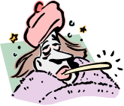
A researcher asked a sample of people, “Is your health good, average or poor?” When a respondent gave the answer ‘good’, the researcher asked, “When you say good, what do you mean?”
- Read the following replies and decide which concept of health best fits each answer; holistic, positive or negative.

  - “I mean there’s nothing wrong with me, as far as I know”
  - “I mean that I look after myself, stay fit and that sort of thing.”
  - “I mean that I feel well balanced. My body and my mind working well together.”

- Which concept of health is closest to the way you feel about your health? Why?

- The researcher then asked “What does ill-health mean to you?” From the replies decide which concept of ill-health best fits each answer; ill-health as a subjective sensation of illness, ill-health as disease symptoms or ill-health as disorder or malfunction.

- “It means having things like heart disease or something blocking your intestines.”
- “All sorts of things. You know sickness and diarrhoea, unbearable pain, lumps growing on your skin.”
- “It’s when you don’t feel well.”

- Claire says, “MY GP tells me that I’m healthy. She says that all signs of infection have gone. But I know she’s wrong, because I don’t feel right in myself. I’ve lost all my confidence.”

- Which concept of health is Claire using?
- Which concept of ill health is implied by what she says?
- Which concept of health is the GP using?
- Which concept of ill-health is the GP using?

- During routine health check, a practice nurse discovers that Younis has high blood pressure. Younis is surprised. He does not feel ill and does not think that he needs any treatment. The practice nurse thinks that there is something wrong with Younis’s circulatory system.

- Which concept of ill health is Younis using?
- Which concept of ill health is the practice nurse using?

Models of Health
There are two main models of health. These are called the (bio-) medical model and the social model.

The Social model of health

- This model considers the origins of ill health e.g. the social conditions that make ill health more prevalent in some groups than others.

- People’s experience of health is influenced by behavioural, structural, cultural and economic factors (e.g. poverty, housing, education, social class, lifestyle choices).

- To address ill health you have to recognise and address the factors that are causing the ill health and eradicate the cause where possible e.g. if someone has high blood pressure due to stress, then removing the source of stress would help.

- Peoples’ own lifestyle choices can make them healthier, or not.

- Does not look for one single cause but recognises a range of contributing factors.

- Individuals’ health has improved not just due to medical advances but also due to social advances e.g. the role of public health since the mid 19th century.

- Societal model has strong links to an ordinary person’s view of health as it takes into account that peoples’ views on health will differ and that sometimes a person’s view of how their health can be improved will be at odds to that of a health professional.

- Social model of health takes into account that when given advice by medical professionals, the service user has lots of choices and factors that will influence whether they take that advice or not.

- APPRECIATES WHY HEALTH PROMOTION CAMPAIGNS MAY BE UNSUCCESSFUL. For example: there have been lots of anti-smoking campaigns but even so many people continue to, or start to, smoke.

Think about the different approaches the government have taken in order to stop people from smoking.

The Medical Model of health

- Model has been around since the mid 19th century and is used mainly by medical professionals.

- Focus is in the body system and how all aspects of the body work together to ensure good health.

- If a part of the body is ‘malfunctioning’ medical services can intervene to restore the body back to good health using a range of medical advances such as surgery, medicines, and other treatments.

- Diseases are caused by viruses, bacterium, and genetic factors – it looks for biological rather than social or emotional causes – so, if a person has flu he has picked up a virus. It doesn’t take into account how stress at work is causing lack of sleep and the person to become run down, leading the person vulnerable to damage from a virus.

- Person receiving treatment is passive not active in becoming healthy again- they do not participate in the medical procedure.

- Health services are targeted towards the sick rather than the healthy – the focus is more on cure rather than prevention.

- Medical research is crucial to curing illnesses and specialist medical services are highly regarded.

- This model is most effective with short-term acute illness than long-term chronic illness as its emphasis is on giving relevant treatment to restore good health. It does not work so effectively with illnesses such as Parkinson’s disease or end of life conditions where the body cannot be cured.

- The medical model approach is not so widely accepted at the present time due to a growing emphasis on the quality of life.

- The Medical model looks at a person’s health, looks at the part of body that is affected by illness and gives treatment or advice on how to reach good health again. This model does not take into account any wider influences which might prevent the treatment or advice being carried out.

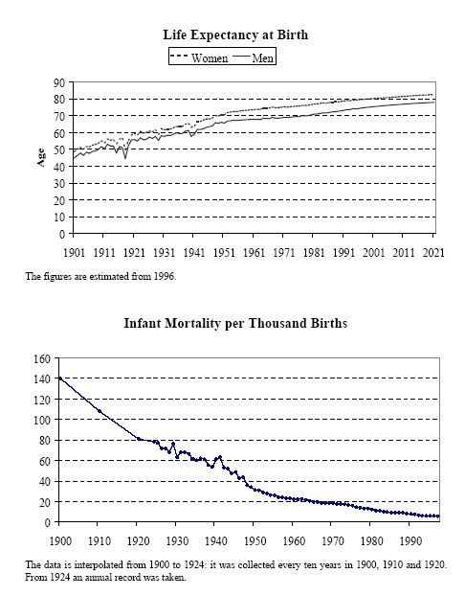

Explain these statistics using both the social and the medical models.

The medical and social models both have different approaches to how someone should address their experience of health and ill health. The social model takes into account that an individuals’ approach to their own health is complex and that due to this they may not respond to the rational health and education advice given by medical professionals such as doctors or midwives.
It can be seen as the medical model being more black and white, and the social model acknowledging all the shades of grey.

Scenario

Jenny is 32; she is an assistant manager of a marketing company. She is overweight, a heavy smoker and is suffering from frequent illnesses and insomnia. Her partner is also a heavy smoker. Jenny also drinks both socially and at home most nights.

1. If Jenny went to the doctor about her health, how would the biomedical model approach this situation? Think about which bodily systems are at risk, what advice would the doctor give, what treatment might the doctor prescribe, and why?

2. Jenny went to the doctor and did not follow the advice she was given. What factors would the social model take into account as to why this may be the case? Take into account all the different factors in the scenario that have an impact on Jenny’s health.

Task

How would the social and biomedical model view AIDS?

Social model – Cause(s) of Aids | Medical model – Cause of Aids
Social Model – How to tackle Aids | Medical model - How to tackle Aids

Health can be affected by…

1. The Different Perspectives of Health

We have already looked at some of the different perspectives people have and how these may affect their health.
A perspective is the way someone looks at health, what makes their health good, what makes their health bad, or what they would do if they became unwell.

The following perspectives can be considered in your coursework:

Lay versus professional

Conventional versus alternative

Positive versus negative

Physical versus holistic

Biological versus social

2. Personal Responsibility for Health

Depending on whether you view your health as your responsibility or someone else’s will greatly determine your lifestyle choices.

For example, if you see yourself as being in control of your own life and health, you are more likely to look after yourself, and choose appropriate lifestyle decisions.

However, if you think, “what will happen, will happen”, then you are more likely to engage in dangerous behaviours.
If people who think that their health is someone else’s responsibility ( such as their GP’s, or their parents), are more likely to participate in dangerous behaviour and lifestyle choices.

The Theory:

Rotter’s Locus of Control
Rotter, J.B. (1966). Generalized expectancies for internal versus external control of reinforcement. Psychological Monographs, 80, whole issue.
People have either an internal or external locus of control. If people believe they control their own destiny then they have an internal locus. If people believe that what happens to them is ‘fate’ or that what they do won’t make a difference, then they have an external locus of control.

This can be linked to health: what has made you healthy? Or what has made you unwell?
Answers can include “because I exercise” (internal), or “because the NHS takes care of me” (external); or “because I got a bacterial infection” (external), or “because I don’t wash properly” (internal).
How people change their locus of control can change their behaviour and lifestyle, especially in terms of how they view health.

So in your Introduction you need to explain how peoples own responsibility for their health can determine how they view health in general.

3. National and local initiatives and health improvement programmes
National Initiatives/HIP depends on both the perspectives of the Government of the day ( the Department of Health) and the health status of the nation.

Current National Initiatives deemed important are:

Choosing Health
Healthy Schools
Five a Day
Smoking Cessation
Reducing Health Inequalities
Reducing Binge Drinking

Stay safe in the sun
Safer Sex
Breastfeeding
Taking more exercise
Reducing drug use
Etc…as there are many many more

Activity

Using the Dept of Health website, (www.dh.gov.uk) try to find details of national initiatives.

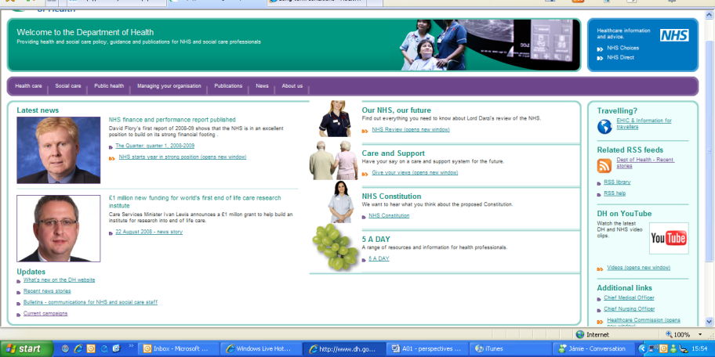
You could try looking at recent news stories or at current campaigns here.
You could try looking at Public Health here.

Using the Bury PCT website, (https://www.burypct.nhs.uk ) to try to find details of local initiatives.

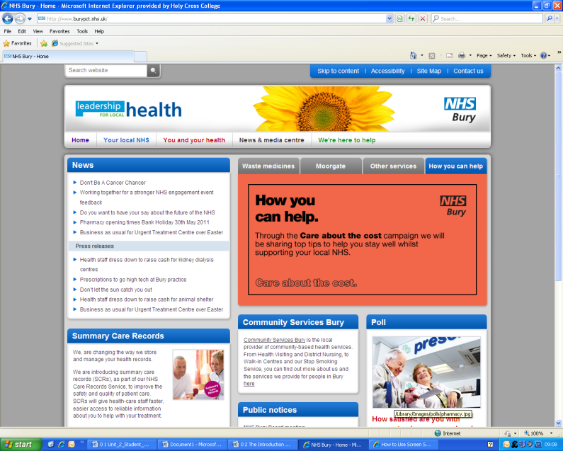

Try looking at Services Provided and then try some of the links on the information bar or on the links below.
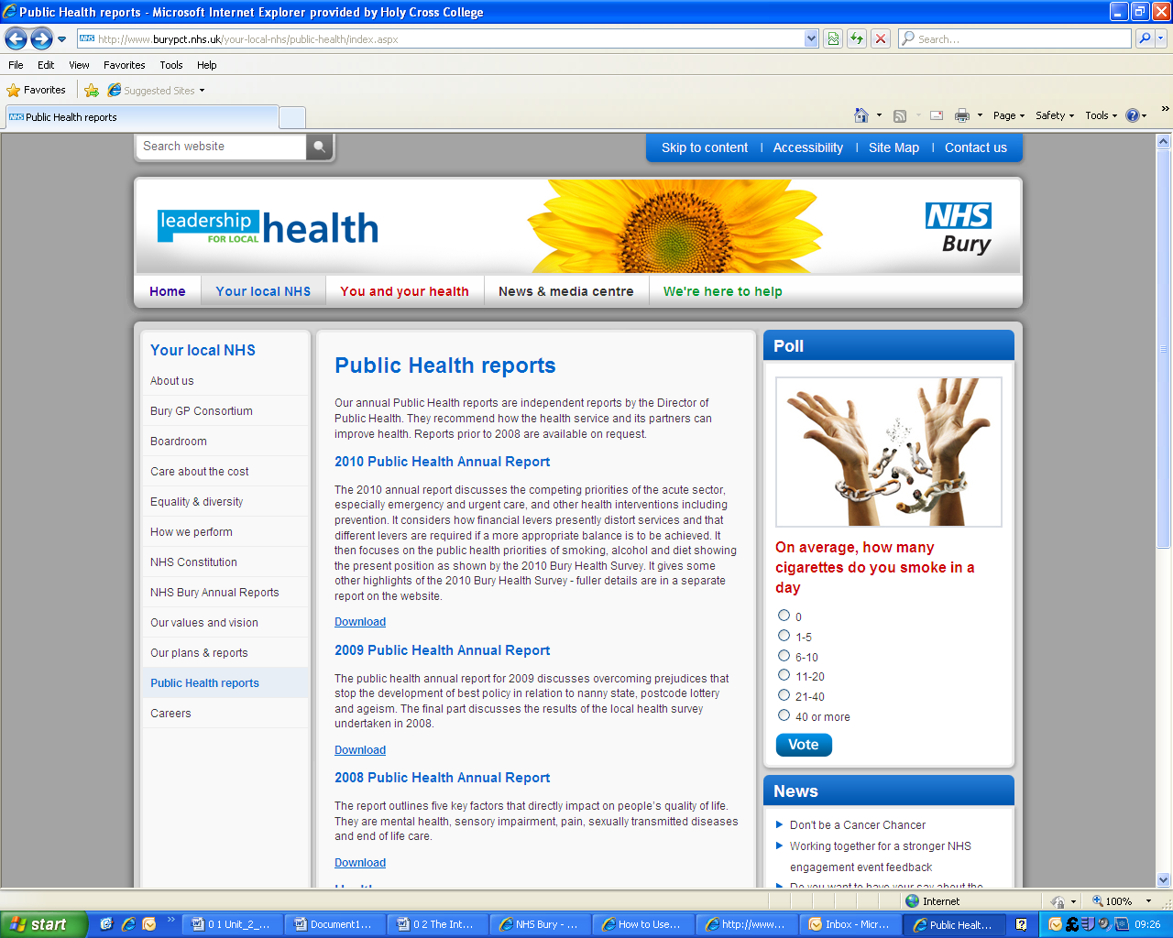

Try looking at about us and then try investigating the different project areas in Bury.

The most recent Annual Report on Public Health 2011, will provide information about local health issues and how these are being tackled in Bury.

You may also find useful resources on the Salford PCT website.

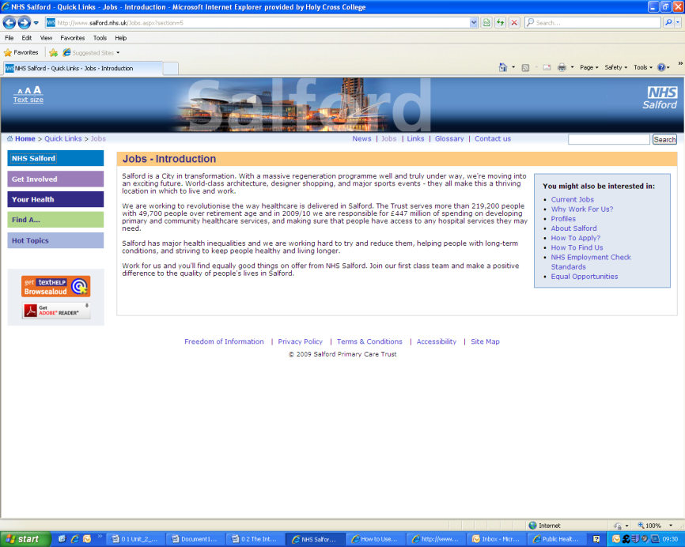
www.salford.nhs.uk

When we return to Unit 2 you will be expected to choose your campaign. You will need to examine Government Initiatives relevant to it.

CHECKLIST FOR INTRODUCTION

- General Introduction
  - Concepts of Health
    - Positive
      - Definition
      - Explanation
      - Example (“I am healthy because…”)
    - Negative
      - Definition
      - Explanation
      - Example
    - Holistic
      - Definition (by W.H.O.)
      - Explanation
      - Example
  - Link paragraph to aspects of health (PIES)
  - Aspects of Health
    - Physical
      - Explanation
      - Examples
    - Intellectual
      - Explanation
      - Examples
    - Emotional
      - Explanation
      - Examples
    - Social
      - Explanation
      - Examples
    - Spiritual (cultural) (only if you understand it)
      - Explanation
      - Examples
    - Societal (environmental) (only if you understand it)
      - Explanation
      - Examples
  - How aspects of health overlap
    - I.e. is smoking just physical, is exercise, is disease?
  - Concepts of Ill Health
    - Explanation
    - Ill health as a subjective sensation
      - Explanation
      - Examples
    - Ill health as disease symptoms
      - Explanation
      - Examples
    - Ill health as a disorder or malfunction
      - Explanation
      - Examples
  - How concepts of ill health overlap
  - Models of Health
    - Medical
      - Explanation
      - Examples
    - Social
      - Explanation
      - Examples
    - How do they differ (cause of/treatment of AIDS)
  - Health and Wellbeing can be affected by…
    - Perspectives of health
      - I.e. the concept of health a person has, the model of health they use, or concept of ill-health
    - National and local initiatives and health improvement programmes
      - Such as post-code lotteries providing different levels of care
    - Personal responsibility for health
      - Rotter’s Locus of Control

