Protecting service users, staff and volunteers from infection
Half Term study booklet
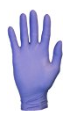
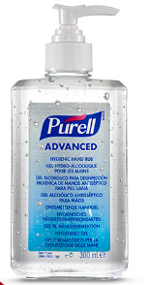
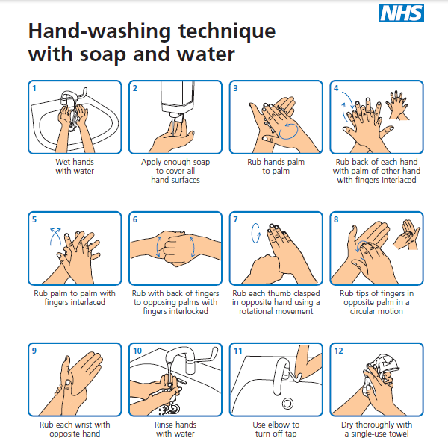
Hand washing procedures, the use of alcohol hand sanitizers and wearing a fresh pair of latex gloves when you deal with a service user is one way of preventing the spread of infection.
There are a range of official procedures to ensure the spread of infection risk is minimalized, which you will need to be familiar with and can refer to in an exam answer.

Protecting from Infections PowerPoint – read through the slides and make notes

Control of Substances Harmful to Health (COSHH) regulations 2002
COSHH is the law that requires employers to control substances that are hazardous to health. You can prevent or reduce workers exposure to hazardous substances by:
- finding out what the health hazards are; in HSC this refers to cleaning chemicals and biological hazards biological agents (germs). If the packaging has any of the hazard symbols then it is classed as a hazardous substance. And germs that cause disease, such as leptospirosis or legionnaires disease and germs used in laboratories
- deciding how to prevent harm to health by use of a risk assessment
- providing control measures to reduce harm to health e.g. PPE equipment
- making sure they are used e.g. training and monitoring staff
- keeping all control measures in good working order e.g. review and monitor
- providing information, instruction and training for employees and others e.g. clear cleaning product instructions and ensuring staff are aware of these
- providing monitoring and health surveillance in appropriate cases;
- planning for emergencies e.g. chemical spillage procedure

Exam practice question; Explain the correct procedure following a child vomiting in a school corridor to ensure safety and infection control. [6 marks]

Exam practice question; Describe what COSHH stands for and what is the purpose of these regulations? [4 marks]

Practice question; Complete the table below [8 marks]
Passage | Examples of the types of infections passed from person to person
Blood borne viruses
Viruses
spread through saliva
Bacterial, passing through contact
Fungal infections spread by touch

What is meant by the term – Hazardous waste?

Reporting of Recorded Accidents and incidents (RIDDOR) regulations 2013
RIDDOR stands for the Reporting of Injuries, Diseases and Dangerous Occurrences Regulations 2013. It is the law that requires the responsible people in a workplace to record and report certain work-related injuries and illnesses. It is crucial that those employed in health and social care understand RIDDOR legislation, the importance of reporting incidents, what specific incidents must be reported, and how to do so, which is why this might be an exam question for you!
Research task; Go onto the Health and Safety Executive website and find the answers to the questions below.
1. Does the death of a care worker at work count as a dangerous occurrence that needs reporting?

2. List FOUR injuries that need reporting, if they occur at work.

3. What is the rule about “Over-seven-day incapacitation of a worker”?

4. What are the rules about a visitor to a service/facility who is in a dangerous occurrence or becomes injured?

5. If a nurse who doesn’t like wearing latex gloves for disinfecting or cleaning then develops dermatitis, would this need reporting?

6. If there was a dispute between two employees about a personal matter that ended in physical violence would this need reporting?

7. Would a nurse catching tuberculosis TB from a patient need reporting?

8. What details need to be recorded on an accident form if a resident falls on the stairs and ambulance is called?

9. Could an accident form be used, as evidence in a Court case?

Health and Safety (First Aid) Regulations (1981)
In a Health and/or Social care setting, there should always be qualified first aiders at incidents where they have been called to assist. This needs reporting in the care setting accident book. Below is the St. John’s Ambulance information regarding the role of a first aider.

The role of a first aider
First aid is the help given to someone who is injured or ill, to keep them safe until they can get more advanced medical treatment by seeing a doctor, health professional or go to hospital.
The role of a first aider is to give someone this help, while making sure that they and anyone else involved are safe and that they don’t make the situation worse.
If you think someone needs your help, these are the seven things you need to do as a first aider:

1. Assess the situation quickly and calmly:
• Safety: Are you or they in any danger? Is it safe for you to go up to them?
• Scene: What caused the accident or situation? How many casualties are there?
• Situation: What’s happened? How many people are involved and how old are they? What do you think the main injuries could be?

2. Protect yourself and them from any danger:
• Always protect yourself first - never put yourself at risk
• Only move them to safety if leaving them would cause them more harm
• If you can’t make an area safe, call 999/112 for emergency help

3. Prevent infection between you and them:
• Wash your hands or use alcohol gel
• Wear disposable gloves
• Don’t touch an open wound without gloves on
• Don’t breathe, cough or sneeze over a wound or a casualty

4. Comfort and reassure:
• Stay calm and take charge of the situation
• Introduce yourself to them to help gain their trust
• Explain what’s happening and why
• Say what you’re going to do before you do it

5. Assess the casualty:
• If there’s more than one casualty, help those with life-threatening conditions first
• Start with the Primary Survey and deal with any life-threatening conditions
• Then, if you’ve dealt with these successfully, move on to the Secondary Survey

6. Give first aid treatment:
• Prioritise the most life-threatening conditions
• Then move on to less serious ones
• Get help from others if possible

7. Arrange for the right kind of help:
• Call 999/112 for an ambulance if you think it’s serious
• Take or send them to hospital if it’s a serious condition but is unlikely to get worse
• For a less serious condition call 111 for medical advice (in England)
• Suggest they see their doctor if they’re concerned about a less serious condition
• Advise them to go home to rest, but to seek help if they feel worse
• Stay with them until you can leave them in the right care.

Reference: https://www.sja.org.uk/sja/first-aid-advice/what-to-do-as-a-first-aider/the-role-of-a-first-aider.aspx

Exam question

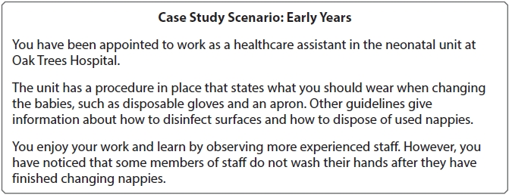

Describe two key objectives that Oak trees Hospital's health and safety policy should address.
(Total for question = 4 marks)
1 Risk assessments completed.
2 Accidents and near misses reported.

This answer scored two marks. Rewrite the answer to gain full-marks.

