Health & Social Care BTEC Level 3 National Extended Certificate

Past Paper Questions Booklet

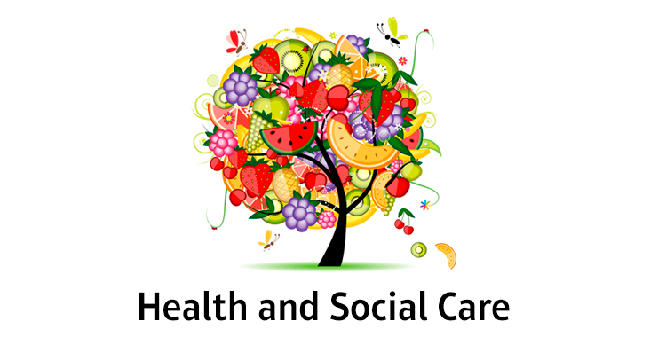

Contents
A Human growth and development through the life stages
A1 | A1 Physical development across the life stages  Growth and development are different concepts:  o principles of growth – growth is variable across different parts of the body and is  measured using height, weight and dimensions  o principles of development – development follows an orderly sequence and is the  acquisition of skills and abilities
In infancy (0–2 years), the individual develops gross and fine motor skills:
o the development of gross motor skills
o the development of fine motor skills
o milestones set for the development of the infant – sitting up, standing, cruising,
walking.
In early childhood. (3–8 years), the individual further develops gross and fine motor skills:
o riding a tricycle, running forwards and backwards, walking on a line, hopping on one
foot, hops, skips and jumps confidently
o turns pages of a book, buttons and unbuttons clothing, writes own name, joins up
writing.
In adolescence (9–18 years), the changes surrounding puberty:
o development of primary and secondary sexual characteristics
o the role of hormones in sexual maturity
In early adulthood (19–45 years), the individual reaches physical maturity:
o physical strength peaks, pregnancy and lactation occur
o perimenopause – oestrogen levels decrease, causing the ovaries to stop producing
an egg each month. The reduction in oestrogen causes physical and emotional
symptoms, to include hot flushes, night sweats, mood swings, loss of libido and
vaginal dryness
In middle adulthood (46–65 years), the female enters menopause:
o causes and effects of female menopause and the role of hormones in this
o effects of the ageing process in middle adulthood.
In later adulthood (65+ years), there are many effects of ageing:
o health and intellectual abilities can deteriorate.
A.2 | A2 Intellectual development across the life stages  • In infancy and early childhood there is rapid growth in intellectual and language skills:  o Piaget’s model of how children’s logic and reasoning develops – stages of cognitive  development, the development of schemas, his tests of conservation, egocentrism  and how his model may explain children’s thoughts and actions  o Chomsky’s model in relation to how children acquire language – Language Acquisition  Device (LAD), the concept of a critical period during which children may learn  language, which may explain how children seem to instinctively gain language.
• In early adulthood, thinking becomes realistic and pragmatic, with expert knowledge
about the practical aspects of life that permits judgement about important matters.
• The effects of age on the functions of memory:
o memory loss in later adulthood.
A.3 | A3 Emotional development across the life stages  • Attachment to care-giver in infancy and early childhood:  o theories of attachment, to include types of attachment and disruptions to attachment.  self-image.
• The development and importance of self-concept:
o definitions and factors involved in the development of a positive or negative
self-esteem
o definitions and factors involved in the development of a positive or negative self-image
A.4 | A4 Social development across the life stages  • The stages of play in infancy and early childhood:  o solo play, parallel play and co-operative play.  • The importance of friendships and friendship groups:  o the social benefits of friendships  o the effects of peer pressure on social development.  • The development of relationships with others.  • The development of independence through the life stages:  o peer influence in adolescence, starting employment, leaving home, starting a family.
B Factors affecting human growth and development
B.1 | B1 The nature/nurture debate related to factors  • Development across the lifespan is a result of genetic or inherited factors – Gesell’s  maturation theory.  • Development across the lifespan is a result of environmental factors – Bandura’s social  learning theory.  • Both factors may play a part – stress-diathesis model
B.2 | B2 Genetic factors that affect development  • Genetic predispositions to particular conditions – cystic fibrosis, brittle bone disease,  phenylketonuria (PKU), Huntington’s disease, Klinefelter’s syndrome, Down’s syndrome,  colour blindness, Duchenne muscular dystrophy, susceptibility to diseases such as cancer,  high blood cholesterol and diabetes.  • Biological factors that affect development – foetal alcohol syndrome, effects of maternal  infections and lifestyle/diet during pregnancy, congenital defects.
B.3 | B3 Environmental factors that affect development  • Exposure to pollution – respiratory disorders, cardiovascular problems, allergies.  • Poor housing conditions – respiratory disorders, cardio vascular problems, hypothermia,  and anxiety and depression.  • Access to health and social care services – availability of transport, opening hours of  services, ability to understand the needs and requirements of particular services.
B.4 | B4 Social factors that affect development  • Family dysfunction – parental divorce or separation, sibling rivalry, parenting style.  • Bullying – effects of bullying on self-esteem, self-harm, suicide.  • Effects of culture, religion and belief – beliefs that may prevent medical intervention,  dietary restrictions
B.5 | B5 Economic factors that affect development  • Income and expenditure.  • Employment status.  • Education.  • Lifestyle.
B.6 | B6 Major life events that affect development  • Predictable events:  o these are events that are expected to happen at a particular time.  While expected, they may still have an effect on a person’s health and wellbeing. This effect can be  positive or negative, regardless of the event.  • Unpredictable events:  o these are events that happen unexpectedly and can have serious physical and  psychological effects on an individual. These effects can be positive or negative,  regardless of the event.  • Many events can be either predictable or unpredictable depending on the life course of the  individual. They can include:  o starting school/nursery  o moving house  o marriage and divorce  o starting a family  o beginning employment  o retirement  o death of a relative/partner/friend  o accidents or injury  o changing employment  o leaving home  o promotion or redundancy  o serious illness.  • The effects of life events on health.  • Holmes-Rahe social readjustment rating scale and the effects of life events on a person’s  stress levels and health.
C Effects of ageing
C.1 | C1 The physical changes of ageing  • Cardiovascular disease – age can increase the risks of cardiovascular disease. This can be  exacerbated by lifestyle choices.  • The degeneration of the nervous tissue.  • Osteoarthritis.  • Degeneration of the sense organs.  • The reduced absorption of nutrients.  • Dementia, to include Alzheimer’s disease.  • Effects of illnesses that are common in ageing.
C.2 | C2 The psychological changes of ageing  • Effects on confidence and self-esteem.  • Effects of social change:  o role changes  o loss of a partner  o loss of friends  o increase in leisure time.  • Financial concerns.  • Effects of culture religion and beliefs.  • Social disengagement theory.  • Activity theory.
C.3 | C3 The societal effects of an ageing population  • Health and social care provision for the aged.  • Economic effects of an ageing population.

Learning Aim A: Human growth and development through the life stages
A1 Physical development questions
1. Arlene is 35 years old. She has a son Kai, who is 12 and a daughter Shona aged 4. Shona is starting school in September.
Discuss how Shona’s fine motor skills will help her independence when she starts school.
6 marks

2. Kai is in the adolescent life stage. Arlene has noticed the physical changes he is experiencing during puberty.
Describe the physical changes Kai will experience during puberty.
6 marks

3. Arlene’s mother, Sofia is 56 years old. Sofia lives with her partner, Clive, and works as a nurse at the local hospital. Sophia has started the menopause.
Discuss possible positive and negative effects of Sofia’s life stage on her health and development.
10 marks

4. Sundus is 24 years old; she came to England to marry her husband, Hassan, who is 41 years old. It was an arranged marriage and she met him for the first time on her wedding day when she was 17. They have six children, Ahmed, 5, Huda, 4, Khalid, 3, Noor,2 and 10-month-old twins Salma and Amira.
Ahmed is a healthy and lively boy looking forward to his sixth birthday next week. He has recently learned to ride a bike.
Discuss the developmental milestones he is expected to have reached by age 6.
10 marks

5. Cathy and Rob are both 40 years old; they married at the age of 18. They have had 6 children, including twins born a year after they were married. Unfortunately, one of the twins, a girl Anna, died suddenly when she was 3 months old, her brother Ben is now 21. Five years later Cathy gave birth to a healthy boy, Daniel, who is now 16. Eleven years ago, they had twins again, Sophia and Sarah, who are now 12. Their last child born three years ago is a son called Harry.
Harry has learnt to do up his buttons.
What type of motor skill is this?
1 mark

6. Explain the effects a decline in progesterone and oestrogen have on women in middle adulthood.
4 marks

7. Growth and development are different concepts.
Describe the concepts of growth and development.
6 marks

8. Eddie is a year old and is able to stand and move around the furniture. He also likes to put things in his mouth.
Explain the difference between gross and fine motor skills.
4 marks

A2 Intellectual development questions
1. Oscar is 8 years old. He has a little sister called Anna who is 18 months old. His father is Jan, aged 48. Oscar is doing well in mathematics at his local primary school.
Describe Oscar’s intellectual development with reference to Piaget’s theories of how children think and learn.
6 marks

2. Arlene is 35 years old and has a son, Kai who is 12 and a daughter Shona who is 4. Shona’s new school provides children with time for free play to explore a range of natural materials that they can use in construction activities and artwork. There are areas with resources for imaginative and role play, and a natural outdoor area.
In the context of Piaget’s theories of cognitive development, justify free play provision for the children.
10 marks

3. Cathy and Rob are both 40 years old; they married at the age of 18. They have had 6 children, including twins born a year after they were married. Unfortunately, one of the twins, a girl Anna, died suddenly when she was 3 months old, her brother Ben is now 21. Five years later Cathy gave birth to a healthy boy, Daniel, who is now 16. Eleven years ago, they had twins again, Sophia and Sarah, who are now 12. Their last child born three years ago is a son called Harry.
Describe the developmental differences in the thinking which emerge during early adulthood.
6 marks

4. Rob’s father Stan, is 68 years old and a recent widower. He collects Harry from nursery each morning.
Describe three effects on the functions of memory in later adulthood.
6 marks

5. Harry is 3 years old and his vocabulary has increased since he started at nursery.
With reference to Chomsky theory, evaluate the evidence that children have innate ability for language acquisition.
10 marks

6. Janet, 43, John, 42, Peter, 11 and Freya, 2, are members of the Gordon family.
Explain what a schema is and how Freya’s schema with relation to large animals might develop.
6 marks

7. Discuss the stages of cognitive development Peter and Freya are at and how they differ.
6 marks

A3 Emotional development questions
1. Kai is 12 years old. He has experienced peer pressure at school from his friendship group.
Identify three negative features of behaviour that may be caused by peer pressure.
3 marks

2. Arlene is 35 years old and split up with her partner, Jeff, three months ago.
Outline how the breakdown in Arlene’s relationship may have affected her emotional and social development.
6 marks

3. Sundus is 24 years old; she came to England to marry her husband, Hassan, who is 41 years old. It was an arranged marriage and she met him for the first time on her wedding day when she was 17. They have six children, Ahmed, 5, Huda, 4, Khalid, 3, Noor,2 and 10-month-old twins Salma and Amira.
Explain the effects a healthy attachment to a loving caregiver can have on emotional development.
4 marks

4. Hassan is very controlling and has a demeaning attitude towards his wife. She is not allowed any contact with people outside the home unless for work or she is accompanied by Hassan. He controls the household money, what is on TV and what books and magazines there are in the house.
To what extent may this have impacted her emotional development?
4 marks

5. Ruby is 1 month old. She lives with her mother but is sometimes looked after by her grandmother. Ruby’s Mum intends to return to work in a few months, so Ruby will go to a nursery.
Use Schaffer and Emerson’s stages of attachment and Bowlby’s theory to discuss how Ruby’s attachments will develop during the infancy stage.
6 marks

6. Janet, 43, John, 42, Peter, 11 and Freya, 2, are members of the Gordon family.
What is a key feature of Peter’s emotional development?
1 mark

7. Sarah has low self-esteem.
Explain how signs of self-esteem might be shown by Sarah.
5 marks

8. Explain what self-image is and how Sarah’s parents can build her self-image as she grows up.
3 marks

9. Sally is 17 and studies Travel and Tourism at the local college. She has a boyfriend called Joe. Joe has been accepted for an engineering apprenticeship with a local employer.
Define the term self-concept.
2 marks

10. Discuss how being accepted for an engineering apprenticeship will impact on Joe’s self-concept.
6 marks

A4 Social development questions
1. Sophia and Sarah are twins. Sophia is more anxious than her sister, and she spends less time texting friends and social networking and spends more time reading.
Outline the impact and importance of friendships and friendship groups on social development.
10 marks

2. Sundus is 24 years old; she came to England to marry her husband, Hassan, who is 41 years old. It was an arranged marriage and she met him for the first time on her wedding day when she was 17. They have six children; Ahmed, 5, Huda, 4, Khalid, 3, Noor, 2 and 10-month-old twins Salma and Amira.
The children are very close in age.
Describe three stages of play.
6 marks

3. Sally is 17 and studies Travel and Tourism at the local college. She has a boyfriend called Joe.
How might having a boyfriend impact Sally’s social development?
4 marks

4. Josie is 19 and has two good friends who have been in a steady relationship for over a year. Both have talked openly about being intimate with their boyfriends and stay overnight at their homes.
Josie has not yet had a steady boyfriend until recently and he has strongly hinted he would like to take their relationship onto an intimate level.
Discuss might Josie feel about this and how it may affect her?
6 marks

5. Define the term independence.
2 marks

6. What key features of developing independence might Josie be experiencing?
3 marks

7. What are the social benefits of Josie’s friendships?
4 marks

8. What is meant by institutionalisation? How may it affect social development in young children who spend their early childhood in hospital?
10 marks

Learning Aim B: Factors affecting growth and development

1. Oscar is 8 years old. He has a little sister called Anna who is 18 months old. His father is Jan, aged 48. Jan’s partner Lena died 10 months ago.
Discuss the likely negative effects of Len’s death on Jan’s development.
10 marks

2. Jan was made redundant from his job and was unemployed for several months, which caused him anxiety and put a strain on the family’s finances. He has now been offered a new, well-paid job in management.
Justify how the change in Jan’s employment status and financial situation may impact on the development and wellbeing of the family.
10 marks

3. The family lives in a small village. A quarry has just opened nearby. This means that heavy lorries constantly pass the family’s house which is close to the road.
Outline the possible effects of the quarry on the family’s health and wellbeing.
6 marks

4. Khadijah has smoked heavily all her adult life. Noor, her two-year-old grandson, has developed a persistent cough, which has caused the health visitor concern. She has made a referral for him to the asthma clinic. Khadijah blames his cough on the family cat.
Outline how Khadijah's addiction to cigarettes could impact on her grandchildren's health and development.
(6 marks)

5. Sundus has started to feel sick in the morning and is worried that she may be pregnant. Their three­ bedroom house is already cramped. The twins sleep in their bedroom, and Huda shares a bed with her grandmother. The three boys share the other bedroom. She doesn't want another baby as they only just earn enough to keep on top of the bills.
(a) Outline how the arrival of another baby will affect the health and development of the other children. (6 marks)

6. Hassan is very controlling and buys all of Sundus's clothes and personal items, even her sanitary protection. Other than at work she is not allowed any contact with people outside the home unless she has his permission, or he knows them. She is not allowed to read any books or magazines that he has not chosen for her and is not allowed to watch TV unless he is with her.
Sundus is a diabetic, and she is insulin-dependent. She had a blood clot in her leg when she was 13 and cannot take the contraceptive pill. Her husband refuses to use contraception as he is a very strict Muslim.
Sundus does not like marital relations and her husband is very demanding, even if her babies are crying. She tells him that she doesn't want these relations with him and sometimes he hits her and still makes it happen. She thinks she may be pregnant and has become bulimic in the hope that it will make her ill enough to miscarry the baby. She has taken to wearing her hijab and niqab all of the time because it makes her feel safe.
Khadija, her mother-in-law, is not very caring or emotionally supportive towards Sundus; she believes her son has not married a suitable wife and that he has married a woman beneath his status. She treats Sundus like a slave but is pleasant to her if Hassan is around. She dotes on her grandchildren and sometimes undermines Sundus on issues of behaviour, mealtimes and bedtime.
Sundus was educated in the Netherlands and did very well in her exams. Her teachers wanted her to study for university, but her parents wanted her to get married. Her mother was very ill with breast cancer and thought it would be better if her daughter were to marry. Her mother died at the age of 39. Sundus's grandma also died of breast cancer at a young age. Sundus has six brothers who are all younger than her. The youngest was only three when the mother died. Her father has since remarried. She has a good command of English, but her reading is not as good as her spoken language.

(b) To what extent has Sundus’ situation impacted on her health and well-being? (12 marks)

(c) With reference to the scenario, explain, giving two examples, how the Diatheses-Stress Model can be applied to Sundus.
(6 marks)

7. After the sudden death of her baby daughter Anna, Cathy developed depression and needed hospitalising for several weeks, which was a big strain on the family. She recovered and was closely monitored during subsequent pregnancies. She sailed through her other pregnancies without any problems. Her third pregnancy was a little unusual as they didn't find out they were having twins again until the delivery. The girls were healthy. When Daniel was 11 he was involved in a road traffic accident and sustained a significant brain injury and the loss of his right leg, which was amputated. On his recovery the family needed to move to a new house in order to accommodate his wheelchair. This was a financial strain on the family and Cathy had to go back to work. Rob's mother helped out with the childcare.
(a) With reference to the Holmes-Rahe social readjustment rating, using the information given and your own knowledge; discuss why the combination of life events overwhelmed Cathy.
(10 marks)

Rob and Cathy earn enough money to afford luxuries for their children. They eat healthy home-cooked meals. Their eldest child is in his final year at university.
(b) Outline the economic factors that affect development. (6 marks)

(c) Discuss the likely negative effects a low income can have on the development of positive self-esteem in early adulthood.
(10 marks)

8. Cystic fibrosis is a hereditary illness; usually men with this condition are infertile.
Outline the differences between a congenital and a hereditary illness.
(6 marks)

9. Johnny is more outgoing than his brothers and has excellent social skills. His vocabulary is advanced for a three-year-old. His grandad lets him play on his iPad and is also teaching him to swim. He has a lot of one-on-one time with his grandad, who encourages him to ask questions and plays games with him. This has given him a lot of confidence.

Justify how a combination of nature and nurture has influenced Johnny's social and intellectual development.
(10 marks)

10. (a) Explain the term adolescence.
(2 marks)

(b) Describe one physical, one social and one emotional feature of adolescence.
(6 marks)

11. (a) Explain the difference between absolute poverty and relative poverty. (4 marks)

(b) Explain two effects of living in relative poverty on a child’s physical development.
(6 marks)

12. After the death of her husband, Lia’s mother started to drink excessive quantities of alcohol.
Identify two short-term effects of drinking an excessive quantity of alcohol. (2 marks)

13. Discuss the interaction between genetic and environmental factors in determining an individual’s health and well-being.
(10 marks)

14. Michael is 42 years of age and lives with his wife and 13-year-old son Liam. They live in a large house in the South of England. Michael became wealthy by developing his own internet company and investing in other businesses. He works long hours on his own at home.
(a) Identify the life stages of Michael and Liam.
(2 marks)

(b) Identify and explain one positive and one negative factor currently influencing Michael’s social development.
(6 marks)

15. A range of factors influence human growth and development.
(a) Define genetic factors.
(2 marks)

(b) Explain how two environmental factors may influence growth and development.
(4 marks)

16. Sari has a low income.
Explain how a low-income impacts on dietary choice. (6 marks)

17. Bill’s wife died from breast cancer over 15 years ago after which he looked after himself until he had the stroke. After his wife died he ate convenience food and relaxed by watching TV with a few cans of beer. He rarely went out with friends. Bill is not obese but he is overweight and was shocked to discover he had become diabetic.
Explain how Bill’s lifestyle may have contributed to his ill health after his wife died.
(6 marks)

18. Ros and Kim are a same sex couple. They have recently adopted Patrick who is just over two years of age and previously lived in foster care before the adoption. Ros is a senior manager in a large financial organisation where Kim was a cleaner. Kim has given up work to look after Patrick.
a) Identify Patrick’s current life stage.
(1 mark)

Patrick has settled in well to his new family life.
b) Explain the meaning of primary socialisation.
(2 marks)

Patrick has been diagnosed with asthma, which can be due to nature and/or nurture.
(c) Explain the difference between nature and nurture.
(2 marks)

Ros is the only family member with an income and now has two dependents, Kim
and Patrick. Her senior manager role is also very demanding.
(d) Discuss how stress may affect Ros’s health and well-being. (8 marks)

15. Individual lifestyle choices may affect a person’s health.
Identify and explain one lifestyle factor and its effect on an individual’s health.
(4 marks)

16. The recent economic recession has increased the number of people living in poverty.
Discuss how living in poverty may affect health and well-being.
(8 marks)

17. Mel and Jon have become parents 12 years after they got married. They needed help with fertility treatment and have had triplets. The community in which they live is very excited as triplets are unusual, although not rare. Mel has had to give up work and Jon has taken paternity leave to support Mel. June, Mel’s mother is staying for a few weeks to help as well.
(a) (i) Define the meaning of triplets.
(2 marks)

Statistics for the triplets are shown below:

Feature | Baby 1 | Baby 2 | Baby 3
Gender | female | male | female
Weight | 3.3 kg | 3.3 kg | 2.6 kg
Head circumference | 34 cm | 35 cm | 32 cm
Length | 508 cm | 509 cm | 450 cm
Eye colour | blue | blue | blue
Hair colour | fair | fair | fair

(ii) State two features from the table that are controlled by genetic inheritance.
(2 marks)

(b) Identify and explain one feature not controlled by genetic inheritance. (4 marks)

Learning Aim C: Effects of Ageing
Case study 1:
George is 65 years old and lives with his wife Polly, who is 53 years old. Their adult daughter, Nita, is 19 years old and has foetal alcohol syndrome. George is soon to retire from his job as a senior manager, which he has held for 35 years.
1. Explain two possible effects of George’s retirement on his emotional development.
(4 Marks)

Due to Nita’s care needs, Polly did not return to her career as a nurse after Nita’s birth. Recently she has considered returning to nursing.
2. To what extent will George’s retirement from a senior role affect Polly’s self-image?
(10 Marks)

Polly has decided to leave George and the family home, leaving George as Nita’s sole carer.
3. Evaluate the effects of ageing on George’s ability to care for Nita.
(10 Marks)

Case study 2:
Iqbal is 74 years old and lives with his wife Yasmina, who is 70 years old and has dementia, in a house on a busy main road. Iqbal has high blood pressure and type 2 diabetes.
Iqbal enjoys his food, particularly the cakes and biscuits his daughter-in-law Nusrat brings with her when she visits with the grandchildren. Iqbal spends much of his time watching daytime television when he isn’t caring for Yasmina.
Recently Iqbal has become anxious, as the council are considering widening the road outside of the house, and the family may have to be re-housed.
4. Explain two possible effects on Iqbal’s physical health of his current lifestyle.
(6 Marks)

5. Describe how Iqbal’s daughter-in-law could support him in improving his emotional health.
(4 Marks)

6. Discuss the potential effects of Iqbal’s current lifestyle on his intellectual wellbeing, referring to relevant theories.
(10 Marks)

7. Evaluate the effects of the council’s potential decision to widen the road on Iqbal and Yasmina’s health and wellbeing.
(10 Marks)

Case study 3:
Hassan's mother Khadijah is 63 and a widow; her husband died unexpectedly. Khadijah now lives with the family. She helps-out with the childcare and cooking. She takes the children to the park every day, pushing them on the swings and helping them on the climbing frame. She attends mosque regularly and serves tea and biscuits at the 'mother and toddler group' held at the community centre. She enjoys taking the children to visit places of interest such as museums. At a recent 'health and well­being check-up' the doctor commented on her good level of fitness, her good mental agility and her excellent emotional health.
8. With reference to the Activity Theory, using the information given and your own knowledge discuss two significant aspects of her life that have helped Khadijah achieved this level of health and fitness.
(10 Marks)

Case study 4:
Clive's wife Vanilla was an only child. Her mother died suddenly a short time after her daughter's death. Frank, her father, took the death of his wife and daughter very hard and has found it difficult to motivate himself and to engage with his grandchildren and son-in-law. Clive is worried that Frank is depressed.
9. Discuss the effects of the Disengagement Theory and, using the information given and your own knowledge; assess how Frank fits into this model.
(10 Marks)

The sudden death of his wife left Frank deeply distressed and unable to resume his usual activities. Prior to his wife's death, he was a devout Catholic and very active in fundraising; until recently he had no energy and had stopped taking care of himself.
Frank's doctor referred him for grief counselling and prescribed him a low dose of antidepressants. He still feels angry sometimes at the sudden death of his wife but he is slowing beginning to accept his situation. He has resumed his voluntary work at the church.
Apart from a few aches and pains, Frank is in very good shape. He takes an active part in the running of the church finances and has a fantastic memory. He goes for an early morning swim every day and swims at least three miles a week.
He collects Johnny, his grandson, from preschool three afternoons a week and takes him back to his house for lunch. This takes some of the pressure off his son.
Frank eats a healthy balanced diet and lately has started to cook Sunday lunch for his son and grandchildren. He attends a men's club run by the church on Saturday and meets up with three friends to catch up on current affairs comparing it to 'the good old days'. They drink tea and chat about their late wives.
He has a busy, active life; the only complaint he has is that he feels more tired than he used to, and he has to get up in the night several times to urinate. Also, he can't open jars of chutney like he used to.
He has a positive mental outlook and good relations with his family and grandchildren whom he says keep him young. Apart from missing his wife, he feels that he has achieved all of his life goals and is and is happy and fulfilled.
Frank has retired and is in receipt of a works and state pension. He is able to take an active role in looking after his grandchildren
10. To what extent will an ageing population impact the economy? (12 Marks)

Frank is very healthy for his age.
11. With reference to the scenario, explain two possible reasons for this. (6 Marks)

Key terms typically used in assessment
The following table shows the key terms that will be used consistently by Pearson in our assessments to ensure students are rewarded for demonstrating the necessary skills.
Please note: the list below will not necessarily be used in every paper/session and is provided for guidance only.

Command or term Definition
Describe | Learners give a clear, objective account in their own words showing recall, and in some cases application, of the relevant features and information about a subject.  For example, ‘Describe gross and fine motor skills in relation to…’.
Discuss | Learners consider different aspects of a topic, how they interrelate and the extent to which they are important.  For example, ‘Discuss how both the environment and genetic factors may account for…’.
Evaluate | Learners draw on varied information, themes or concepts to consider aspects such as strengths or weaknesses, advantages or disadvantages, alternative actions, and relevance or significance.  For example, ‘Evaluate possible explanations for the development of…’.

Command or term Definition
Explain | Learners show they understand the origins, functions and objectives of a subject and its suitability for purpose. They give reasons to support an opinion, view or argument, with clear details.  For example, ‘Explain two possible features of the development of…’.
Identify | Learners indicate the main features or purpose of something, and/or are able to discern and understand facts or qualities.  For example, ‘Identify the services that might be available to…’.
Justify | Learners give reasons or evidence to support an opinion or prove something right or reasonable.  For example, ‘Justify how overcoming…’.
Outline | Learners provide a summary or overview or a brief description of something.  For example, ‘Outline ways in which this might affect their physical health.’
To what extent | Learners show clear details and give reasons and/or evidence to support an opinion, view or argument. It could show how conclusions are drawn (arrived at).  For example, ‘To what extent might recent…’.
Which | Learners specify one or more items from a definite set.  For example, ‘Which body part…’.

Long answer questions (10 and 12 marks)
PEEL Structure
Improve your 10 and 12-mark long answer questions using “P.E.E.L.”

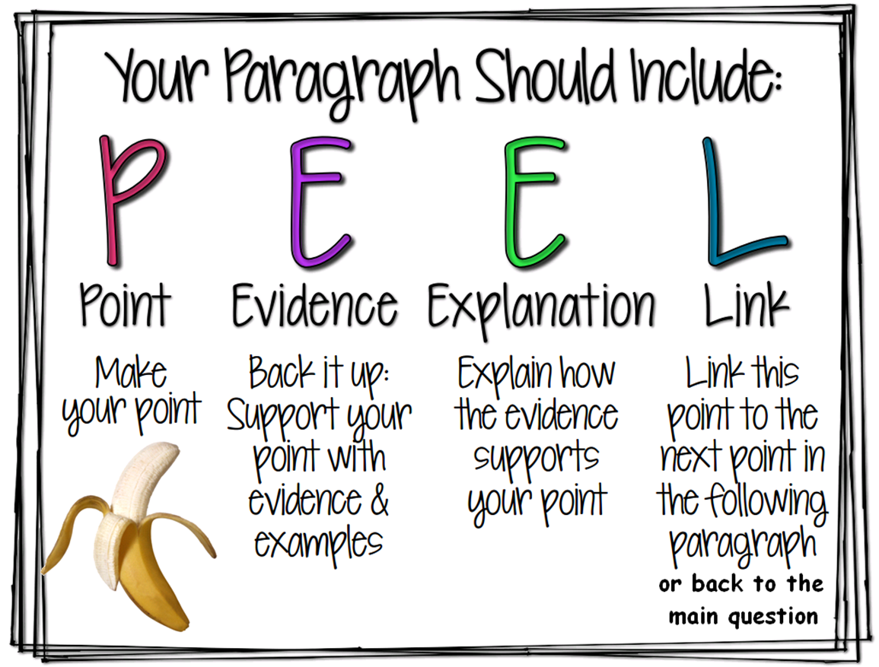

What is a Concluding Sentence?
A concluding sentence should signal the essay is finished. Remember, it must link back to the question and should not include any information that has not already been discussed.
Examples of concluding sentence starters include:
- In conclusion
- In summary
- As expressed
- Overall
- As a result
- Finally
- Lastly
- To review
- In general

