Contextualise your learning. Read the following article and write down its relevance to what we are learning about currently. Highlight the key words that are important/ shocking in this article.

What is your opinion regarding this subject matter?

Any unfamiliar terminology:

Relevant data. What information from this article could you use in your coursework.
Bases of discrimination –
Discriminatory behaviour –
The effect –

'Age discrimination within NHS' leaves elderly neglected

Appalling standards of care on some NHS wards have led to complaints of neglect of elderly patients increasing by more than a third over the past year, according to a new report.
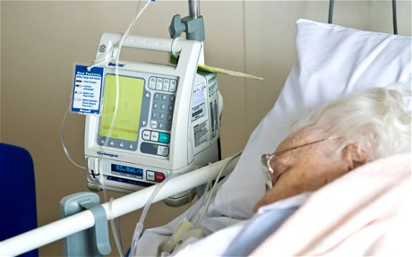

The Patients Association is shocked at the 'huge increase' in neglect. Photo: Alamy
By Gordon Rayner
6:46AM GMT 09 Nov 2011
Follow
The Patients Association highlights harrowing cases of pensioners being left starving or suffering in agony, and relations being ignored as they watch their loved ones die because nurses claim to be “too busy” to help.
The head of the charity said the report, which “shames everyone involved”, showed that despite government promises of action following a series of other damning reports, standards of care continue to get worse.
Andy Burnham, the shadow health secretary, said the report was proof of “age discrimination” in NHS hospitals.
The Patients Association is so alarmed by the “huge increase” in reports of neglect that it is launching a campaign demanding basic standards of dignity and care in hospital wards.
Cases highlighted in the Patient Stories report include:

Related Articles
• Nurses taking 15 minutes to respond to a patient who pressed his emergency button as he was left “gasping for life”.
• A pensioner who was told to soil his clothes by a nurse who did not have time to take him to the lavatory.
• A patient who spilt boiling soup over her legs, scalding herself, after a nurse insisted that she was too busy to help.
• A man who had forcibly to refuse an injection to relieve “internal bleeding”, with which he was not suffering, because of a mix-up over his medical notes.
• A patient who was left without blankets or a pillow and told to eat ice cream with his fingers because there were no spoons.
The Patients Association, which normally receives 5,000 calls per year from patients and relations asking for help and reporting concerns, said that since January it had received 961 calls reporting neglect, a 37 per cent increase on the same period in 2010.
Surveys of patients who are treated in NHS hospitals suggest the true number of patients who suffer neglect is more than 200,000 per year. Katherine Murphy, the chief executive of the Patients Association, said: “The accounts of care contained in this report shame everyone involved.
"In the 21st century, in one of the most developed countries and health systems in the world, patients should not be left starving or thirsty, they shouldn’t be left in pain and they shouldn’t be forced to urinate or defecate in their bed because the nurse designated to them says it’s easier for them to change the sheets later than to help them to the toilet now. Yet this is what is happening around the country every day."
Last month the Care Quality Commission said in its annual report that elderly patients in half of NHS hospitals were being neglected because of a lack of “kindness and compassion”.
Mrs Murphy said: “It’s simply not good enough for this report to be recognised and then business to carry on as usual.”
With £20 billion in NHS efficiency savings demanded by the Government, there are fears that the problem will only get worse if hospitals allow numbers of front line staff to decrease.
The Patients Association has joined forces with Nursing Standard magazine for the Care Campaign, which demands that hospitals deliver satisfactory standards of care in four key areas.
It calls on hospital workers to care with compassion; assist with toileting, ensuring dignity; relieve pain effectively and encourage adequate nutrition.
A spokesman for the Department of Health said: “Everyone admitted to hospital deserves to be treated with compassion and dignity. Wherever there is poor performance we will root it out, and whatever the reason for that poor performance we will tackle it.’’
• Elderly patients are increasingly being kept in hospital beds because there is no one to support them at home, or there are no places available in residential homes, figures show. The number of hospital bed days lost to so-called ''bed blockers’’ across NHS hospitals in England has risen from 115,648 during September and October in 2010, to 128,517 in the same two-month period this year.

