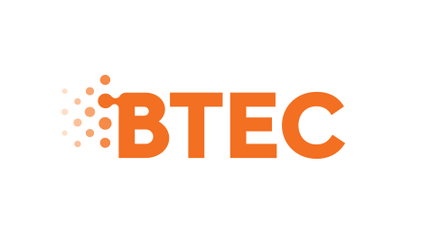

Health and Social Care Unit 14 Physiological Disorders and their Care

Consent form

I consent to my personal health information being used as a case study for the Unit 14 Physiological Disorders and their Care Assignment at Holy Cross College.

I understand that my name will be changed, and my identity will be kept confidential.

Signed _____________________________________* Date_________________________

Name (Please print) _________________________________________________________

*Must be signed by a parent or legal guardian in the case of a child under age 18 or legal guardian in the case of an adult (if applicable).

