Chomsky and Piaget PPQs Answer sheet
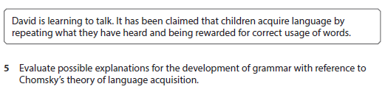

Evaluate possible explanations for the development of grammar with reference to Chomsky’s theory of language acquisition (10 marks)

Abbey house is a pupil referral unit. Pupils have lessons in literacy and numeracy.
Evaluate how the work of Piaget could help staff plan the literacy and numeracy lessons at Abbey House. (9 marks)

Outline two features of the constructivist perspective from Piaget (4 marks).

