NorthNorth WeWestst

The A – Z Quiz

A | B | C | D | E
F | G | H | I | J
K | L | M | N | O
P | Q | R | S | T
U | V | W | X | Y
Z

NHS Triva Quiz

Questions

How many people are employed by The NHS in England?
1.3million 1.5million 2.0million 2.1million

The NHS is one of the largest employers in the world, along with the Chinese People’s Liberation Army, the Indian railways and the Wal-Mart supermarket chain. Put them in order.

- What percentage of workforce is female?
37% 45% 65% 77%

How many volunteering roles are there within the Health and social care setting?
50+ 100+ 200+ 500+

Nurses make up the largest part of the NHS workforce. At what percentage?
25% 41% 31%

Each day, in the UK, how many people will visit their GP surgery or practice nurse?
500,000 835,00 1,000,000

NHS Chiropodists/Podiatrists inspect more than how many pairs of feet every week?
100,000 150,000 250,000

Community Pharmacies dispensed how many million prescription items in 2010?
926.7 850 500

The NHS Ambulance Service receives how many emergency calls in a year?
5 million 7 million 8 million

Of these how many resulted in an emergency response?

- In 2009, approximately how many babies were born in the UK?
710,000 791,000 730,000

Approximately, how many people go for an eyesight test each day?
16,000 28,000 40,000

NHS Direct receives more than …………………. Calls over a year.
Fill in the gap: 1 million 5 million 8.5 million 12 million

How old was the oldest person in the world to have a hip replacement?

NHS Triva Quiz

Questions

How many hip replacement operations were carried out in 2010?
71,000 90,000 100,000 120,000

Britain’s first sextuplets were born to Sheila Thorn at Birmingham Maternity Hospital in what year?
1948 1958 1968

The first heart transplant in the UK took place on May 3 1968 at the National Heart Hospital in Marylebone, London. Approximately, how many heart transplants occur in the UK in a year?
250 150 700

When was the NHS established, July 5th of which year?
1940 1945 1948 952

Louise Brown was the first test tube baby to be successfully born in 1978. How many babies have been born since using IVF?
100,000 150,000 200,000

Healthcare Science Quiz

Questions
- Can you name the three main areas that Healthcare Science covers?

- How many Healthcare Science careers are there within the NHS?

- Name the five senses

- What is your largest organ?

- Where are the four taste zones on your tongue

- How many pints of spit does the average human produce in a lifetime

- How many brain cells are lost each day after the age of 30?

- How many miles of veins, arteries and capillaries are there in a human body

- Whose hearts beat faster – women or men?

- How many bacteria occupy every sq. inch of the human body?

- What is the smallest cell in the human body?

- Is the brain more active sleeping or watching t.v?

- Where is your strongest muscle located?

- How many joints are in the human body?

- What is the average length of you smallest intestine?

- How many gallons of blood flow through your kidneys in one day?

- How many times do you blink during the day

- How many hairs grow on the head

- What has more bacteria – your mouth or your armpit?

- Name ten parts of the body that are three letter words

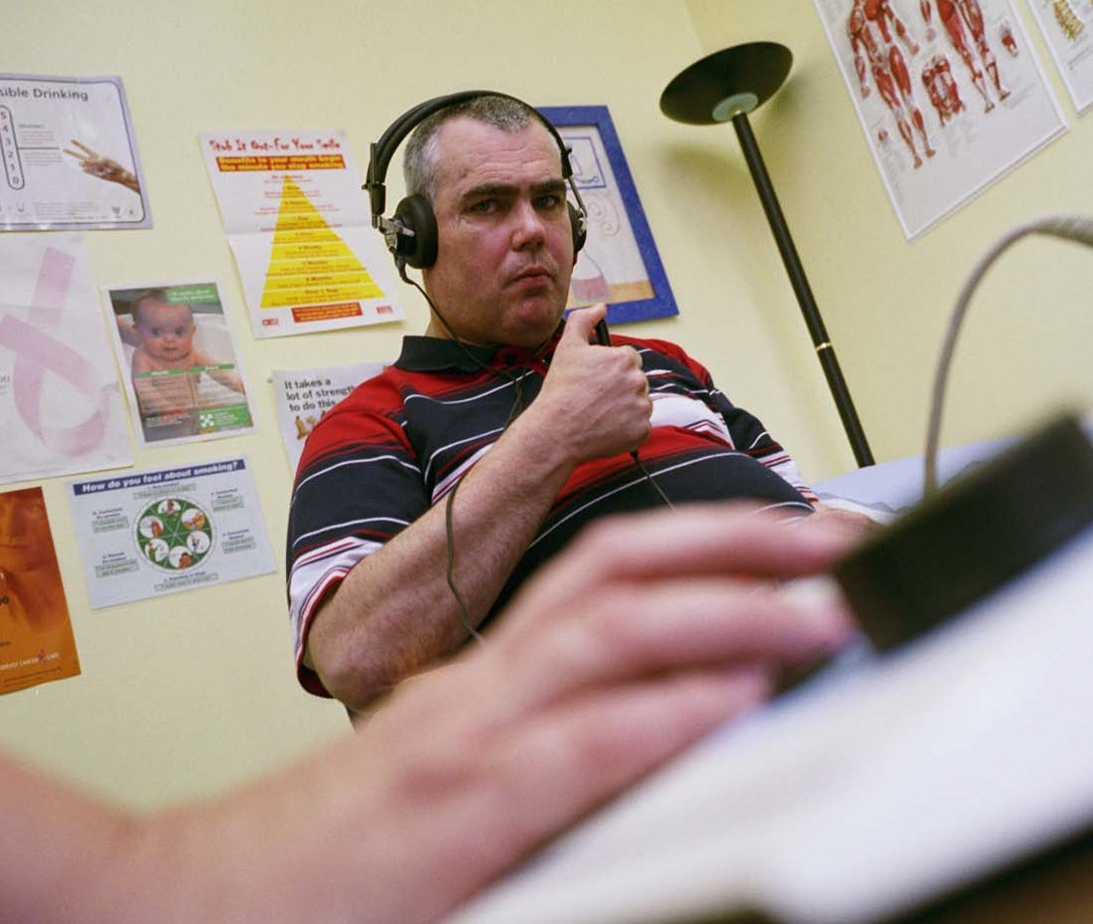

Audiologist

What skills would someone need to become an Audiologist?
- What qualifications are required to enable someone to obtain this job?
- Who would an Audiologist come into contact with?

Audiologist

Skills
- Have an interest in science and anatomy
- Have a clear speaking voice
- Have a good delivery style which enables patients to lip-read
- Be able to get on well with people of all ages and from a wide variety of backgrounds
- Have a caring and understanding attitude
- Be able to work well in a team
- Be able to give clear instructions
- Be able to think logically and adopt a scientific approach
- Have good manual dexterity
- Be able to write clear reports

Qualifications and training
There has been a programme change to modernise scientific careers in the health sector. The changes mean that the four year BSc degree in Audiology is being replaced by a 3-year degree in healthcare science (neurosensory sciences - in which audiology is one of the pathways you can follow). This is part of the NHS Practitioner Training Programme (PTP). Academic and work based learning are combined and initially, there is a broad approach to the specialisms which are – audiology, neurophysiology and ophthalmic and vision science – followed by specialisation in years 2 and 3. The programme is run in a number of approved universities. For the latest up to date list of approved courses see NHS Networks
For entry onto a BSc healthcare science degree, you will typically need at least 2 if not three A2/A’ levels including science subjects and a good spread of GCSEs at A-C grade. Alternative/equivalent qualifications may be accepted by some universities, but you are advised to check with each university (or visit their website) before making an application.
Alternatively, graduates with a good science degree (2:1 or 1st) can apply to the Scientist Training Programme (STP). You would be employed in an audiology department and you would follow a part time Masters in Neurosensory science. The process for 2012 has not been fully established yet

Who would they come into contact with?
- Patients – of all ages unless they wish to specialise in a particular area
- Parents and carers
- Other members of the health team
- Organisations that may supporting the patient – e.g. social services, hearing charities, schools etc.

Audiologist (continued)

Key sources of further information:
Audiology Resources – www.aud.org.uk
British Academy of Audiology (BAA) – www.baaudiology.org British Society of Audiology (BSA) – www.thebsa.org.uk Health Professions Council (HPC) – www.hpc-uk.org
NHS Careers – www.nhscareers.nhs.uk
NHS Networks – http://www.networks.nhs.uk/nhs-networks/msc-framework-curricula/ptp-1/accredited-bsc- hons-healthcare-science-programmes
Step into the NHS – www.stepintothenhs.nhs.uk
NHS Scientist Training Programme (STP) - http://www.nhscareers.nhs.uk/details/Default.aspx?Id=2105 Skills for Health – www.skillsforhealth.org.uk

Catering Assistants

What skills would someone need to become an Catering Assistant?
- What qualifications are required to enable someone to obtain this job?
- Who would an Catering Assistant come into contact with?

Catering Assistants

Skills
- Good communication skills – verbal & written
- Time management
- Able to organise
- Ability to carry out physical tasks:
- Ability to prioritise own work load
- Good attendance records
- A high standard of personal hygiene
- Smart appearance
- Pleasant manner
- Able to work under pressure
- Able to work in hot humid conditions

Qualifications and training
Good general education – possibly GCSEs A-E or equivalent. Food HygieneTraining Level 2 Food Safety Certificate or Basic Food Hygiene Certificate may be useful with a willingness learn. Training would be towards a QCF in hospitality and catering – it may be food preparation, depending on the role. This could be a possible apprenticeship route.

Who would they come into contact with?
- The kitchen team
- Patients
- Staff
- Visitors
- Possible wider community if special events take place

Key sources of further information: NHS Careers – www.nhscareers.nhs.uk Skills for Health – www.skillsforhealth.org.uk
National Apprenticeship Service – www.apprentices.org.uk
People 1st – the Sector Skills Council for the hospitality industry – www.people1st.co.uk/ and link to www.uksp. co.uk/ for careers information

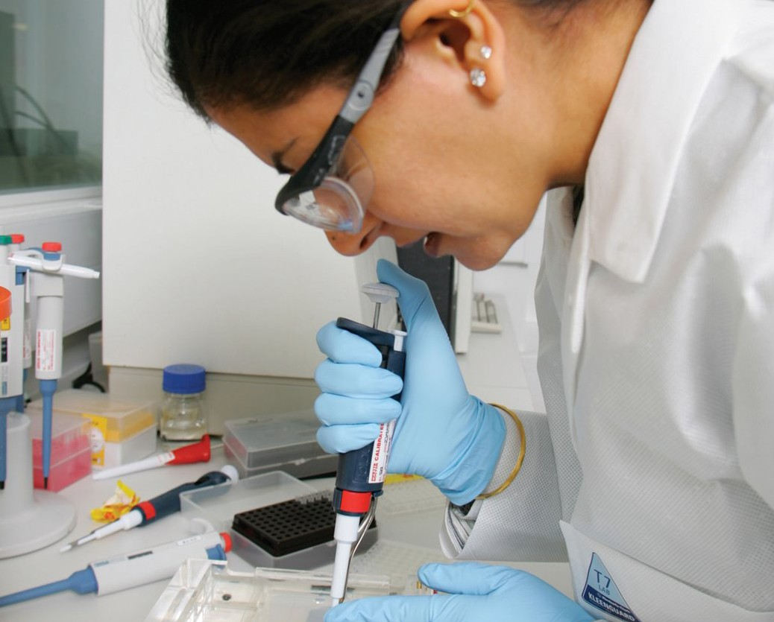

Clinical Biochemists

What skills would someone need to become an Clinical Biochemists?
- What qualifications are required to enable someone to obtain this job?
- Who would an Clinical Biochemists come into contact with?

Clinical Biochemists

Skills
- A strong interest in science
- An ability to carry out complex biological and chemical analyses
- Manual dexterity
- To be innovative
- To be able to plan and organise
- Have good communication skills to be able to communicate to the clinicians
- To be able to write concise and accurate reports
- The ability to manage other biomedical staff
- To be able to take on responsibility

Qualifications and training
A good honours degree in the life sciences would be preferred for entry into this job role. Entry to the degree would be via A levels or equivalent with science such as chemistry – check NHS Careers job profile and the ACB site for further information. The degree would then enable them to apply for the NHS Scientist Training Programme (STP). There must be a willingness to develop their training further and to keep up to date. Clinical biochemists must register with the Health Professions Council (HPC) and must follow Continuous Professional Development (CPD) to maintain their registration.

Who would they come into contact with?
- A range of staff in the laboratories
- Clinical staff like doctors, consultants and nursing staff
- Some may work directly with patients depending on the treatment that is taking place
- Other clinical scientists

Key sources of further information:
The Association for Clinical Biochemistry (ACB) – www.acb.org.uk
NHS Scientist Training Programme (STP) – http://www.nhscareers.nhs.uk/details/Default.aspx?Id=2105 NHS Careers – www.nhscareers.nhs.uk
Skills for Health – www.skillsforhealth.org.uk

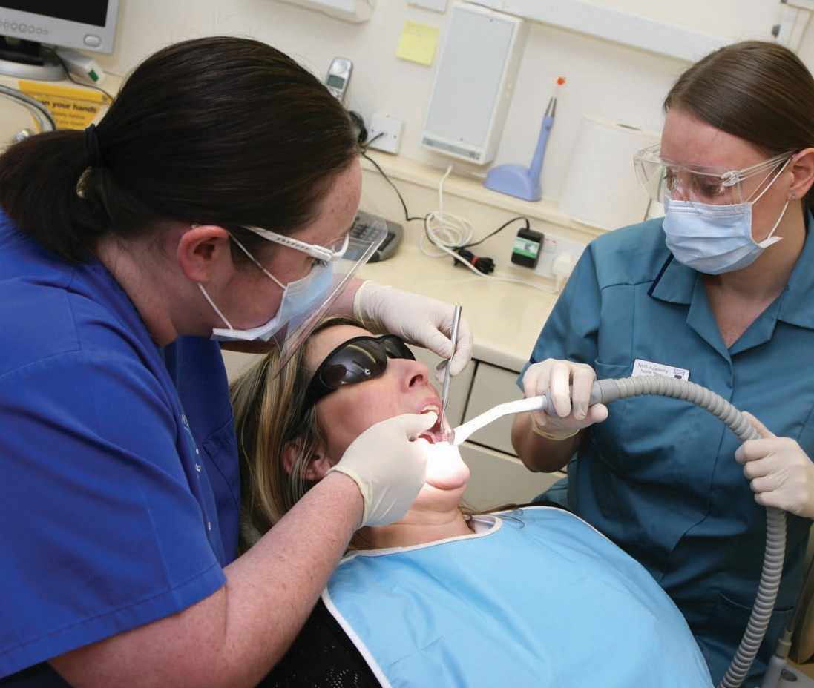

Dental Therapist

What skills would someone need to become an Dental Therapist?
- What qualifications and training are required to enable someone to obtain this job??
- Who would a Dental Therapist work with?

Dental Therapist

Skills
As clinical decisions will ultimately be based on the needs of the individual patient, the dental therapist will have autonomy over the way that the treatment plan is undertaken. This will include the choice of instruments and materials to be used, which requires expert knowledge and skills.
- Encouraging anxious patients
- Patience
- Excellent communication skills
- Interpersonal skills
- Empathetic and caring approach
- Proficient and highly technical clinical skills
- Good time management
- Organisational skills
- Confidentiality

Qualifications and training
Five GCSE subjects graded A-C, plus two A levels or a recognised qualification in dental nursing. You may also be required to have some experience of dental nursing before taking the course. To practice, you must be on the
General Dental Councils roll of dental therapists. You achieve this by obtaining the diploma in dental therapy offered by a number of hospitals.
The length of the diploma course is about 27 months, depending on the dental hospital at which you study. Some dental schools offer part time courses for dental hygienists wishing to qualify as dental therapists. Some universities offer joint dental hygiene and dental therapy degrees and diplomas – see the NHS Careers Course finder for details.

Who would they come into contact with?
- Patients of all ages
- Parents and carer’s
- Other Dental specialists
- Non clinical staff e.g. receptionist/clerks
- Outside organisations (dental laboratories)
- Sales reps

Key sources of further information:
General Dental Council – www.gdc-uk.org
British Association of Dental Therapists – www.badt.org.uk NHS Careers – www.nhscareers.nhs.uk
Skills for Health – www.skillsforhealth.org.uk

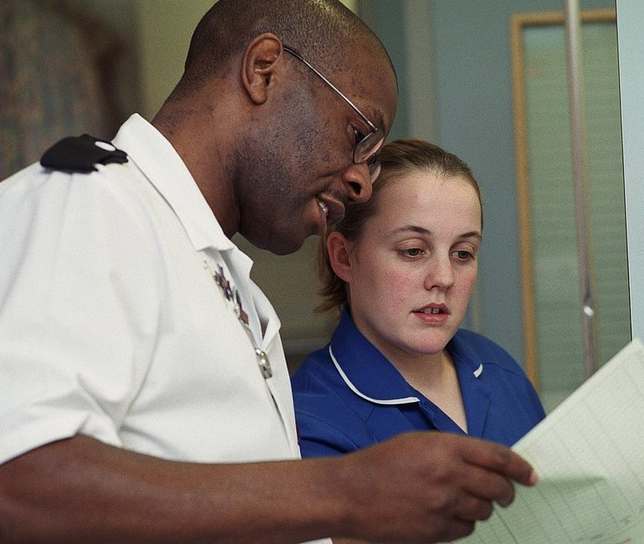

Nurse

What skills would someone need to become a Nurse?
- What qualifications and training are required to enable someone to obtain this job??
- Who would a Nurse work with?

Nurse

Skills
Excellent people skills – able to put people at their ease, gain their confidence and deal sympathetically with their problems and fears.
Good communication and observation – good at listening as well as talking and be constantly alert to changes in patients’ conditions and the implications in terms of care.
Ability to answer questions and offer advice – you must be able to answer questions by patients, share your knowledge and skills with patients, their families and friends
They are happy to work as part of a team – that includes doctors, physiotherapists, anesthetists, pharmacists, dietitians and many more. You will need to know their roles
Dealing with emotionally charged situations – managing distress - playing a key part in helping patients and families come through their crises.

Qualifications and training
To work as a nurse you must follow a Nursing and Midwifery Council (NMC) approved programme to register as a qualified nurse. From 2013, you will only be able to follow a degree programme as diplomas are being phased out. Each university will set its own entry requirements. As a guide, you need 5 GCSEs plus 2 A levels or equivalent for the degree and 5 GCSEs including, English and maths or science for the diploma. You will need to show evidence of literacy, numeracy and good character. You could start your career at different entry points – by working as a healthcare assistant and developing your qualifications and experience or by direct entry to university. Some sort of voluntary work or work experience will help your application to nurse training, which can show evidence of skills such as working with people, team work and communication.

Who would they come into contact with?
- Patients of all ages
- Families
- Clinical staff e.g. Doctors, Pharmacists
- Allied health professionals e.g. Physiotherapist, Dietician
- Health care assistants
- Non clinical staff – Porters, ward clerks, etc

Key sources of further information: Nursing and Midwifery Council – www.nmc-uk.org Nursing Careers – www.nhscareers.nhs.uk/nursing Royal College of Nursing – www.rcn.org.uk
University and College Admissions Service – www.ucas.ac.uk Skills for Health – www.skillsforhealth.org.uk

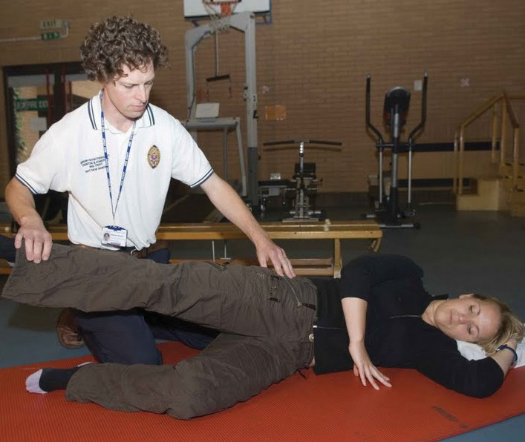

Occupational Therapist

What skills would someone need to become a Occupational Therapist?
- What qualifications and training are required to enable someone to obtain this job??
- Who would a Occupational Therapist work with?

Occupational Therapist

Qualifications and training
You need five GCSE passes and at least two, (usually three) ‘A’ levels. A science subject at ‘A’ level is sometimes required. Alternatives to ‘A’ levels are also considered, such as an approved access course, VCE and Scottish qualifications. It is essential to check the entry requirements of the university/universities to which you wish to apply.
Training normally consists of a three year course leading to a BSc in occupational therapy. If you are already employed as an occupational therapy support worker or a technical instructor, however, you might be able to study part-time, in which case the course would take four years. There are also graduate entry schemes to a two year accelerated course which also lead to a formal qualification. You are then able to apply for the necessary registration to work in the NHS or social services.

Who would they come into contact with?
- Patients, families and carers
- Staff within the Therapy Department
- Medical and Nursing Staff
- Allied Health Professionals within acute, Mental Health & community settings
- Administration and Clerical staff
- Other staff as applicable to the role e.g. Social Services, Voluntary agencies, Out-patient dep’t
- Therapy Students and Work Experience Students

Key sources of further information:
University and College Admissions Service – www.ucas.ac.uk College of Occupational Therapists – www.cot.org.uk
NHS Choices – www.nhs.uk
NHS Careers - www.nhscareers.nhs.uk Skills for Health – www.skillsforhealth.org.uk

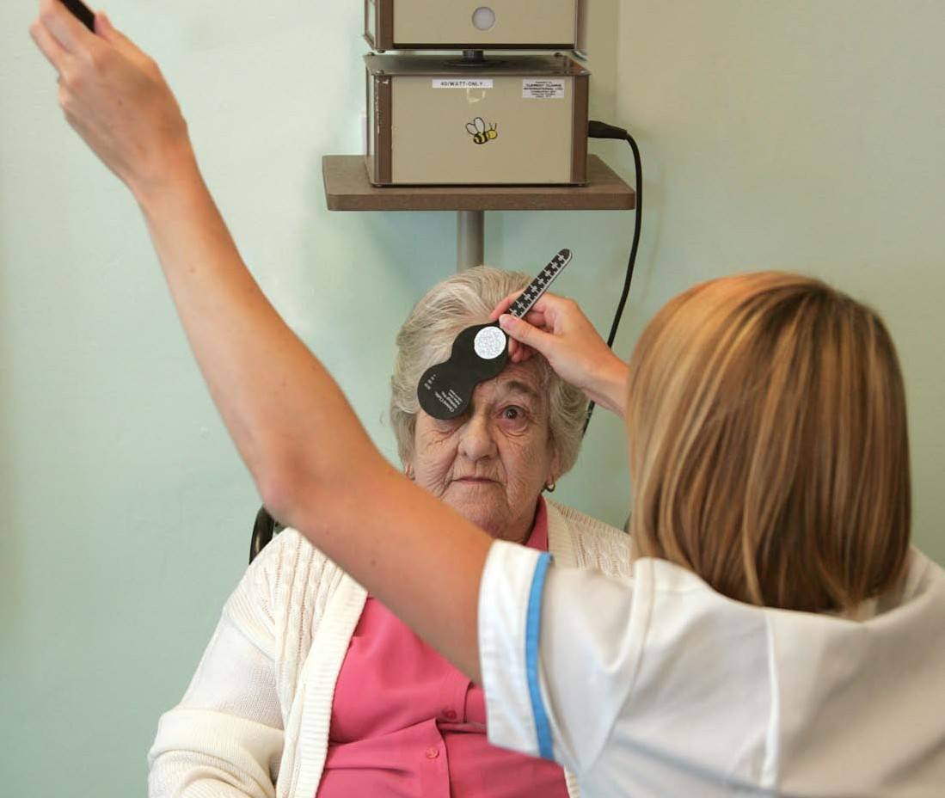

Orthoptist

What skills would someone need to become an Orthoptist?
- What qualifications and training are required to enable someone to obtain this job??
- Who would a Orthoptist work with?

Orthoptist

Skills
- Good communication skills
- Able to relate to both children and adults
- Good organizational skills
- Patience
- Good sense of humour
- Self motivated
- Observant
- Capable of working under your own initiative and as part of a team

Qualifications and training
You will usually need five GCSE passes (or the equivalent) including English, maths and at least one science, and three A levels. Alternative qualifications, including BTEC or access courses will also be considered. This will be followed by a three-year full-time degree course, available at Liverpool and Sheffield universities. Each year
consists of both theory and clinical experience. Following completion of the course you are eligible to apply for the registration necessary to work as an Orthoptist in the NHS.

Key sources of further information:
British and Irish Orthoptic Society – www.britishorthopticsociety.co.uk NHS Careers – www.nhscareers.nhs.uk
University and College Admissions Service – www.ucas.ac.uk Skills for Health – www.skillsforhealth.org.uk

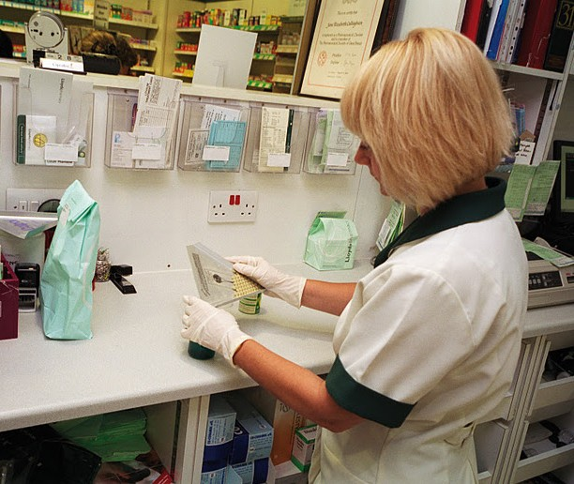

Pharmacist Technician

What skills would someone need to become an Pharmacist Technician?
- What qualifications are required to enable someone to obtain this job??
- Who would a Pharmacist Technician work with?

Pharmacist Technician

Skills
- An ability to communicate widely with colleagues, other health professionals and patients
- Be able to explain information clearly
- Attention to detail
- An interest in science
- Practical Skills
- Be able to deal with figures with an ability to calculate
- Be able to keep information confidential

Qualifications and training
There are no minimum entry requirements, but you would usually need four GCSEs or their equivalent including English, maths and science. You would go on to study on the job to work for a QCF level 2, progressing on to a level 3 qualification to become a pharmacy technician.
This training can be done as part of an apprenticeship.

Who would they come into contact with?
- Other members of the pharmacy team – pharmacists and pharmacy assistants
- Other healthcare professionals possibly in a clinical situation
- Patients

Key sources of further information:
Royal Pharmaceutical Society – www.rpharms.com/careers-in-pharmacy/careers-materials.asp NHS Careers – www.nhscareers.nhs.uk
Skills for Health – www.skillsforhealth.org.uk
National Apprenticeship Service – www.apprentices.org.uk

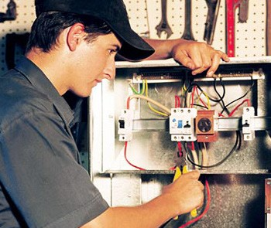

Skilled Trades Staff

What skills would someone need to become a skilled tradesman?
- What qualifications are required to enable someone to obtain this job??
- Who would a skilled tradesman come into contact with?

Skilled Trades Staff

Skills
- Practical Skills
- Interest in the use of tools eg engineering or joinery tools
- Good attendance and time keeping
- Able to work as part of a team
- Able to work under supervision
- Able to communicate clearly both verbally and in writing
- Able to be able to work with figures when appropriate
- Computer literate
- Willing to take on personal responsibility
- Show respect and understanding for patients, staff and fellow workers

Qualifications and training
There are different entry points for people who want to work in the health sector. If an application for an apprenticeship is made, good GCSEs, including English, maths and/or science or their equivalent would be required to enable study for a QCF in the chosen skilled area eg electrical engineering, plumbing or other craft related skill. Some organisations may ask for a pass in an entrance test and interview. There would be an expectation for attendance at a college under day release and experience would be built up under the supervision of the estates and facilities team. It may be possible to progress on to a higher level course such as a Higher National Diploma or a foundation degree or to enter at that level.

Who would they come into contact with?
- Other members of the estates and facilities team
- Other members of the health staff
- They would not have direct contact with patients but they would need to be aware of the patients and visitors and behave appropriately
- Outside companies related to their work area

Key sources of further information: NHS Careers – www.nhscareers.nhs.uk Step into the NHS – www.stepintothenhs.uk
National Apprenticeship service – www.apprenticeships.org.uk Skills for Health – www.skillsforhealth.org.uk
bConstructive – information on construction careers – www.bconstructive.co.uk/
SEMTA – the SSC for engineering – http://www.semta.org.uk/careers qualifications.aspx Summit Skills – the SSC for building services engineering - http://www.goodday.org.uk/Careers/7 Asset skills cover areas such as facilities management and property – www.assetskills.org/

Ward Clerk

What skills would someone need to become an Ward Clerk?
- What qualifications are required to enable someone to obtain this job??
- Who would a Ward Clerk work with?

Ward Clerk

Skills
- Good communication skills on the telephone and in writing
- An ability to deal with people, some of whom may be upset
- IT skills
- An organiser
- Able to plan work well
- An understanding of confidentiality
- A team player, but an ability to work on your own and take the initiative when appropriate
- A willingness to continue to learn
- An ability to work under pressure

Qualifications and training
To enter into an administrative post, no qualifications are essential, but GCSEs in maths and English or equivalent are preferred. Candidates would be able to go for a QCF level 2 and 3 qualification in Business Administration
or customer service. It would be possible to enter with this qualification or it may be possible to undertake an apprenticeship.

Who would they come into contact with?
- Patients
- Patient families and carers
- The ward health team
- Other health professionals from different departments
- Non clinical staff from other departments
- Outside agencies who are in contact with patients or on behalf of patients

Key sources of further information: NHS Careers – www.nhscareers.nhs.uk Skills for Health – www.skillsforhealth.org.uk
National Apprenticeship Service – www.apprenticeships.org.uk

Useful Careers Information – Community Toolkit

- Step into the NHS – aimed at 14-19 year olds, an opportunity to look at careers in the NHS with videos, a diary room and much more.
Visit: www.stepintothenhs.nhs.uk

- NHS Careers – if young people need information only, then the NHS Careers service would be a good starting point. This service does not provide advice and guidance. NHS Careers also offers information and resources specifically for teachers and advisers.
www.nhscareers.nhs.uk

- The Health Learning and Skills Advice Line – is a free helpline service which can provide advice and guidance to anyone considering career options in the health sector. Teachers and advisers can also use this helpline if they need assistance.
Telephone: 08000 150 850

- Skills for Health – website has information on a variety of areas including:

  - Apprenticeships
  - Careers information and advice
  - Independent sector
  - Labour Market infornation
  - Qualifications www.skillsforhealth.org.uk

Other useful websites for further information include:
- NHS Jobs – www.jobs.nhs.uk

- 14-19 – www.direct.gov.uk/en/EducationAndLearning/14To19

- Job Centre plus – www.direct.gov.uk/en/Employment/Jobseekers

Congratulations

would like to present you with a certificate of attendance

