BTEC National Health and Social Care Level 3

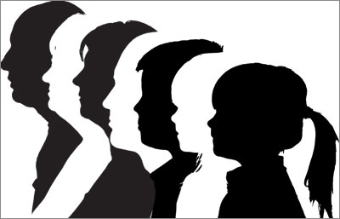

Unit 1: Human Lifespan Development

Essential Content:

|  |  |
| --- | --- |
| A | Human Growth and Development through the Life Stages |
| B | Factors Affecting Human Growth and Development |
| C | Effects of Aging |

**Essential Content A: Human Growth and Development through the Life Stages**

**A1: Physical Development across the Life stages**

Starter: Think of someone you have known for a long time (ideally since they were a child.) How have they changed from when you first met them?

|  |  |  |
| --- | --- | --- |
|  | **Similarities between now and when you first met them** | **Differences between now and when you first met them** |
| **Physically** |  |  |
| **Intellectually** |  |  |
| **Emotionally** |  |  |
| **Socially** |  |  |

Challenge: Why do you think people grow and develop differently?

|  |
| --- |
|  |
|  |
|  |

Sarah is a 1 year old girl who is developing normally. Her health visitor has come to visit her for a one year check. When she was born, Sarah weighed around 3kg, the health visitor finds that she now weighs 9kg. Sarah’s mother mentions that Sarah has recently begun to use words such as ‘dada’ and ‘moo,’ the health visitor says that this is normal language development and Sarah won’t move on to two-word phrases until around 2 years old. Next, the health visitor measures Sarah and finds that she is 74cm long; the health visitor reassures Sarah’s mother that this is normal for her weight and age. Finally, the health visitor gives Sarah some toys to play with and monitors her abilities; Sarah can build a tower with three blocks, point to a picture of a sheep in a book and can sit herself up after lying down.

How has Sarah…

|  |  |
| --- | --- |
| Grown? | Developed? |
|  |  |

Key Terms:

Growth:

|  |
| --- |
|  |
|  |

Development:

|  |
| --- |
|  |
|  |

Principles of Growth:

|  |
| --- |
|  |
|  |
|  |
|  |
|  |
|  |
|  |
|  |
|  |
|  |
|  |
|  |
|  |
|  |
|  |
|  |
|  |
|  |
|  |

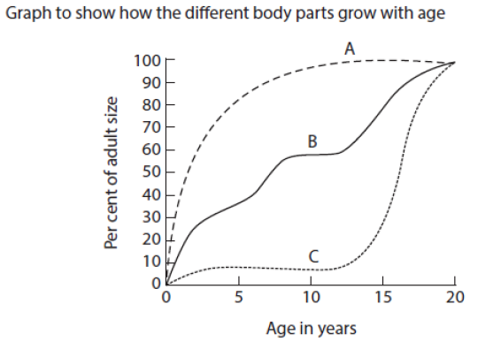Task:

1. Which part of the body is illustrated by lines A, B and C on the graph?

A____________________________________

B____________________________________

C____________________________________

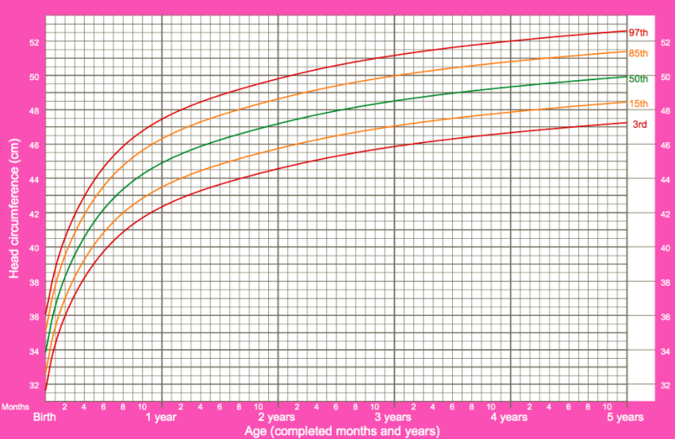

1. Using the graph above answer the following questions:
2. Ella is 1 year 2 months old. She is on the 50th centile line of growth. What is her head circumference? ______________________________
3. Josie is 3 years old and her head circumference is 50cm.

What centile line of growth is she on? _______________________________

What does this mean? ________________________________________________________

___________________________________________________________________________

Principles of Development

|  |
| --- |
|  |
|  |
|  |
|  |
|  |
|  |
|  |
|  |
|  |
|  |
|  |
|  |
|  |
|  |
|  |
|  |
|  |
|  |
|  |

What milestones/developmental norms due you think occur during infancy?

|  |  |
| --- | --- |
| Physical |  |
| Intellectual |  |
| Emotional |  |
| Social |  |

**DON’T FORGET YOU CAN LINK THIS AREA TO GESELL’S MATURATION THEORY**

The Life Stages

|  |  |
| --- | --- |
| Life Stage | Age Range |
|  |  |
|  |  |
|  |  |
|  |  |
|  |  |
|  |  |

Physical Development in Infancy (0-2 years)

|  |  |
| --- | --- |
| Gross Motor Skills Definition | Fine Motor Skills Definition |
|  |  |

Gross and Fine Motor Skill Developmental Milestones

|  |  |  |
| --- | --- | --- |
| Age | Gross Motor Skills | Fine Motor Skills |
|  |  |  |
|  |  |  |
|  |  |  |
|  |  |  |
|  |  |  |
|  |  |  |
|  |  |  |
|  |  |  |
|  |  |  |

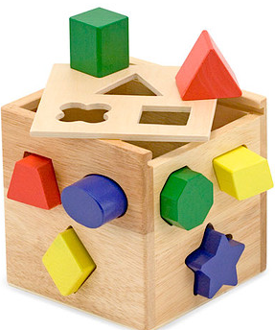Question: How can this toy help improve both gross and fine motor skills for an infant?

|  |
| --- |
|  |
|  |
|  |
|  |

Physical Development in Early Childhood (3-8 years)

Children continue to grow and put on weight during this life stage.

Gross and Fine Motor Skill Developmental Milestones

|  |  |  |
| --- | --- | --- |
| Developmental Milestone | Age | Gross or Fine Motor Skill? |
| Skip |  |  |
| Ride a 2 wheeled bike |  |  |
| Use a knife and fork |  |  |
| Walk along a thin line |  |  |
| Use joined up handwriting |  |  |

Physical Development in Adolescence (9-18 years)

Getting you thinking…

Adolescence is often defined as a period of transition- why do you think this is?

|  |
| --- |
|  |
|  |

How could we define ‘puberty?’

|  |
| --- |
|  |
|  |
|  |
|  |

Primary Sexual Characteristics are…

|  |  |
| --- | --- |
| Males | Females |
|  |  |

Secondary Sexual Characteristics are…

|  |  |
| --- | --- |
| Males | Females |
|  |  |

The Role of Hormones in Puberty

Females Males

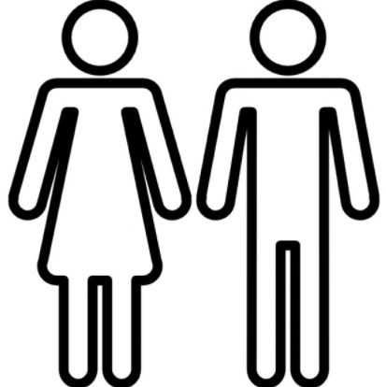

Is Puberty Getting Earlier?

|  |
| --- |
|  |
|  |
|  |
|  |
|  |
|  |
|  |
|  |
|  |
|  |
|  |
|  |
|  |

Physical Development in Early Adulthood (19-45 years)

Young adults are usually at the peak of their physical performance between the ages of 19-28 years old. By this time they are at their full height and strength and have peaked in terms of manual dexterity and reaction time. After this age, adults lose some strength and speed but these declining capabilities are only exacerbated if the adult does not have a healthy diet or take regular exercise.

One of the biggest physical changes in this life stage is pregnancy….

What hormonal changes occur during pregnancy?

|  |
| --- |
|  |

How does the body change during pregnancy?

|  |
| --- |
|  |
|  |
|  |
|  |
|  |
|  |

Challenge: Can you think of specific changes to the breasts? (Hint: They are needed for lactation.)

|  |
| --- |
|  |
|  |
|  |

Perimenopause

|  |
| --- |
|  |
|  |
|  |
|  |
|  |
|  |
|  |
|  |
|  |
|  |
|  |
|  |
|  |
|  |
|  |
|  |
|  |

Physical Development in Middle Adulthood (46-65 years)

Menopause

Women are most fertile (able to conceive children) in their late teens and early twenties. The risk of miscarriage and pregnancy complications rises with age. Between 45-55 years old age, fertility reduces and then comes to an end in a process called the menopause. It can take several years to complete.

The menopause involves:

* Gradual ending of menstruation (or stopping having periods) and a large reduction of fertile eggs in the ovaries.
* An increase in the production of hormones called gonadotropins that try to stimulate egg production, which can cause irritability, hot flushes and night sweats.
* A reduction in the sex hormones (oestrogen and progesterone) produced by a woman’s ovaries, resulting in some shrinkage of sexual organs and sometimes reduction in sexual interest (libido.)
* Associated problems such as osteoporosis, which can be caused by a reduction in the production of sex hormones.

For some women, the general hormone changes, especially reduction in oestrogen levels experienced during the perimenopause and menopause, can lead to mood changes, depression and anxiety. This can make a woman feel that she is on an emotional rollercoaster. Some women experience overwhelming sadness that they are no longer able to have children and this can affect their self-image of being a ‘desirable’ woman. Self-esteem and self-image can become low, which may impact on self-confidence and the quality of life during this transitional stage of the lifespan. Some women may try hormone replacement therapy (HRT) where oestrogen is prescribed in order to replace the decline and relieve the symptoms.

Task:

1. Read through the information above- highlight or underline any key terms.
2. The information concerns how menopause affects women physically and emotionally- use notes in the margin/highlighters/underlining to show which information concerns which area of development.

Challenge:

How is menopause different to perimenopause?

|  |
| --- |
|  |
|  |
|  |
|  |

Other effects of the aging process in middle adulthood:

1._________________________________________________________________________________

2. _________________________________________________________________________________

3._________________________________________________________________________________

4._________________________________________________________________________________

Example Exam Question Responses for Peer Marking

Question: Describe 3 physical symptoms of perimenopause (6 marks)

|  |  |
| --- | --- |
| Student 1 | Student 2 |
| Hot flushes due to a hormonal imbalance in the body can cause the metabolism to increase causing the woman to feel hot frequently when others feel that it is cold. She may feel that her body temperature rises and in the night may experience sweating known as night sweats.  Fatigue; this is when the muscles become overtired and can no longer keep going without more energy. She may feel that she needs to rest more and find everyday tasks exhausting. It is known as crashing fatigue and is caused by changes in the hormonal balance.  Julie will also experience urinary urgency, needing to empty her bladder more frequently. She may also find that her bladder leaks when she coughs or sneezes. | When a woman starts to feel the physical symptoms of perimenopause she may find that she feels fatigue all of the time and she has no energy to work or do anything because she feels drained all the time.  Another symptom is mood swings. This will be confusing for a woman as she may be happy one minute and then angry or sad the next minute.  Another symptom of perimenopause is vaginal dryness so when she wants to have fun in bed with her partner or whatever she will find it uncomfortable. To this extent she may stop doing this activity and do other things instead, this could lead to her avoiding sex altogether. |
| Mark out of 6: | Mark out of 6: |
| Comment/Suggestion for improvement: | Comment/Suggestion for improvement: |
| Examiner’s mark and comment: | Examiner’s mark and comment: |

Physical Development in Later Adulthood (65+)

It is difficult to predict development in old age because, as life expectancy has risen, people’s ideas about what is ‘old’ are also changing.

Life expectancy is an estimate of the number of years, on average, that a person can expect to live. It is sometimes called longevity. Male life expectancy has risen however it is still lower than female life expectancy.

Deterioration of Health

Most body systems continue to function fairly well however, the heart becomes more susceptible to disease. Individuals may begin to lose height in middle adulthood which continues into later life. By the age of 80, individuals may have lost as much as 5cm in height. This is caused by changes in posture and compression of the spinal discs and joints. The aging process also continues with further loss of strength and muscle loss, as well as a reduction in stamina. Mobility (gross motor skills) and dexterity (fine motor skills) become more difficult. There are small changes to the brain which include loss or shrinkage of nerve cells and a general slowing of movement and responses.

Visual and hearing problems may interfere with daily life. Older people can be more susceptible to accidents and falls due to a lack of muscular strength and problems with balance or reaction time.

However, not all older people experience the same deterioration, especially if they have a healthy diet and exercise regularly.

Deterioration of Intellectual Abilities

Aging involves the natural loss of nerve cells in the brain and the reduction in their ability to transmit electrical signals. This doesn’t mean that older people lose their ability to think logically or to reason because they have their life experience to help them. However, older people may have difficulty with memory recall and may feel it takes longer to do things (as if they are ‘slowing down.’) They may also take longer to respond to questions. Furthermore, reaction times may be slower but older people often compensate for these changes, for example by driving more carefully.

Some older people develop more serious diseases and conditions that can affect health and wellbeing; for example Parkinson’s disease and Alzheimer’s disease, are more common in older people. As people are living longer, Alzheimer’s disease has become more prevalent, an early symptom may be mild cognitive impairment (when a person has trouble remembering, learning new skills, concentrating or making decisions that affect their everyday life.)

|  |
| --- |
| Development Mini Quiz (see file)  My score:  Areas requiring more revision: |

**A2: Intellectual Development across the Life Stages**

There are 5 important aspects associated with intellectual development. What are they and why are they important?

|  |  |
| --- | --- |
| Aspect of Intellectual Development | Why is it Important? |
|  |  |
|  |  |
|  |  |
|  |  |
|  |  |

Stages of Intellectual Development across the Lifespan

|  |  |
| --- | --- |
| Stage | Development |
| Infancy and early childhood | Stages of rapid intellectual development |
| Adolescence to early adulthood | Development of logical thought, problem solving and memory recall skills |
| Middle adulthood | Can think through problems and make sound judgements using life experiences. |
| Later adulthood | Changes in the brain can cause short term memory decline and slower thought processes and reaction times. |

Intellectual and Language Skills in Infancy and Early Childhood

|  |  |
| --- | --- |
| **Age** | **Language Development** |
| Around 3 months | Infants begin to make babbling noises as they learn to control the muscles associated with speech |
| Around 12 months | Infants begin to imitate sounds made by carers such as ‘da da’. This develops into single words. |
| Around 2 years | Infants begin to make two word sentences, such as ‘cat goed’ (meaning the cat has gone away.) The infant begins to build their vocabulary. |
| Around 3 years | Children begin to make simple sentences, such as ‘I want drink.’ This develops into the ability to ask questions. Knowledge of words (vocabulary) grows rapidly. |
| Around 4 years | Children begin to use clear sentences that can be understood by strangers but may make mistakes of grammar. ‘We met lots of peoples at the shops’ |
| 5 years | Children use full adult grammar. Although vocabulary continues to grow, most children are using language effectively by 5 years old. |

How can carers promote language development?

|  |  |  |
| --- | --- | --- |
| Infants | Young Children | Adolescence |
|  |  |  |

Piaget’s Theory of Intellectual Development (how children develop logical and reasoning)

* Piaget believed that children passed through a series of stages in cognitive development.
* Although the stages are described in terms of age, Piaget did not claim that all children would reach a stage at a particular time but he did think the sequence of stages was universal.
* Piaget focused his research on how children develop the ability to think; he concluded that children think differently to adults. He theorised that very young children cannot use **abstract logical thinking** (the ability to solve problems using imagination) because they are not mature enough.
* Instead infants use **egocentric thinking** (they understand the world only from their own perspective and cannot imagine that other people will see, hear or feel things differently.)
* At around 7 years old children can use **concrete logical thinking** to solve problems; this means they can use logic as long as they can physically see or handle the issues involved.

Stages of Development

|  |  |  |
| --- | --- | --- |
| Age and Stage | What Occurs?  (How do children think and act?) | Experiment |
| Sensorimotor (0-2 Years) |  | Blanket and Ball Study (1963) |
| Preoperation  (2-7 Years) |  | Three Mountains (1956) |
| Concrete Operational  (7-11 Years) |  | Conservation of Number (1954) |
| Formal Operational  (11+ Years) |  | Pendulum Task (1958) |

The Development of Schemas

An important aspect of Piaget’s cognitive development theory was the idea that children go through a series of stages of intellectual development; he referred to these stages as schemas.

Schemas are cognitive frameworks that help us to organise and interpret information. They are developed through experience and can affect our cognitive processing.

Piaget viewed schemas as the basic unit or building block of intelligent behaviour. He described them as mental structures that help to organise past experiences and provide a way of understanding future experiences. According to Piaget, a schema is a category of knowledge as well as the process of acquiring knowledge.

A child develops concepts about the world around them (a state of **equilibrium**.) As they experience situations where new information is presented, their schemas are upset and they reach a state of **disequilibrium**. As the new information is **accommodated**, the original schemas are modified or changed so they again reach a stage of equilibrium.

Task:

Define these key terms

|  |  |  |
| --- | --- | --- |
| Equilibrium | Disequilibrium | Accommodation |
|  |  |  |

Tests of Conservation

If you are given an exam question about Piaget’s test of conservation, refer back to the ‘conservation of number’ experiment you researched on page 16.

Task

Create a short comic strip or doodle to represent Piaget’s test of conservation:

|  |
| --- |
|  |

Homework:

Shona is 4 years old. Shona’s new school provides children with time for free play to explore a range of natural materials that they can use in construction activities and artwork. There are areas with resources for imaginative and role play, and a natural outdoor area.

In the context of Piaget’s theories of cognitive development, justify free play provision for the children. (10 marks)

*Hint:*

*You need to make clear links between experience-based activities and Piaget’s theory of how children develop their thought processes by accommodating their new experiences.*

|  |
| --- |
|  |
|  |
|  |
|  |
|  |
|  |
|  |
|  |
|  |
|  |
|  |
|  |
|  |
|  |
|  |
|  |
|  |
|  |
|  |
|  |
|  |
|  |
|  |
|  |
|  |
|  |
|  |
|  |
|  |
|  |
|  |
|  |
|  |
|  |
|  |
|  |
|  |
|  |
|  |
|  |
|  |
|  |
|  |
|  |
|  |
|  |
|  |
|  |
|  |
|  |
|  |
|  |
|  |

Has additional A4 paper been used? Yes No

Teacher Feedback:

|  |  |
| --- | --- |
| Link the theory to free play |  |
| Don’t go off topic |  |
| More examples needed |  |
|  |  |

|  |  |
| --- | --- |
| Detailed knowledge of Piaget’s theory |  |
| Good knowledge of Piaget’s theory |  |
| Piaget’s theory is well linked to free play |  |
| Some links between Piaget’s theory and free play |  |
| Identified a criticism of free play |  |
| Some attempt made at answering the question |  |
| A well-structured response |  |



Chomsky’s Model of Language Acquisition

Chomsky believed that the ability to develop a signed or spoken language is genetically programmed into individuals.

This means all individuals have the ability to understand and use language, regardless of their other abilities, and to become fluent in their first language by the age of 5 or 6.

Chomsky states that all individuals are born with a **language acquisition device (LAD**) that allows children to recognise and develop languages- they are pre-programmed to acquire language and it evolves naturally.

Questions:

1. What is the language acquisition device?

___________________________________________________________________________________________________________________________________________________________________________________________________________________________________________________

1. Can language be learned rapidly at any age? Why?

____________________________________________________________________________________________________________________________________________________________________________________________________________________________________________________________________________________________________________________________________

1. What evidence is there for the LAD?

_______________________________________________________________________________________________________________________________________________________________________________________________________________________________________________________________________________________________________________________________________________________________________________________________________________________________________________________________________________________________________________________________________________________________________________________

1. Why can’t children learn language simply through imitation?

____________________________________________________________________________________________________________________________________________________________________________________________________________________________________________________________________________________________________________________________________

1. Challenge: How can Chomsky’s theory of language acquisition be criticised?

__________________________________________________________________________________________________________________________________________________________________________________________________________________________________________________________________________________________________________________________________________________________________________________________________________________________________________________________________________________________________________________________________________________________________________________________________________________________________________________________________________________________________________________________________________________________________________________________________________________________________________

Intellectual Development across Adulthood and Later Adulthood

Early to Middle Adulthood

In early adulthood, individuals apply the knowledge, skills and experience they have gained during their life. This helps them to think logically and find realistic answers. At this life stage, they are likely to be in job roles which require them to think through problems and make decisions, sometimes relating to complex situations. New brain cells will continue to develop even though, in middle adulthood, there may be a gradual decline in the speed of processing information.

Memory Loss in Later Adulthood

The brain produces new brain cells at any age and lifestyle, health activities and daily activities have an impact on the brain. Age-related memory lapses are frustrating but are not always a sign of dementia.

There are different parts of memory, for example procedural (how to do something) and episodic (remembering an event.) These types of memory are most likely to decline with age.

Check your understanding:

Draw a life pathway, labelling each life stage along the route.

You must include: Age ranges for each life stage and one example of physical and intellectual development at each life stage.

**A3: Emotional Development across the Life Stage**

Summary Table:

|  |  |
| --- | --- |
| Life Stage | Emotional Development |
| Infancy  0-2 Years | Attachment:  Bowlby- infants have an inbuilt need to bond with a caregiver.  Securely attached infants grow up with the emotional resources needed to cope with uncertainty in life. |
| Early Childhood  3-8 Years | Understanding self and others:  Children use imagination to understand social roles that other people play.  Begin to imagine a ‘me,’ an idea of self-concept.  Relationships with family members may influence how valued a child feels. |
| Adolescence  9-18 Years | Identity:  Sense of self continues to develop.  Self-esteem may depend on developing identity. |
| Early and Middle Adulthood  19-65 Years | Intimacy:  Self-esteem is influenced by lifestyle (e.g. job, marital status)  Self-image is affected by personal appearance and how others see you.  Need to learn to cope with emotional attachment to a sexual partner. |
| Later Adulthood  65+ Years | Making Sense of Your Life:  Older people need a secure sense of self to cope with physical changes associated with ageing and death. |

Attachment

What is Attachment?

A strong emotional connection between a child and caregiver.

Schaffer and Emerson’s Sequence of Attachment Stages

|  |  |
| --- | --- |
| Age Range | Stage |
| Up to 3 months |  |
| 3-7 months |  |
| 7-9 months |  |
| 9+ months |  |

Factors Affecting Whether an Attachment is Made Easily



Attachment may not go smoothly because of:

Theories of Attachment: Bowlby

Bowlby suggested that children were biologically pre-programmed to form attachments and that infancy is a critical period in which a secure attachment must be formed.

Bowlby observed that children experience separation anxiety (intense distress when separated from their mother.) He said that the child’s distress and anxiety did not disappear when they were being fed by another carer- therefore infant attachment must be about more than just food for survival.

Bowlby believed that attachment evolved from the caregiver providing safety and security for the infant; infants have a universal need to seek out close proximity with their caregiver when under stress.

If attachment is disrupted then the child will suffer long term consequences; these could include delinquency, depression or aggression.

Criticisms of Bowlby

*Schaffer and Emerson*

Babies attach to caregivers that respond effectively to their signals. This is not necessarily the person who spends the most time with them- so it doesn’t have to be their main caregiver. They called this sensitive responsiveness and said that the most important factor in forming attachments is having someone to play and communicate with the baby.

*Rutter*

Argued that maternal deprivation on its own is not enough to lead to long term problems. Instead privation is more damaging; privation occurs when children have not had the opportunity to form any attachments or have a lack of social/intellectual stimulation.

*Learning Theory*

Attachment could be a learned process influenced by the environment, culture and/or the baby’s temperament.

Case Study:

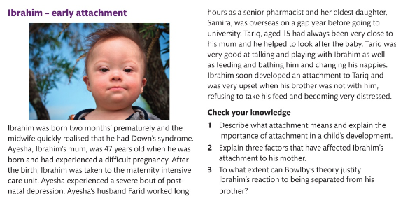

|  |
| --- |
|  |
|  |
|  |
|  |
|  |
|  |
|  |
|  |
|  |
|  |
|  |
|  |
|  |
|  |
|  |
|  |
|  |
|  |
|  |
|  |
|  |
|  |
|  |
|  |
|  |
|  |
|  |
|  |
|  |

Exam Link

Jan is 48 years old, he has a daughter, Anna, who is 18 months old. Jan has been Anna’s main caregiver since she was born and has formed a strong bond with her. Anna will be starting nursery soon and Jan is worried that she may not want to stay at the nursery without him.

Outline the importance of the development of a strong attachment between Anna and Jan before she starts nursery, with reference to theories of attachment. (6 marks)

|  |
| --- |
|  |
|  |
|  |
|  |
|  |
|  |
|  |
|  |
|  |
|  |
|  |
|  |

Types of Attachment

Ainsworth (1978) built on Bowlby’s work. She devised an experiment called the ‘strange situation’ which exposed the infant to both separation and stranger anxiety.

|  |  |  |  |
| --- | --- | --- | --- |
| The Strange Situation | 1. | 2. | 3. |
| 4. | 5. | 6. | 7. |

Types of Attachment

|  |  |  |
| --- | --- | --- |
| Type of Attachment | Explanation | Implications for the Child in Later Life |
| Secure | Distressed when caregiver leaves.  Not comforted by the stranger.  Calms down when care giver returns. | Able to make friends and meet new people.  Adolescents can manage the transition more successfully throughout school. |
| Insecure- Avoidant | Show no preference between caregivers and stranger. | Have difficulty maintaining relationships as have difficulty with emotions. |
| Insecure- Ambivalent | Distress when caregiver leaves.  Avoids stranger.  Child resists contact when caregiver returns. | May have difficulty trusting others in relationships. |
| Insecure- Disorientated (added later) | Displays avoidant or unsure behaviour.  May appear to be in a ‘daze’ | May have trouble with attachments in later life. |

Exam Link

Mark is 3 years old. His parents were alcoholics and Mark suffered from extreme neglect; he was placed into care at 18 months old and has been in several foster homes. Mark has now been accepted into a long term foster placement.

Justify to what extent Mark is likely to experience difficulties in forming relationships in his long term foster placement. (6 marks)

|  |
| --- |
|  |
|  |
|  |
|  |
|  |
|  |
|  |
|  |
|  |
|  |
|  |
|  |
|  |
|  |
|  |
|  |
|  |

The Development and Importance of Self-Concept

What is self-concept?

Self-concept is a sense of identity. It is an awareness that you are a unique individual, different from everyone else. It is formed in early childhood and encompasses self-image and self-esteem.

Definitions and Factors involved in Developing Positive or Negative Self-Esteem

How is self-esteem developed?

Positive self-esteem is an important part of emotional wellbeing. Self-esteem involves both self-confidence and self-acceptance. In children, self-esteem is shaped by what they think and feel about themselves. Children who have high self-esteem have an easier time in relationships, resisting peer pressure, making friends and handling conflicts. Children with a positive self-esteem have a generally optimistic view of the world and their life in general. Babies and infants can achieve a growing sense of self and a positive self-esteem through the attachments they develop with their main caregivers (see below)

|  |  |
| --- | --- |
| Age | Developmental Stage |
| 0-18 months | During infancy, babies start to build self-esteem by having their basic needs met (e.g. love, comfort, closeness.) Babies gradually become aware that they are loved as their primary caregiver provides them with attention, comfort, care and support. This shows the infant that they are important. |
| 18 months- 2 years | Although infants don’t yet have a clear understanding of self-esteem, every time they learn a new skill they learn things about themselves; what they can do, what they look like and where they belong. If infants are shown love by their primary caregivers and treated as special this impacts on their self-esteem. Infants who feel unloved find it more difficult to develop a sense of self-worth and to value themselves. |

By the time a child reaches the age of four, positive self-esteem is reinforced by what the child can do successfully and independently, and also by the feedback they receive from their carers. Parents can encourage self-esteem by teaching problem solving skills and including children in tasks that provide a sense of accomplishment, asking children for their opinions and introducing children to social settings. Parents should also encourage young children to accept failure as a learning experience and not a negative process.

What happens when children have low self-esteem?

Children with low self-esteem can become passive, withdrawn and depressed. They often have difficulty dealing with problems, are very self-critical and speak negatively about themselves. Factors leading to low self-esteem include; bullying, have no friends at school, struggling with schoolwork, sibling rivalry, parental arguing. Children facing these problems become pessimistic, easily frustrated and see temporary problems as permanent issues.

Self-esteem and Puberty

The physical and emotional changes which occur during puberty and adolescence can present new challenges to young people. Fitting in with peer groups and gaining acceptance is very important. Young people use this time to learn from their own mistakes and take responsibility for their actions. Self-esteem can become fragile and changeable. Teenagers may be overly concerned with their appearance and how they are viewed/accepted by peers. Body image is an essential part of young person’s self-esteem; poor body image can equal low self-esteem. Research indicates that low self-esteem at this time can lead to poor school achievement and behavioural problems. It may lead to bullying, teenage pregnancy, smoking, refusing to go to school, depression and thoughts of suicide.

Definitions and Factors involved in Developing Positive or Negative Self-Image

What is self-image?

Self-image is the mental picture, a personal view that an individual has of themselves. It encompasses the characteristics an individual feels that they have (e.g. intelligent, talented, kind, selfish, ugly.) It is more than what an individual looks like or how they are seen by others; it is also how a person thinks, feels and reacts to self-perceived physical attributes.

How does self-image develop?

Self-image is developed in early childhood by the quality of social interaction and the influence of parents or caregivers. A parent who makes positive comments about a child’s appearance in a consistent way lays the foundation for positive self-image. If a parent ignores a child or constantly makes negative comments then this can impact on the way the child begins to see and think about themselves. Experiences with other people (including teachers, family and friends) can reinforce what we think and feel about ourselves. If an individual is being made fun of for the way they look then this can lead to physical and psychological problems.

What physical and psychological problems can occur due to negative self-image?

An individual’s self-image can be a real or distorted view of who they actually are. It does not necessarily reflect reality. Feelings about image can become internalised and affect how an individual acts. During adolescence, physical appearance becomes particularly important because young people have to come to terms with changes in their body shape as well as some unwanted physical changes such as acne. A young person with anorexia or bulimia who is thin may have a self-image in which they see themselves as fat. A negative body image can lead to psychological problems inducing anxiety, eating disorders and depression.

How is self-image affected by life events and social roles?

Life events and social roles influence how others see us and how we define ourselves. Roles such as learner, parent or member of a team not only help other to recognise the status of an individual but also provide guidelines for behaviour (e.g. now I am a parent I should stop smoking.)

Life events and social roles influence personal traits that can also be an important part of self-image; people may describe themselves with these traits; ‘I am impulsive,’ ‘I am caring,’ ‘I tend to worry a lot.’

How does self-image and self-esteem develop in adulthood?

Self-image: Younger people tend to describe themselves in terms of personal traits whereas, older people describe themselves in terms of social status (e.g. I am a midwife, I am a mother.) This may be why older people are so affected by changes to their roles (e.g. through divorce, redundancy or having a child.)

Self-esteem: Self-esteem is not fixed and fluctuates through the life stages. In adulthood, the factors that impact on self-esteem may change. Career development and other personal achievements will increase a person’s self-worth while stress ad life event that are difficult to cope with can result in a lack of confidence and negative self-image.

Homework:

You need to use your booklets, textbooks and the internet to create a leaflet about self-esteem and self-image.

Assignment Brief:

Your leaflet will be titled ‘The Development and Importance of Self-Concept’

You can fold/layout your leaflet in any way you choose

Your leaflet’s audience will be parents attending a local children’s centre: they may have children aged between infancy and adolescence.

You should include the definitions and factors involved in developing positive or negative self-esteem and self-image.

You should use key terminology but explain it in an easy to understand, accessible way.

You could use images to illustrate your points.

**See file for completed leaflet**

Homework Feedback: Marking Criteria

|  |  |
| --- | --- |
| Work has clearly been completed to the best of your ability. |  |
| Some good effort shown in places |  |
| Well done on completing the additional challenge task |  |
| Good understanding of self-image and self-esteem |  |

|  |  |
| --- | --- |
| Work is not complete |  |
| Work is not the best of your ability |  |
| Some key terms are not explained well |  |
| Work is rushed and therefore lacks meaning/understanding |  |

Complete the self-concept exam question on page 30.

|  |  |
| --- | --- |
| **Information included:** | **Mark out of 5** |
| Student has clearly defined the terms self-concept, self-esteem and self-image |  |
| Student has explained how self-esteem and self-image develops across infancy, early childhood and adolescence. |  |
| Student has given advice on how parents can encourage positive self-esteem and self-image |  |
| Student has explained the importance of positive self-esteem and self-image |  |
| Student has explained how low self-esteem and low self-image can have negative effects |  |
| **Challenge Task:** Student has included relevant local or national statistics relating to the effects of positive/negative self-esteem and/or self-image. |  |



Exam Practice

Oscar is 8 years old. He has experienced bullying in school.

Outline how bullying may affect Oscar’s emotional development. 6 marks

|  |
| --- |
|  |
|  |
|  |
|  |
|  |
|  |
|  |
|  |

**A4: Social Development across the Life Stages**

What is social development?

Social development involves learning how to interact socially with other individuals in the family and society in general. Social development provides the opportunities and skills that enable people to develop relationships. Not all individuals will experience social relationships in the same way.

The stages of play in infancy and early childhood

|  |  |  |
| --- | --- | --- |
| Type of Play | Age | Description of Play |
| Solo Play | 0-12  Months |  |
| Solo Play | 12-18 Months |  |
| Parallel Play | 18 months- 2 years |  |
| Associative Play | 3-4 years |  |
| Co-operative Play | 4-6 years |  |
| Co-operative Play | 6-8 years |  |

Questions:

1. What are the potential physical, intellectual and emotional benefits of play?

|  |
| --- |
|  |
|  |
|  |
|  |

1. How does play help social development?

|  |
| --- |
|  |
|  |
|  |
|  |

1. How has play changed over the last two or three generations?

|  |
| --- |
|  |
|  |
|  |
|  |

Task:

Use Piaget’s stages of cognitive development to show how the theory helps to explain the stages of play.

Hint: Consider the importance of senses for infants when they are absorbed in solo play (sensorimotor stage) and of symbolic play and language for children during co-operational play (pre-operational stage.)

|  |  |
| --- | --- |
| Stage of Play | Link to Piaget’s stages of cognitive development |
| Solo Play |  |
| Parallel Play |  |
| Associative Play |  |
| Co-operative Play |  |

Extension:

Now try to link Chomsky’s model of language development in terms of the development of play

|  |
| --- |
|  |
|  |
|  |
|  |
|  |
|  |
|  |
|  |
|  |
|  |
|  |
|  |
|  |
|  |
|  |
|  |
|  |
|  |
|  |
|  |
|  |
|  |
|  |
|  |

The Importance of Friendships and Friendship Groups

Questions:

1. What are the social benefits of friendships?

|  |
| --- |
|  |
|  |
|  |
|  |
|  |
|  |
|  |

1. Why do people lose friendships?

|  |
| --- |
|  |
|  |
|  |
|  |
|  |
|  |
|  |

1. What effect does peer pressure have on social development?

|  |
| --- |
|  |
|  |
|  |
|  |
|  |
|  |
|  |

1. What is the difference between formal and informal relationships?

|  |
| --- |
|  |
|  |
|  |
|  |
|  |
|  |
|  |

1. How do young children develop friendships?

|  |
| --- |
|  |
|  |
|  |
|  |
|  |
|  |
|  |

Challenge:

6a. Mia is 15 years old. Her parents have recently divorced and now she must move to a new area and a new school. Why would it be beneficial for Mia to make friends at her new school?

|  |
| --- |
|  |
|  |
|  |
|  |
|  |
|  |
|  |

6b. Mia’s new friends are pressuring her to smoke and involve herself in underage drinking. Why is Mia likely to conform to her friends’ behaviour?

|  |
| --- |
|  |
|  |
|  |
|  |
|  |
|  |
|  |

Fill in the gaps

The Development of Social Relationships:

|  |  |
| --- | --- |
| Life Stage | Social Development |
| Infancy  0-2 Years | Interacting with Carers  Infants appear to have an in-built tendency to interact with carers. By 2 months they may start to smile at human faces. At 3 months, they will respond when adults talk. At 5 months, infants can distinguish between familiar and unfamiliar people. Infants, make their first relationships as they form an emotional _______________________ to carers. In the later stages of infancy, infants will _________ alongside other children (this is called _________________ play.) |
| Childhood  3-8 Years | First Social Learning  Young children are emotionally attached and dependent on the adults that care for them. Children begin to learn social __________ and behaviour within their family context (first or primary socialisation). A family environment might provide a safe base from which to explore social relationships with other children through play. Children will learn to co-operate with each other (______________ play.) As children grow older they become increasingly _______________ and begin to form relationships based on a sense of mutual trust. Friendships become increasingly important as children grow towards adolescence. Children may form social networks or circles of friends who like and agree with each other. |
| Adolescence  9-18 Years | Secondary Social Learning  During adolescence a person’s sense of _____________ may be more influenced by their peers than by their ______________. Adolescents copy the styles of dress, beliefs, cultural values and behaviours of their own network. Adolescence can by a time of stress and adolescents have to cope with the development of their own sexuality (the impact of sex ______________ at puberty) and the social transition to full independence from the family. Recent research suggests that this transition is likely to be smooth with little conflict with parents. |
| Adulthood  19-65 Years | Maturity  During early adulthood, friendship networks continue to be very important. For most people, early adulthood is dominated by forming intimate partnerships and by the need to find employment/establish a career. For many people, ____________and ______________ represent major social development in their life.  In middle adulthood individuals experience time pressures that may limit their social activity. Mature adults may have to split their time between work, caring for parents, other family commitments and wider social activities. Some adults report a reduction in the amount of social activity due to these pressures. |
| Older Adulthood  65+ Years | Following retirement, older adults have more free time to develop friendships through taking up new hobbies, pastimes and travel. Others may choose to increase their involvement with close friends and family rather than extend their network of social contacts. |

The Development of Independence through the Life Stages

|  |  |
| --- | --- |
| Stage of Life | Independence |
| Infancy and Childhood | In infancy, young children are totally dependent on others for their care but, towards the end of this life stage, they begin to assert their need to become independent and attempt to do more for themselves. This comes with increased skills and abilities in dressing and feeding themselves. In early childhood, although still very dependent on parents and carers, they are widening their experience- starting school and joining clubs and activities. Children gradually become less reliant on close family and start to make their own decisions. Initially, these may be limited to activities, food choices or which clothes to wear but, by the time they reach the end of this life stage, they will have developed clear likes and dislikes. |
| Peer Influence in Adolescence | In adolescence, young people begin to question their sense of identity and begin to see themselves as separate and independent from their family. Young people may begin to question their family’s values and become influenced by peer group norms and values. Peer influence can lead young people to question choices that have been made on their behalf. Young people can learn from real-life experiences about the consequences of making good or poor choices. |
| Starting Employment | Between the ages of 16 and 18, young people begin to make important decisions about their career options. They need to be realistic and empowered to make informed choices about their future career prospects. Starting employment is an important transition and is effectively the first step into an adult world as their status changes from learner to employed worker. It is important to adapt from the rules and routines of a school/college/university day to the policies and procedures of the workplace. The financial independence associated with starting employment is also a step towards full independence. Managing finances, from reading a wage slip, opening a bank account to developing budgeting skills are all important aspects of becoming independent. |
| Leaving Home | There is a clear relationship between leaving home, independence and adulthood. At some stage in their early 20s many young people decide to leave their family home. Although many now stay at home longer, because they are studying, unable to work or cannot afford to live independently. Leaving home could mean making certain sacrifices such as a lower standard of living. While this allows for a new level of independence and self-reliance, juggling household chores with work and managing household bills require young adults to develop a new set of skills. |
| Starting a Family | A new status and responsibilities associated with starting a family may be an important aspect of developing independence. Developing parenting skills and becoming part of a new family unit can provide a sense of identity and a feeling of achievement. Becoming a parent requires lifestyle changes and sometimes financial difficulties. New parents must put the needs of the new baby before their own, which can involve making sacrifices. For instance, a parent may choose to put their career on hold or change working patterns and this can impact on financial and emotional independence. Although family members may be able to offer support, the ultimate responsibility is with the new parents. |
| Middle Adulthood | People often have fewer family responsibilities and they can more easily pursue their hobbies and interests. Individuals in this life stage are more likely to reach the peak of their career and they may have more disposable income that gives them more independence, choice and freedom; leading to more travel and establishing new social networks. However, changes to the pension system may result in individuals working longer or taking on part-time work when retired. Furthermore, many people act as carers for grandchildren or provide support for elderly parents. |
| Older Adulthood | After retirement (between 65-75 years old,) many older people enjoy a busy social life due to freedom from their career. Many older people take advantage of free bus passes and concessionary entrance costs; this means independence can be maintained in later life. The internet and social media makes it easier to explore new interests and relationships However, some older people begin to disengage from society, especially if spouses and friends have died. Furthermore, accidents and illness may lead to relying on others for care. |

Task:

Create a timeline of factors affecting independence to show how it changes over the life span

Infancy and Early Childhood

Later Adulthood

Middle Adulthood

Early Adulthood

Adolescence

Case Studies:

Are these people independent? What factors affect independence?

Isabelle is 4 months old. Her parents care for her needs by feeding, bathing and changing her nappies. Her mother takes her to baby play group.

Marley is 5 years old. He puts his uniform on without help each morning and chooses his own pyjamas at night. He has free school meals and chooses what he wants from the canteen. Marley does not like vegetables, he doesn’t eat them when he is at school but his parents make him eat them at home.

Debbie is 31 years old and she has recently given birth to a daughter. Before giving birth, Debbie regularly went to the gym and took part in an amateur dramatics group on weekends. Debbie has been to the gym once since her daughter was born as she struggles to get a babysitter.

Louisa has recently had a baby. Louisa describes being a mother as ‘an important part of her identity’ and believes that becoming a parent has taught her a lot about herself. Louisa has given up work and the household has had to make many financial sacrifices as a result of the reduced income.

Mark is 16 years old. He will be leaving school in 5 weeks and will be beginning an apprenticeship in September. The apprenticeship will mean that Mark earns a small wage however, he must attend his work placement from 8-5 every day.

Phil is 48 years old. He works from 8-5 everyday however, he is well paid and enjoys several holidays a year. When Paul’s teenage son moved out of the family home Paul has turned his son’s old bedroom into a hobby room for his model trains. However, he keeps a spare bed so that his grandson can come and stay at the weekend.

Millie is 55 years old. She works as a shop assistant and would like to retire; however, the Conservative changes to the pension system mean that Millie cannot retire for another 10 years. Millie’s mother is disabled and so Millie goes to her house each evening to make her dinner and leave breakfast and lunch in the fridge for the morning.

Steven is 15 years old. He does not like school and regularly truants. Steven’s friends drink alcohol and pressure Steven to do the same.

Mabel is 70 years old. She is physically well and able to get around easily due to her free bus pass. Mabel enjoys visiting museums and is pleased that she only pays concessionary fare and can visit during the week when it is quieter. Mabel has a Facebook account and uses the chat function to speak to her children and see pictures of her grandchildren.

Terry is 82 years old. He is physically disabled and requires a wheelchair to get around. Terry’s council house is no longer suitable for his needs as he cannot get upstairs and there is no tracking for his hoist. The council has no disabled access flats available in Terry’s area therefore he must move 40 miles away to live in a house suitable for his needs. Terry’s son has offered to pay for a place in a care home so that Terry can live close to family.

Extension:

What aids and adaptations are available for older people and how can they be accessed?

Explain 3 examples you find on the internet and explain the different ways of accessing them.

|  |
| --- |
|  |
|  |
|  |
|  |
|  |
|  |
|  |
|  |
|  |
|  |
|  |
|  |
|  |
|  |
|  |
|  |

**Essential Content A Complete**

Reflection Point:

|  |  |
| --- | --- |
| Where am I? | Student Comment: |
| I am up to date with my work booklet- no gaps |  |
| I have identified any areas which require clarification. |  |
| I have attended lunchtime intervention (if needed) for extra help |  |

Revision Questions:

1. Daisy and Alfred are 70 years old. What life stage are they in? What changes may occur in their life stage?
2. Aaron is 3 years old. What life stage is he in? What type of play might he engage in and what are the benefits?
3. Bhavisa is 14 years old. What changes will occur to her in her life stage?
4. Define ‘self-concept’ and outline two factors that can affect it.

**Essential Content B: Factors Affecting Human Growth and Development**

**B1: The Nature/Nurture Debate**

Revision Point:

You have already covered several theories of human development. Did these theories believe development/behaviour was influenced mainly by nature or nurture?

|  |  |
| --- | --- |
| Theory: | Nature or Nurture? Why? |
| Piaget’s theory of cognitive/intellectual development |  |
| Chomsky’s language acquisition hypothesis |  |
| Bowlby’s theory of attachment |  |
| Shaffer and Emerson’s stages of attachment |  |

What is the nature/nurture debate?

**Nature** refers to genetic inheritance and other biological factors, whereas **nurture** refers to external influences on development such as the environment you grow up in, social influences and economic factors. There is great debate about which of these influences has more impact on human development and behaviour.

Characteristics and differences not observed at birth but which emerge later in life, are referred to as **maturation**. The ‘nature’ perspective is based on an assumption that all individuals have an inner biological clock that determines when and at what rate physical development will progress.

Development as a Result of Genetic or Inherited Factors

Gesell’s Maturation Theory

Gesell developed a new way of studying child development- called the normative approach. He observed large numbers of children to find the skills and abilities that most children had in each age group.

His findings were used to establish ‘norms’ or milestones for each developmental aspect.

Gesell came to the conclusion that each child moves through the sequence at their own pace but that development was predetermined with little influence from the environment.

If a child experiences delayed development, then the problem is hereditary rather than the result of the child’s environment and circumstances.

Exam Link:

Anna is 18 months old. Anna’s growth and development are being monitored by a health visitor.

Discuss the importance of monitoring Anna’s growth and development, with reference to centiles and maturation theory. (10 marks)

*The health visitor will measure Anna’s height and weight and check these against centiles that show the average for girls of Anna’s age. He or she will plot this on a ____________________________. If Anna is growing more slowly or quickly than expected, the health visitor will____________________________________________________________________________________.*

*Maturation theory was developed by observing the abilities and skills of large numbers of children at different ages. The information was used to determine norms called _______________________ that children reach at a given age. The health visitor can apply them when she or he_______________ and ______________ development.*

*The health visitor can use the information from the assessments to identify _________________________*

*________________________________.*

*Using information that shows the expected norms for children is important because it will enable to health visitor to________________________________________________________________________________*

*_______________________________________________________________________________________.*

Can you complete the essay?

Extension and Challenge:

Critics of Gesell suggest that maturation theory is not helpful in explaining individual or cultural differences or for children with learning difficulties.

Research how cultural differences or learning difficulties affect milestone development and summarise your findings below:

|  |
| --- |
|  |
|  |
|  |
|  |
|  |
|  |
|  |
|  |
|  |
|  |
|  |
|  |
|  |
|  |
|  |
|  |
|  |
|  |
|  |
|  |
|  |
|  |
|  |
|  |
|  |
|  |
|  |
|  |
|  |
|  |
|  |
|  |
|  |
|  |
|  |
|  |
|  |
|  |
|  |
|  |

Development as a Result of Environmental Factors

Bandura’s Social Learning Theory

Bandura theorised that we don’t need to be directly reinforced; he thought that humans learn through the observation and imitation of others.

This makes sense as young children often model behaviours they have seen (e.g. pretending to be on the phone, dance moves or aggression.)

Bandura’s theory is based on his famous ‘bobo doll’ studies:

Task:

Create an annotated picture of what happened in the Bobo doll studies…

Bandura suggested that there are 4 stages of behavioural learning:

1. The child notices the behaviour of another person (usually someone close to them or that they admire.)
2. The child internalises the action by remembering what they have observed.
3. Although they may not copy the behaviour straight away, they will copy it when the opportunity occurs.
4. Finally, depending on the outcome (punishment or reinforcement,) children will either repeat the behaviour again or stop.

Task: Read through the case study below.

|  |  |
| --- | --- |
| Tilly is 4 years old and her brother Stephen is 8 years old.  Stephen has a pet rabbit and, when he cleans it out, his mum gives him a star on his rewards chart. Tilly doesn’t have to clean out the rabbit but she sees Stephen getting ready to do it and decides to help him. Tilly then gets a star on her reward chart as well.  Stephen doesn’t like peas, he refuses to eat them at dinner time and throws his plate on the floor. | Why is it important that Stephen models good behaviour for Tilly?  __________________________________________  __________________________________________  __________________________________________  __________________________________________  __________________________________________  __________________________________________  __________________________________________  __________________________________________  __________________________________________  __________________________________________ |

Development as a Result of Both Nature and Nurture

Stress-Diathesis Model

It is extremely unlikely that personality traits and behaviour are solely due to genetic inheritance or social learning.

The stress-diathesis model explains how stress caused by life events (nurture) can interact with an individual’s genetic vulnerability (nature) to impact on their wellbeing.

According to this theory, individuals are born with certain biological or genetic pre-dispositions towards mental illness (this is called **diathesis**.) However, a person with a genetic pre-disposition towards a disorder may never develop the disorder if they do not experience stress in their life (e.g. abuse, family conflict or problems at school.)

High levels of stress could trigger the onset of a disorder for those with a predisposition.

Task:

Frank is 38 years old and works as a police officer. His job is very difficult and Frank is often tired due to working different shifts. Frank has been married for 6 years; he enjoys jogging with his wife and she is supportive in talking and listening to him.

Frank’s wife is concerned about his mental health; Frank’s father died of prostate cancer last year and Frank has been missing meals and using sleeping tablets. Frank eventually saw the GP and was diagnosed with depression; the GP prescribed medication which Frank is taking as directed.

How might the nature versus nurture debate help to explain Frank’s health and development?

|  |
| --- |
|  |
|  |
|  |
|  |
|  |
|  |
|  |
|  |
|  |
|  |
|  |
|  |
|  |
|  |
|  |
|  |
|  |
|  |
|  |

**B2: Genetic Factors that Affect Development**

What does it mean to have genetic predisposition towards a certain condition?

A predisposition is the possibility that you will develop a certain condition. A genetic predisposition means that you inherit that possibility from one or both of your parents.

There is no way of changing the genetic make-up that pre-disposes these conditions, however, that doesn’t mean it is a certainty that the condition will develop.

Altering environmental factors and receiving support and treatment can allow individuals to develop and lead life as healthily as possible.

There are some inherited conditions, some rarer than others, that have serious consequences for a child’s growth and development- you need knowledge of these for the exam.

|  |  |  |  |
| --- | --- | --- | --- |
| Condition | Description | Effects on Health and Development | Treatment? |
| Cystic Fibrosis |  |  |  |
| Brittle Bone Disease |  |  |  |
| Phenylkentonuria (PKU) |  |  |  |
| Huntington’s Disease |  |  |  |
| Klenfelter’s Syndrome |  |  |  |
| Down’s Syndrome |  |  |  |
| Colour Blindness |  |  |  |
| Duchenne Muscular Dystrophy |  |  |  |
| Susceptibility to disease such as cancer, high blood pressure and diabetes. |  |  |  |

Biological Factors that affect Development

The environment inside a mother’s womb can have a dramatic influence on a child’s development. If a woman smokes or drink alcohol during pregnancy, foetal development may be affected. The nicotine inhaled in smoking contains carbon dioxide which gets into the blood stream restricting the amount of oxygen to the foetus. Children born to mothers who smoke tend to weigh less at birth and are more prone to infections and are twice as likely to die of cot death. It can affect a child’s long term development including their attention span and learning abilities. Taking drugs and getting some types of infection can also damage a child’s development in the womb.

Foetal Alcohol Syndrome

* **Foetal alcohol syndrome** is the name for a condition that occurs as a result of the mother drinking during pregnancy. The foetus is unable to break down the alcohol that crosses the placenta. This affects the amount of oxygen and nutrients required for brain and organ development.
* As well as characteristic facial features such as small or narrower eyes or a smaller head, the child with FAS may also have learning disabilities, difficulties with language or problems with memory or attention. Specifically, they may struggle to translate thinking into speaking due to not developing reasoning at an appropriate age. They may not develop full vocabulary as an adult due to not being able to assimilate language spoken by others. They may have poor short term memory due to inability to process the information.

Maternal Infections in Pregnancy

* If a pregnant woman is exposed to or gets an infection such as rubella (a type of measles) or cytomegalovirus (a herpes-type virus) the foetus may be negatively affected.
* **Rubella** is particularly dangerous during the first month of pregnancy- if a mother is infected during this time then the baby may be born with impaired hearing/eyesight or a damaged heart. Most women are vaccinated to prevent this.
* **Cytomegalovirus** (CMV) is a common virus belonging to the herpes family and it spreads via bodily fluids. Most people contract CMV at some point and have no symptoms but if it is passed to a foetus it is referred to congenital CMV and a small percentage of babies born with this develop deafness and learning difficulties.

Lifestyle/Diet during Pregnancy

* Babies are affected by what their mothers eat during pregnancy and breastfeeding.
* Recent research suggests that if a woman has a high fat/sugar diet it can result in an increased risk of high blood cholesterol and later heart disease for the child.
* Malnutrition or a lack of healthy food during pregnancy may result in a lifetime of poor health for the child.
* The **Food Standards Agency (FSA)** recommends that pregnant women should eat plenty of fresh fruits and vegetables, plenty of starchy foods (e.g. bread and pasta,) food rich in protein (e.g. lean meat, chicken and fish,) plenty of fibre and foods containing calcium such as milk and cheese. Women should also avoid alcohol and too much caffeine as it can lead to low birth weight.

Congenital Defects

* **Congenital** means ‘present at birth.’ Congenital defects are the most common cause of childhood illness, disability and death. About 9 in every 1000 children in the UK are born with congenital defects; the most common are heart defects, Down’s syndrome and neural tube defects (defects of the brain, spine or spinal cord e.g. spina bifida.)
* Congenital defects may be genetic but other factors can also be responsible e.g:
  + Socio-economic factors- e.g. lack of sufficient nutritious food during pregnancy
  + Environmental factors- such as working/living in polluted areas, exposure to chemicals or pesticides, excessive use of tobacco, alcohol and drugs during pregnancy
  + Infectious diseases during pregnancy- such as syphilis and rubella.

Some congenital defects can be prevented by adequate antenatal care including screening, vaccination and adequate intake of nutrients (especially folic acid.)

Extension:

Is enough information given to pregnant women about the effects of these biological factors on development? Complete some research and summarise your findings.

|  |
| --- |
|  |
|  |
|  |
|  |
|  |
|  |
|  |
|  |
|  |
|  |
|  |
|  |
|  |
|  |
|  |
|  |
|  |
|  |
|  |
|  |
|  |
|  |
|  |
|  |
|  |
|  |

**B3: Environmental Factors that affect Development**

Exposure to Pollution

Air and water pollution can influence development and be a major source of ill health. There is growing concern about the impact of air quality, both indoors and outdoors, and the contribution it makes to causing particular illnesses such as asthma and other respiratory problems. The environment may contain many chemicals (e.g. carbon monoxide) from vehicle exhaust systems and industrial emissions; people who live near busy roads may be particularly exposed to this pollution Household **pollutants** (substances that contaminate air/water and may make it unsafe) include mould and some cleaning products that emit poisonous gases.

How has air pollution improved?

Power stations are burning less coal, which has contributed to a fall in sulphur dioxide pollution. Improved vehicle technology, such as catalytic converters, has also contributed to a reduction in air pollution.

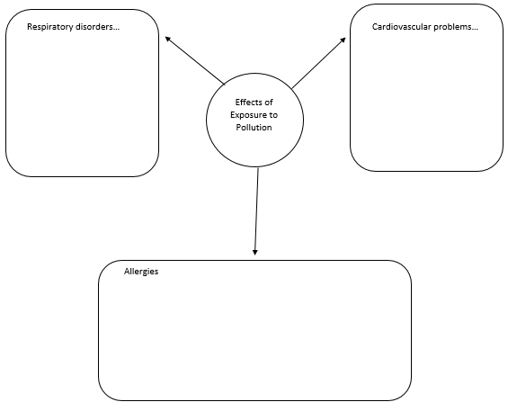

Poor Housing Conditions

Evidence suggests that living in poor housing increases the risk of respiratory and cardiovascular disease, as well as anxiety and depression. A cold damp home with excessive mould and structural defects presents many different risks to health and wellbeing, including accidents and illness.

Overcrowded housing may limit people’s access to washing, cooking and cleaning facilities. Indoor air pollution, drying clothes indoor and inadequate ventilation can be associated with respiratory disorders. Infection is more easily spread in overcrowded conditions with inadequate sanitary provision. There may also be issues with the lack of access to outdoor exercise and green spaces in some low income areas, reducing opportunity for physical activity outdoors. The Child Poverty Action Group (2013) reported more play areas in deprived areas in the UK, but poorer quality spaces and equipment, vandalism, playground misuse and danger of injury being deterrents to their use.

Respiratory Disorders

Anxiety and depression

Cardiovascular Problems

Hypothermia

Access to Health and Social Care Services that affect Development

According to National Institute for Health and Care Excellence (NICE,) local authorities need to improve services for people who do not usually use health and social care services. Each local authority has to ensure multi-agency and partnership working within health and social care services to meet the needs of people who live in the local community.

In line with the Equality Act (2010) all health and social care services should be inclusive and have a positive impact on local people and communities. The local authority has a responsibility to identify barriers to accessing services. These could include transport, opening times, cultural and behaviour barriers. Additionally new ways of supporting people who would not normally access services needs to be identified.

|  |  |
| --- | --- |
| Groups that struggle to access HSC services… | Why is it important that they do access services? |
| Homeless people |  |
| Travellers |  |

Difficulties in accessing services:

|  |
| --- |
| Availability of Transport |
| Opening Hours of Service |
| Needs and Requirements of Particular Services |

Homework:

Using the information given about Julia and your own knowledge, discuss how **both** genetic factors **and** the environment may account for Julia’s current state of health. (10 Marks)

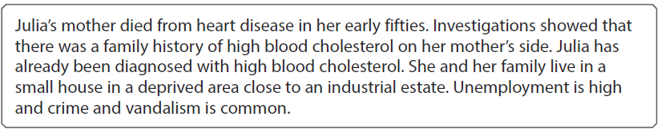

|  |
| --- |
|  |
|  |
|  |
|  |
|  |
|  |
|  |
|  |
|  |
|  |
|  |
|  |
|  |
|  |
|  |
|  |
|  |
|  |
|  |
|  |
|  |
|  |
|  |
|  |
|  |
|  |
|  |
|  |
|  |
|  |
|  |
|  |
|  |
|  |
|  |
|  |
|  |
|  |
|  |
|  |
|  |
|  |
|  |
|  |
|  |
|  |
|  |
|  |
|  |
|  |
|  |
|  |
|  |
|  |
|  |
|  |
|  |
|  |

Has additional A4 paper been used? Yes No

Teacher Feedback:

|  |  |
| --- | --- |
| Link to key theories |  |
| Don’t go off topic |  |
| More examples needed |  |
| Try to weigh up pros and cons of each explanation |  |
| Lack of technical language |  |

|  |  |
| --- | --- |
| Identified correct genetic factors |  |
| Identified correct environmental factors |  |
| Able to discuss how factors work together |  |
| Linked to theory |  |
| Some attempt made at answering the question |  |
| A well-structured response |  |



**B4: Social Factors that affect Development**

Family Dysfunction

A dysfunctional family is one which does not provide all of the support and benefits associated with being in a family. There are many reasons a family may become dysfunctional; family members may become stressed because of health problems including mental health problems, poor housing and low income. Some adults have poor parenting skills. Some may try to control other family members in aggressive or manipulative ways. Others may be insufficiently involved with their children and neglect them. Some parents may be inconsistent in the way that they teach children to behave socially and may have grown up within a dysfunctional family themselves and have little practical experience of providing appropriate relationships and support for other family members. Stressful family environments may disadvantage children. It may be hard to develop self-confidence if there are constant emotional tensions at home.

Task:

Read through these family case studies; what impression do you get about the parent’s style of parenting? What kinds of behaviour would you expect to see from the children? How do you think the children will cope when they attend school or attend a play setting?

|  |  |
| --- | --- |
| Case Study | Your Thoughts |
| Layla is 3 years old and her brother, Parnell, is 6 years old. The children have a chore chart at home; Layla must make her bed, put away her toys and feed their cat every day. Parnell must make his bed, put away his toys and help wash the dishes after dinner each evening. Layla and Parnell get stickers on their chart when they complete their chores each day and, once they have filled a week’s worth of stickers, they get pocket money at the end of the week. Yesterday, Layla had a tantrum, she threw her toy car and broke it. Layla was given a ‘time out’ in her bedroom and her parents explained that she would need to use her pocket money to replace her toy car. |  |
| Mason is 10 years old. He lives with his mother and a baby brother. Mason is told to go to bed at 8pm each evening but there is no bedtime routine and he often ignores his mum. Mason gets frustrated with his brother and punches the wall; his mother says she doesn’t want to punish him because she knows it is hard that he doesn’t see his dad. |  |
| Xander is 13 years old and lives with his parents. Before school each day he must feed and walk the dog, clean his bedroom and wash the breakfast dishes. After school, Xander must complete homework and silent revision for 2 hours. Xander once lied to his parents and said he had no homework, when they found out Xander’s x-box was confiscated for 1 month and he was not allowed to eat with the family at mealtimes. |  |

Parenting Styles

**Baumrind** identified three different parenting styles that she felt could contribute to the overall development of children.

1. **Authoritative**: Parents are not overly strict; children are brought up to respect authority and develop appropriate values and boundaries. Children in these households are often more resilient and conform more easily to the social norms of society.
2. **Authoritarian**: Parents have very high expectations, often overwhelming their children with strict rules and regulations. Children in these households are often rebellious and may become problematic both in the family home and in wider social settings.
3. **Permissive**: Parents make few demands and may be reluctant to implement rules or values into the lives of their children. Children in these households often lack a sense of self-control as they have no set boundaries or respect for personal space- children may later experience problems in managing relationships and adult responsibilities.

A fourth parenting style (called **uninvolved parenting**) was identified through further research. This type is characterised by parents who are not involved in their children’s lives. They make few demands of them and lack responsiveness.

Task:

Create a case study that illustrates uninvolved parenting

|  |
| --- |
|  |
|  |
|  |
|  |
|  |
|  |
|  |
|  |

Parental Divorce or Separation

Parental divorce can be associated with negative outcomes and children/adolescents can experience emotional problems that may affect their self-esteem and self-confidence, leading to emotional distress, moodiness and depression. Children and adolescents may lack resilience, placing greater resilience on and being influenced by their peers. Additionally, there is some evidence that children of divorced parents are more likely to experience poverty and underachievement in education.

Sibling Rivalry

In his social learning theory, Bandura explored the impact of role modelling and imitating behaviour. Constant exposure to high levels of family conflict, especially in dysfunctional families, could lead to a child becoming aggressive and displaying bullying behaviour towards other children in the family. Research by Rosenthal and Doherty (1984) suggests that children who are in rivalry with their siblings or involved in bullying behaviour have quite often been bullied by their primary carers. This can be a way of children trying to gain a sense of control and power in a household in which they feel helpless and powerless. Parents or primary caregivers may also be responsible for deliberately or inadvertently causing sibling conflict by encouraging competition, and sometimes conflict, between siblings.

Example exam question responses for peer marking.

Julia and her husband divorced when Sarah was five. Outline how this divorce may have affected Sarah’s emotional development. (6 marks)

|  |  |
| --- | --- |
| Student 1 | Student 2 |
| Sarah’s emotional development might have been affected by the divorce as it might have made her feel insecure so that she doesn’t feel she can trust people. This is because she feels that her parents have broken their trust with each other and with her. Sarah might also feel that other people will let her down. Sarah could feel that the divorce is somehow due to something she did wrong and could feel guilty. This could reduce her self-esteem she might feel that she has to take sides and this will worry her as she loves both parents and doesn’t want to upset them. | Sarah might feel alone and like her parents let her down, due to them not staying together to ensure she has a good easy life. However, she may feel more happy due to there being less arguments in her home. |
| Mark out of 6: | Mark out of 6: |
| Comment/Suggestion for improvement: | Comment/Suggestion for improvement: |
| Examiner’s mark and comment: | Examiner’s mark and comment: |

Extension and Challenge:

Research what Erikson believed about the effects of family dysfunction and parental influence.

(Hint: It involves emotional intelligence.)

Write up your research and include it in your file.

Exam Link:

Noah is 4 years old, he is currently the youngest member of the family and has a close relationship with his mother. Noah’s mother is 5 months pregnant. Outline why it is important that his parents encourage a good relationship between Noah and his new sibling. (4 marks)

|  |
| --- |
|  |
|  |
|  |
|  |
|  |
|  |
|  |

Bullying

What is the definition of bullying?

|  |
| --- |
|  |
|  |
|  |
|  |

What are the different forms of bullying?



Different forms of bullying

How does bullying affect development?

|  |  |  |  |
| --- | --- | --- | --- |
| Physical | Intellectual | Emotional | Social |
|  |  |  |  |

Individuals may be bullied for many reasons, for example their religion, race or particular group or culture they belong to. Bullying can have long term effects on self-esteem, lasting even into adulthood. The Department for Education provides advice and guidance to educational settings about how to deal with bullying behaviour that includes measures to prevent bullying and that clearly outlines the steps that must be taken to support young people. The workplace should also have procedures to report and deal with bullying.

Extension:

Find your school anti-bullying policy online; how is it dealt with? Next, research a workplace anti-bullying policy; how is it dealt with? Do you think either policy treats bullying seriously enough?

|  |
| --- |
|  |
|  |
|  |
|  |
|  |
|  |
|  |
|  |
|  |
|  |
|  |
|  |
|  |
|  |
|  |
|  |
|  |
|  |
|  |
|  |
|  |
|  |
|  |
|  |
|  |
|  |
|  |
|  |

Bullying and self-harm:

The effects of bullying can impact a child’s growth and development, especially on their emotional development. It might lead to a child feeling unsafe, lonely and isolated, losing self-confidence. They may become self-critical and believe that what is said about them is true or that it is their fault. For some people (children, young people and adults,) self-harm is a way of releasing their feelings of guilt, self-loathing, distress and emotional pain. Hurting themselves makes them feel better. Self-harmers often hide their behaviour, for example by always wearing long sleeves to disguise cuts on their arms. Some children, adolescents and even adults can experience anxiety and severe depression which may result in suicidal thoughts or even suicide.

Exam Link:

Oscar is 8 years old. He has experienced bullying at school.

Outline how bullying may affect Oscar’s emotional development. (6 marks)

|  |
| --- |
|  |
|  |
|  |
|  |
|  |
|  |
|  |
|  |
|  |
|  |
|  |
|  |
|  |
|  |
|  |
|  |

Culture, Religion and Beliefs

How people develop is influenced by the community they live in and the values and beliefs of the people around them. An example of cultural influence is **religion.**

The UK is a religious and culturally diverse society. Health and social care providers may be working with service users whose culture or religious beliefs could influence treatment decisions. This can lead to complex situations and emotional distress that affects the relationship between the care provider and family members.

Being with other people with the same values, beliefs or religion as yourself can create a feeling of acceptance and being valued. Sometimes people are excluded or discriminated against because of their beliefs. An understanding of service user beliefs can impact the care decisions they make.

|  |  |  |
| --- | --- | --- |
| Service Users who are… | Medical Intervention | Dietary Restrictions |
| Jehovah’s Witnesses |  |  |
| Muslim |  |  |
| Buddhist |  |  |
| Jewish |  |  |
| Traditional Chinese Beliefs |  |  |

Remember: It is important not to make assumptions about what a patient will or will not do based on their religion, but discuss this with the patients to make their care plan.

Extension and Challenge:

Research what is meant by a care plan. Why is it important that religious beliefs are considered in a patient’s care plan?

|  |
| --- |
|  |
|  |
|  |
|  |

More on Vegetarianism:

Not all service users are vegetarian due to religious beliefs; some make the choice due to personal values concerning ethics and health.

|  |  |
| --- | --- |
| Health Benefits of Vegetarian Diet | Health Risks of a Vegetarian Diet |
|  |  |

Case Study:

Louise is 75 years old. She needs to go into hospital for a hip replacement. Louise has been a vegetarian for 40 years and it is an important part of her identity. Why is it especially important that Louise receives a balanced diet during her hospital stay?

|  |
| --- |
|  |
|  |
|  |
|  |
|  |
|  |
|  |
|  |

Race and Beliefs

Race refers to someone’s heritage, it may include religion but also core beliefs such as those belonging to a traveller community.

Case Study:

Mary is from a traveller community. Her two year old son, Damon, has recently been ill and in hospital. At the first follow up appointment, Mary and Damon took along several members of their extended family and the GP refused them access to the room while he examined Damon, but allowed them back in for the discussion of what was wrong. When Damon is well again, the family plan to travel round the country for several months.

1. How had the family’s race affected their development?

|  |
| --- |
|  |
|  |
|  |
|  |
|  |

1. How did the GP adapt his service to suit this situation?

|  |
| --- |
|  |
|  |
|  |
|  |
|  |

1. What were the benefits of him doing this?

|  |
| --- |
|  |
|  |
|  |
|  |
|  |

1. When the family start to travel again, what effect might this have on their development?

|  |
| --- |
|  |
|  |
|  |
|  |
|  |

**B5: Economic Factors that affect Development**

Personal development can be affected by a number of key money-related or economic factors.

Income and Expenditure

Income is the amount of money that households receive. People with a low income and who experience poverty are most likely to suffer ill health and reduced opportunities for personal development. A lack of income may mean a lack of resources and not being able to live in the minimum acceptable way of society. Household resources include clothing, food and housing. Those people without the means to pay for essential resources are deemed as living in absolute poverty. Some people can afford basic resources but not much else. This is known as relative poverty, as they are poor compared to the rest of the people in society. A lack of resources may mean that a person finds it hard to take part in the community. This can lead to social exclusion and a family becoming marginalised. Children born into poverty may find it difficult to escape and become trapped in a situation that has a powerful effect on their confidence and self-esteem.

Research by the Child Poverty Action Group has highlighted that poverty is associated with higher risks of illness and premature death. Poorer health has an impact on life expectancy. For example, professional people on higher incomes live on average 8 years longer than unskilled workers on low wages. Children born in the poorest areas of the UK weigh on average 200g less at birth than children who are born into wealthier families and have a higher risk of mortality at birth.

|  |  |
| --- | --- |
| Where does income come from? | Key groups who are more likely to be on a low income |
| Wages from employment  Profits from your business (if you’re self-employed)  Benefits paid by the government  Money from invested wealth (e.g. interest on bank accounts)  Money raised through the sale or rent of property you own. | Lone parent families  Unemployed people  Older people  Sick people or people with disabilities  Families with single earners  Unskilled couples (where only one of the couple work and in an unskilled occupation.) |

Employment Status

Employment status is characterised by whether a person is in work or not, the type of work they do and the type of contract they have. Being out of work is likely to mean that families live on a low income.

Even when in work, the type of job can affect a person’s wellbeing. Work that is low paid, has low status and/or is temporary puts additional stress on individuals which can lead to ill health and possibly depression. Individuals are more likely to have low self-esteem. All types of work can provide social interaction which is important for wellbeing. Work that has status, responsibility and is well paid and secure can boost health and wellbeing and result in high self-esteem. Research has shown that people who are in work are likely to be healthier both mentally and physically.

Independent Work:

You need to use your booklets, textbooks and the internet to create a report about the impact of low income on children and adults.

Assignment Brief:

Your report will be titled ‘The impact of low income on wellbeing and development.’

Use the Office for National Statistics, The Joseph Rowntree Foundation and the Child Action Poverty Group websites. Using the statistics you find, explain whether poverty rates are improving or worsening (you may wish to use a chart, graph or table.) Compare and contrast the different statistics found on the three different websites.

Find the Guardian article on the nutritional problems faced by long term foodbank users (March 2015) and summarise why the use of food banks may have negative physical effects.

Read the research by Paxton and Dixon (2004) and summarise their findings. (see textbook)

Next, create a summary PIES table, explaining the negative physical, intellectual, emotional and social effects on development of having a low income and living in poverty.

Finally, create a summary PIES table, explaining the negative physical, intellectual, emotional and social effects on development of employment status.

**See file for completed report**

Feedback: Marking Criteria

|  |  |
| --- | --- |
| **Information included:** | **Mark out of 5** |
| Student has used internet research effectively |  |
| Student has explained whether poverty rates have improved/worsened using statistics |  |
| Student has compared/contrasted the different statistics found online concerning poverty rates. |  |
| Student has included information on the negative physical effects of food banks |  |
| Student has included research from Paxton and Dixon |  |
| Student has created a PIES table which effectively explains how low income/poverty affects development. |  |
| Student has created a PIES table which effectively explains how employment status affects development. |  |

Education

People with few or no ____________________ are more likely to be unemployed or employed in _________ paid work. This can lead to low ________ - image. A good education brings wider career and lifestyle ______________. In adulthood, individuals are more likely to earn a higher ________________ and have more job ____________________. This can lead to positive self-image and high self- _________. Of course, some high paid jobs are high pressured and can lead to high levels of ____________.

Lifestyle

Lifestyle refers to how a person spends their time and money, a style of living.

Read through the case studies below; how have their lifestyle choices affected their development?

|  |  |
| --- | --- |
| Case Study | PIES Comment |
| Marie smokes 5-10 cigarettes a day. She is currently 5 months pregnant. |  |
| Sam is 55 years old. He was addicted to alcohol for 25 years however, he has attended rehab and now considers himself ‘sober.’ |  |
| Johnathon is 18 years old. He enjoys smoking cannabis with his friends. |  |
| Sahar is vegetarian. She eats a balanced diet and exercises twice a week at the gym. |  |
| Mara works long hours and often eats convenience meals from take-away. She rarely has time to exercise. |  |
| Kevin is 19 years old. He takes ecstasy and cocaine when he goes out with friends. He says that he enjoys the initial rush but he does feel down after the effects have worn off. |  |
| Saffron doesn’t drink during the week however she regularly drinks 2 or 3 times the government recommended units of alcohol at the weekend. She would be described by doctors as a binge drinker. |  |

Factors affecting lifestyle:

To a certain extent lifestyle is something that you choose; however, factors affect the choices we make.

Can you think of how these factors link to lifestyle?

|  |  |  |
| --- | --- | --- |
| Education | Income | Employment Status |
|  |  |  |

**B6: Major Life Events that Affect Development**

Key Terms:

|  |  |
| --- | --- |
| Predictable Events | Unpredictable Events |
| Events that are expected to happen at a particular time. While expected they may have a positive or negative effect on a person’s health and wellbeing. | Events that happen unexpectedly and which may have serious physical and psychological effects on the individual. These effects can be positive or negative. |

Are these life events predictable or unpredictable?

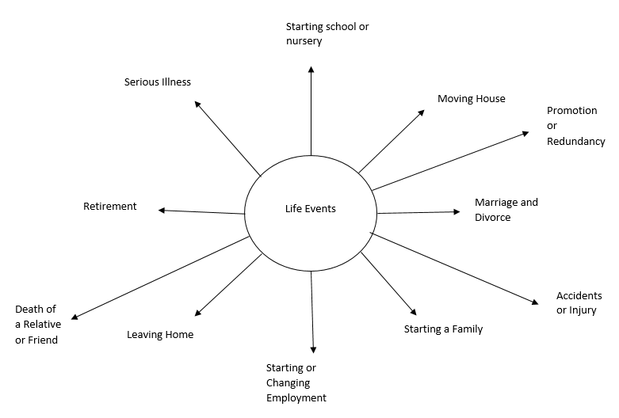

Try putting these events into order from the most to the least stressful:

Most Stressful Least Stressful

Predictable Life Events

|  |  |  |
| --- | --- | --- |
| Predictable Events | Possible Influence on Development | |
| Positive Learning | Risk of Stress |
| Starting school/nursery |  |  |
| Beginning and changing employment |  |  |
| Leaving home/leaving care |  |  |
| Leaving prison |  |  |
| Marriage |  |  |
| Parenthood |  |  |
| Retirement |  |  |

Unpredictable Life Events

|  |  |  |
| --- | --- | --- |
| Unpredictable Events | Possible Influence on Development | |
| Positive Learning | Risk of Stress |
| Birth of a sibling |  |  |
| Redundancy |  |  |
| Illness and serious injury |  |  |
| Divorce |  |  |
| Bereavement |  |  |

The effects of life events on health

Major changes in life may interact with all aspects of growth and development. For example, retirement, redundancy, divorce, bereavement or serious injury might all result in a loss of income or having to live on a low income. Leaving home, marriage or parenthood might all involve changes in your home or in your community and friendship networks. Major life events will change your social, emotional and economic circumstances. Life events may involve feelings of loss and grief and involve lifestyle changes. Being seriously injured or being divorced requires an individual to change and adapt to a new lifestyle, which can have physical, psychological and financial implications. Even predictable and welcome changes can involve learning new things and coping with a range of losses. For example, leaving primary school and starting secondary school requires adapting to new rules and routines used to a new environment.

Task:

Select 3 predictable and 3 unpredictable life events. Explain how these events will affect the development of those going experiencing them. Remember to consider how it will affect them physically, intellectually, emotionally and socially but also how it will influence their lifestyle economically.

Predictable Life Events

Unpredictable Life Events

Holmes-Rahe Social Readjustment Rating Scale (SRRS)

What is stress?

Stress is an automatic response to dealing with challenging situations or life events.

Notes about the stress response:

Stress and Health:

Stress can cause an individual to become irritable, fatigued, have headaches, lack motivation and be unable to concentrate. This can lead to over/under eating, smoking or drinking too much alcohol to cope. Chronic stress can lead to anxiety attacks, depression and cardiovascular problems (caused by high levels of stress hormones.) Once an individual is experiencing chronic stress and depression it becomes harder to recover, especially if they have low levels of social support. The individual may be irritable, depressed and apathetic, which may alienate family and friends who could offer support.

High levels of stress hormones over a long period of time can affect many of the body’s systems causing a variety of health problems, for example:

|  |  |
| --- | --- |
| Immune system | Susceptibility to infections and colds, especially if unhealthy behaviours such as excessive alcohol consumption are used to deal with the stress |
| Cardiovascular system | High blood pressure, heart attacks, arrhythmias and sudden death |
| Respiratory system | Breathlessness, asthma |
| Digestive system | Loss of appetite, gastric ulcers, duodenal ulcers, irritable bowel syndrome |
| Musculoskeletal system | Tension headaches, taut muscles, muscular twitches |
| Endocrine system | Diabetes, loss of sex drive, absence of menstruation |

People who are stressed can be indecisive, have impaired judgement, muddled thinking and make errors. This can sometimes be through their inability to sleep and feeling fatigued. They may also be more accident prone.

Stress can affect an individual’s emotions, especially self-esteem and self-image.

Holmes-Rahe Social Readjustment Rating Scale (SRRS)

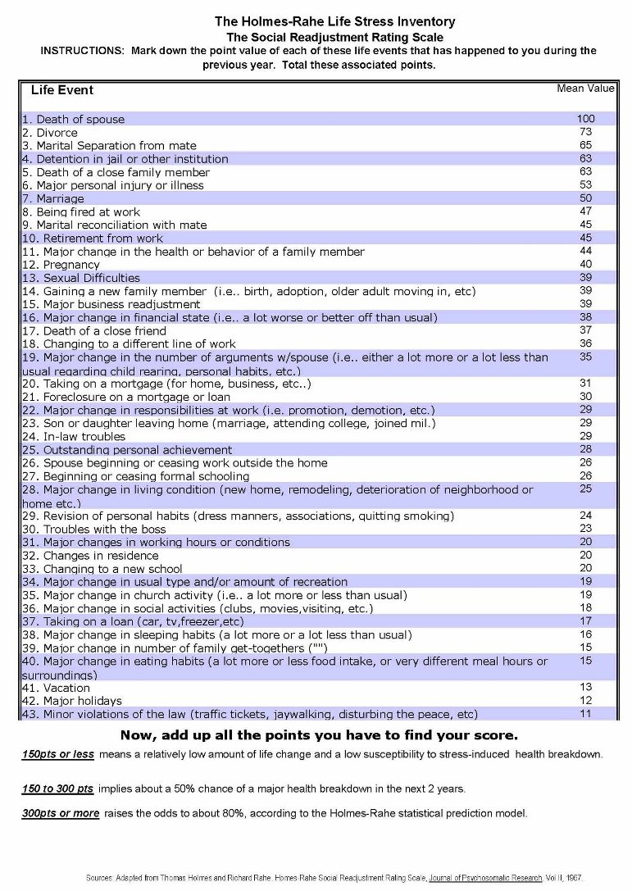In 1967 Thomas Holmes and Richard Rahe carried out a study to explore whether stress had an impact on illness. They surveyed patients about life events in the previous two years. Each of these events had points attached to them. They found the higher score of points, the more likely the individual to experience ill-health.

Exam Link:

|  |
| --- |
| Julia’s father Joseph is a 77-year-old widower. His health has deteriorated since his wife died. Julia is worried because her father does not follow a healthy diet. In addition, he has breathing difficulties and a raised cholesterol level. He has taken to drinking alcohol to try and brighten his mood.  After he retired, Joseph worked occasionally stacking shelves in a supermarket. However, an increasing problem with his breathing led to him missing many days of work. Then, last year, following incidents of drinking at work, he was asked to leave the supermarket job. Since then, Joseph has become unhappy and drinks heavily. His health problems have been getting progressively worse, which makes it difficult for him to get around the house and he needs to use a stick to walk. Though she hates doing it, Julia buys him alcohol to stop his aggressive shouting and occasional violent outbursts. The money she spends on alcohol stretches her limited budget to near breaking point.  Julia noticed that Joseph‘s personal hygiene became increasingly poor and he became more forgetful. For a while, he managed without any help. Due to deterioration in his health, Joseph had a period of respite in a residential care home. When carers refused to buy him alcohol, Joseph argued aggressively with them and occasionally tried to strike out at them. He often refused to eat the meals provided and would not go to bed, stating he was more comfortable sleeping in his chair. His personal hygiene habits resulted in some staff refusing to work with him. After he assaulted a member of staff, the police were called to the residential home and Joseph was charged with assault. Following discussions with residential staff and an examination by a GP, the charges were dropped and he was transferred to a local inpatient respite facility. During Joseph’s time at this facility he made numerous allegations about being assaulted by hospital staff. However, when investigated, staff claimed that ‘bathing’  Joseph could not be construed as assault; and that they had been using allowable ‘restraint’ techniques when he became violent. More recently, a combination of drug therapy, a healthier diet and some focused help with his alcohol problem has brought about some changes for the better. |

To what extent might recent life changes have affected Joseph’s emotional wellbeing? (12 marks)

|  |  |
| --- | --- |
| Student 1 | Student 2 |
| The combination of Joseph’s wife dying and losing the job at the supermarket would have combined to negatively affect his emotional wellbeing. The Holmes-Rahe Social Readjustment Scale shows that the combination of these two factors will have a big effect on Joseph, leading to raised stress levels. Added to this the loss of his partner will cause a big social change, possibly leading to low self-esteem as Joseph has to go places on his own, affecting his confidence levels. Joseph may not have been used to going places without his wife and so he may feel nervous, leading to social isolation, anxiety and depression. | Joseph used to be depressed as he lost his job and turned to drinking. He also had poor physical hygiene which may have made him disgusted with himself. However, after his respite care his emotional wellbeing may have improved. He is eating healthier and has better personal hygiene and his drinking problem is being combated- this hopefully will lead Joseph to becoming less aggressive and depressed. |
| Mark out of 12: | Mark out of 12: |
| Comment/Suggestion for improvement: | Comment/Suggestion for improvement: |
| Examiner’s mark and comment: | Examiner’s mark and comment: |

Mark Scheme

|  |  |  |
| --- | --- | --- |
| Level | Marks | Descriptor |
| 1 | 1-3 | Demonstrates isolated knowledge and understanding of relevant information; there may be major gaps or omissions.  Provides little evidence of application and links between relevant information. Response likely to consist of basic description of information.  Arguments may be presented, but are likely to be generic assertions rather than supported by evidence.  Meaning may be conveyed but in a non-specialist way; response lacks clarity and fails to provide an adequate answer to the question. |
| 2 | 4-6 | Demonstrates accurate knowledge and understanding of relevant information with a few omissions.  Evidence of application demonstrating some linkages and interrelationships between factors leading to a judgement/judgements being made.  Arguments are presented leading to conclusions being arrived at but some may be lacking support.  Demonstrates the use of logical reasoning, clarity, and appropriate specialist technical language. |
| 3 | 7-9 | Demonstrates accurate and thorough knowledge and understanding of relevant information with a few minor gaps or omissions.  Evidences application demonstrating linkages and interrelationships between factors leading to a judgement/judgements being made.  Displays a well-developed and balanced argument leading to rationalised conclusions.  Demonstrates the use of logical reasoning, clarity, and appropriate specialist technical language. |
| 4 | 10-12 | Demonstrates accurate and thorough knowledge and depth of understanding of relevant information; any gaps or omissions are minor.  Evidences thorough application demonstrating linkages and interrelationships between factors leading to judgements being made.  Displays a well-developed, balanced and coherent argument demonstrating a thorough grasp of competing viewpoints, leading to supported conclusions.  Demonstrates the use of logical reasoning, evidenced throughout response which is clear and uses specialist technical language consistently and fluently. |

**Essential Content B Complete**

Reflection Point:

|  |  |
| --- | --- |
| Where am I? | Student Comment: |
| I am up to date with my work booklet- no gaps |  |
| I have identified any areas which require clarification. |  |
| I have attended lunchtime intervention (if needed) for extra help |  |

Revision Questions:

1. Define nature and nurture and give one argument for and against.
2. Identify two genetic conditions that can affect development.
3. Describe two ways in which pollution can impact upon health.
4. What is an economic factor? How can it impact upon health?
5. Identify four life events and the effect they have on the individual.
6. What is the Holmes-Rahe Social Readjustment Scale?

Revision Activity:

Create six revision cards, one for each of the different life stages. On each, write the life events that are most likely to occur within each life stage. Then bullet point the positive and negative effects that these life events may have. Take it further and then evaluate three factors and the influence they can have on development. What connections are there between these different factors?

**Essential Content C: Effects of Aging**

**C1: The Physical Changes of Aging**

Revision Point:

We have already covered later adulthood as part of essential content A.

What physical, intellectual, emotional and social changes occur as we get older?

By the time an individual reaches their late sixties, their body functions begin to decline. For example, they may experience hearing loss in higher frequencies. They may become far sighted and experience impaired night vision. Joints may become stiffer and bones may lose calcium and become brittle bringing an increased risk of fractures. However, each individual is unique and their experience of the aging process is different. Some people develop serious problems associated with aging in their fifties, whereas other people have few problems even in their nineties.

The physical changes associated with aging may come about because there is a limit to how many times body cells can repair and renew themselves and because of damage that builds up over a lifetime. However, some physical changes are linked to lifestyle; i.e. those who take regular exercise may expect to live longer than those who do not.

Cardiovascular Disease

As an individual ages they have an increased risk of cardiovascular disease (disease of the heart and blood vessels). The main purpose of the heart is to pump blood around the body. Many older people develop narrowing of the arteries and other blood vessels due to fats such as cholesterol being laid down I the walls of blood vessels. This process of ‘clogging up’ is called atherosclerosis. Atherosclerosis can result in higher blood pressure (which puts the person at risk of stroke) and heart attacks. The blood vessels can also start to lose their elasticity causing the heart to work harder, increase in size and raise the blood pressure. Fatty deposits can break away and block the artery. If the coronary artery is partly blocked, it may cause angina, experienced as breathlessness and chest pains. If there is significant blood flow blockage, the person may experience a heart attack.

How do lifestyle choices affect the risk of cardiovascular disease?

There are a number of risk factor associated with cardiovascular disease, including a family history of heart disease, ethnic background, poorly controlled diabetes and a prolonged rise in blood pressure (hypertension). Poor lifestyle choices, such as being overweight/obese, smoking and lack of exercise, increase the risks of cardiovascular disease and its effects in older age.

Task:

Malcom is 72 years old. He has arrived at the doctor’s surgery for an appointment with you (his GP.) You measure Malcom’s BMI and find that he is overweight. His blood pressure is normal but Malcom has type 2 diabetes and has not taken steps to change his diet to keep it under control. Malcom smoked for most of his life, however, he gave up 2 years ago and hasn’t smoked since. Malcom’s wife enjoys walking and he sometimes accompanies her.

Malcom notices a poster in your waiting room about cardiovascular disease, he asks what it is and whether he should be concerned about it. What do you tell him?

|  |
| --- |
|  |
|  |
|  |
|  |
|  |
|  |
|  |
|  |
|  |
|  |
|  |
|  |
|  |
|  |
|  |
|  |
|  |
|  |
|  |
|  |
|  |
|  |

Extension Task:

Research cardiac rehabilitation; what is it? How does it target those at risk of heart attack?

|  |
| --- |
|  |
|  |
|  |
|  |
|  |
|  |
|  |
|  |

Degeneration of Nervous Tissue

What is nervous tissue?

Your brain and spinal cord are your central nervous system.

All the nerves which branch off from this system are your peripheral nervous system; they take information from your senses and ‘feed it’ to your brain so that an appropriate behavioural response can be made.

What happens when neurons become damaged?

When neurons are damaged they no longer transmit information efficiently; they may not carry signals towards the brain or they may not be able to transmit behavioural messages towards the muscles and glands. This is why older people have slower reaction times; it takes longer for the signal to reach the brain then return to the muscles.

Memory:

Challenge: Why is it harder to comprehend fast speech?

Words and vocabulary:

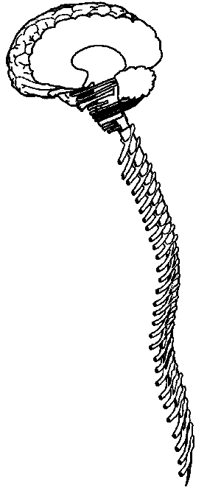

Decreased sensation, slower reflexes and ‘clumsiness’:

Blood flow to the brain:

Why does nervous tissue degeneration occur?

Challenge: Neurogenesis

Cognitive ability:

Extension: Parkinson’s

Research Parkinson’s and find out how it links to nerve degeneration in older people. Summarise your findings below.

|  |
| --- |
|  |
|  |
|  |
|  |
|  |
|  |
|  |
|  |
|  |

Osteoarthritis

Homework:

You need to use your booklets, textbooks and the internet to research the condition Osteoarthritis.

You must know about this condition for your Unit 1 exam.

Questions you should answer within your homework:

What is osteoarthritis? (i.e. what does it mean and what happens at the joints?)

What are the symptoms of osteoarthritis?

How does osteoarthritis make daily life difficult for sufferers of the condition?

How is osteoarthritis different to osteoporosis?

What risk factors increase the likelihood of developing osteoarthritis?

**See file for completed notes (you may use diagrams/pictures to illustrate your points.)**

Homework Feedback:

|  |  |  |
| --- | --- | --- |
| Work has clearly been completed to the best of your ability. |  |  |
| Some good effort shown in places |  |  |
| Well done on completing the additional challenge task |  |  |
| Good understanding of self-image and self-esteem |  |  |

|  |  |
| --- | --- |
| Work is not complete |  |
| Work is not the best of your ability |  |
| Some key terms are not explained well |  |
| Work is rushed and therefore lacks meaning/understanding |  |

Degeneration of the Sense Organs

As part of the aging process, sensory awareness gradually decreases. For example, an individual’s sense of balance can become impaired, both hearing and vision may deteriorate and the ability to taste and smell may diminish. These can all lead to a range of physical problems.

Changes generally begin when people are around 50 years of age. However, they become noticeable when an older person begins to need to turn up the sound on the radio/T.V. or add more salt and pepper to their food. Furthermore, they may need glasses with stronger magnification.

Vision:

Why does vision get worse as we get older?

|  |
| --- |
|  |
|  |
|  |
|  |
|  |

|  |  |
| --- | --- |
| Cataracts | Glaucoma |
|  |  |

Hearing:

Why does hearing worsen age we age? (Especially for high pitched sounds)

|  |
| --- |
|  |
|  |
|  |
|  |
|  |
|  |
|  |
|  |
|  |
|  |
|  |
|  |
|  |

The Reduced Absorption of Nutrients

The older population are more at risk from inadequate diet and malnutrition due to a decrease in the effectiveness of the body to absorb nutrients from food.

Gastrointestinal changes can also mean that older people may not be able to taste food as well and brittle teeth can cause difficulty in eating.

As nutrition is an important factor in preventing illness, there are consequences to this malnutrition. Nutritional screening commonly takes place on admission to hospital to help identify where people may need extra support. As taste and smell can deteriorate in older age. The ability to identify different tastes diminishes which may mean that older people may find eating less enjoyable.

Balanced diet and old age:

Energy requirements may change in older age, particularly if physical activity is restricted or reduced. As energy requirements decrease, older people may need more protein rich foods in their diet (e.g. eggs, pulses, dairy foods and lean meat.)

It is also important that older people’s diets include foods containing vitamins and minerals. Minerals such as zinc, calcium, magnesium and sodium are found in dairy products, meat, eggs, fish, bread, cereals, fruit and vegetables.

Vitamin D is important for good health and essential for absorbing calcium from food. It is largely obtained from sunlight so older people who are housebound, or in residential care, may be at risk of vitamin D deficiency (leading to osteoporosis and bone fractures.) To prevent osteoporosis, some older people are prescribed vitamin D and calcium supplements.

Vitamin C is essential for several body functions, including wound healing and forming and maintaining healthy tissues; older people should eat plenty of fruits and vegetables to ensure they get enough vitamin C.

Iron absorption may be reduced in older people and, along with low dietary intake, this can increase the risk of iron deficiency anaemia. Water helps with digesting food and absorbing nutrient; older people may lose their sense of thirst and become dehydrated.

|  |  |  |
| --- | --- | --- |
| Case study | Dietary concerns | How could they be supported? |
| Nora lives in a residential care home. The cafeteria offers a balanced diet however, Nora often misses meals as she claims she isn’t hungry. Nora sits in her room for much of the day as she has no visitors. |  |  |
| Harold in hospital for a serious fall. His sister came to visit him and noticed that his lips were dry and cracked; Harold said that he doesn’t like to bother the ward nurses for a drink because they seem so busy. |  |  |
| Stuart lives alone since his wife died. He is unused to cooking for himself as his wife always prepared their meals. Stuart’s daughter has noticed that he now eats mostly ‘meals for one’ from the supermarket with little fresh fruit and vegetables. |  |  |

Dementia

Dementia is more likely to occur in older people; as many as 20 per cent of people over the age of 80 are affected by dementia. However, the majority of people who live to extreme old age will never develop dementia.

What is dementia?

Dementia is a brain disorder that seriously affects a person’s ability to carry out daily tasks and activities. A person with dementia is likely to experience problems with understanding what is happening around them, communicating, reasoning, finding their way and remembering recent events. There are different kinds of dementia- two major types are **Alzheimer’s disease** and **vascular dementia.**

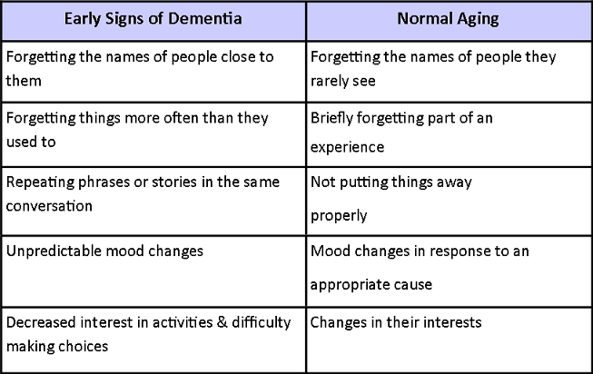

Task:

You need to use your booklets, textbooks and the internet to create a leaflet about **Alzheimer’s disease**.

Assignment Brief:

You can fold/layout your leaflet in any way you choose

Your leaflet’s audience will be people attending a local day care centre for elderly people.

You should explain the symptoms of Alzheimer’s disease and how it is treated.

You should explain how Alzheimer’s disease can affect a sufferer in their daily life.

You should use key terminology but explain it in an easy to understand, accessible way.

You could use images to illustrate your points.

**See file for completed leaflet**

Marking Criteria

|  |  |
| --- | --- |
| **Information included:** | **Mark out of 5** |
| Student has clearly explained the symptoms of Alzheimer’s disease |  |
| Student has explained how Alzheimer’s disease affected the daily life of sufferers |  |
| Students has clearly explained how Alzheimer’s is treated |  |
| Student has worked well and demonstrated good effort |  |
| **Challenge Task:** Student has included information about an Alzheimer’s support group. |  |

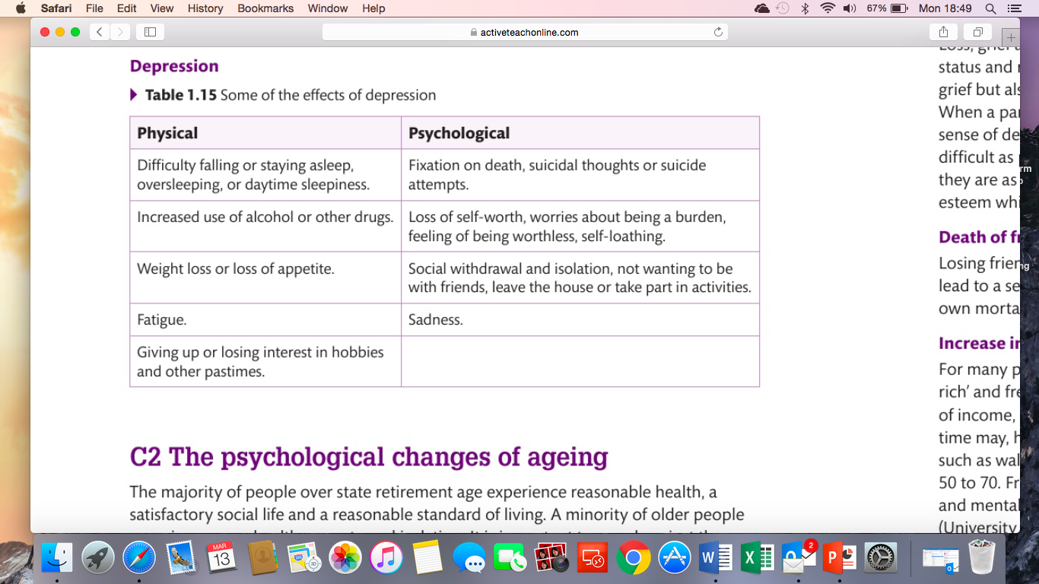Effects of Illnesses that are Common in Ageing

Each of the conditions common in ageing bring its own symptoms, but each one can have wider effects on holistic development. Having a chronic condition in addition to the usual physical and psychological changes during the ageing process can worsen stress or depression for many older people (see table 1.15).

Depression affects an individual’s mood patterns, changes to appetite and headaches. Additionally, physical aches and pain such as those associated with conditions like arthritis, can worsen.

Social development may be severely affected by chronic conditions. The effects of illness and mobility can restrict a person’s social life as they may have difficulty getting out and meeting people. This will reduce their circle of friends causing further emotional stress. The decline of senses or neural capacity can also impact on friendships as they depend upon communicating with others. Individuals may be unable to hear or see sufficiently well to take part in interests or hobbies they used to enjoy, such as reading or going to the cinema. This can reduce motivation and increase isolation.

Illness brings with it a number of physical changes that you have covered as part of C1: The physical changes of ageing. Many conditions result in losing mobility caused either by neurological problems or because of pain, stiffness of the joints or a reduction in stamina. This can be a vicious circle, as lack of exercise or even movement can result in the onset or worsening of conditions such as heart disease. A reduction in sensory awareness and neurological illness brings with it an additional problem of dizziness or difficulty in moving that results in an increase in falls in older people, often causing fractures.

A common problem in ageing is incontinence, which is a loss of bladder control. It can happen because of weakness of muscles, enlarged prostate (common in older men,) or neurological illness such as Alzheimer’s. Whether it is temporary or chronic, it is unpleasant for the individuals and can lead to embarrassment and emotional distress.

Many older people experience insomnia or disorders which can disrupt sleep patterns and cause fatigue, stress and anxiety. This can have adverse effects on their attention span and ability to carry out everyday tasks.

**C2: The Psychological Changes of Ageing**

The majority of people over state retirement age experience reasonable health, a satisfactory social life and a reasonable standard of living. It is important to guard against the stereotype that old age is always a story of decline and isolation.

Effects on confidence and self-esteem

Case study B:

Daisy is 70 years old. She has recently retired from her position as a senior marketing manager in a company she has worked for, for 35 years. Daisy did not want to retire; she misses being at work and, despite owning her own home, she will have to adjust her lifestyle now she is living on her pension.

Case study A:

Eric is 82 years old. He has 2 children and 5 grandchildren; he sees his family regularly and enjoys seeing his grandchildren each weekend. Eric worked as a lorry driver all his life and retired with a pension that allows him a comfortable standard of living. Eric’s eyesight is poor but he enjoys reading large print books and doing jigsaw puzzles.

How have events in later adulthood affected the confidence and self-esteem in these case studies?

|  |
| --- |
|  |
|  |
|  |
|  |
|  |
|  |
|  |
|  |

Confidence and self-esteem are not fixed and people experience rises and falls in both during their lifespan.

Confidence and self-esteem may increase in older age because:

* May feel settled in life and that they have achieved many life goals.
* Have reached a certain level in their job
* Own their own home
* Raised a family

However, confidence and self-esteem may decrease in older age because:

* The physical effects of ageing make daily tasks difficult or impossible
* Feel marginalised by a society that places great emphasis on material possessions and position in life.
* Feel less worthy now they no longer have a high status job.
* Struggling to cope financially on state pension

Effects of Social Change

The majority of older people enjoy effective social networks with only 1 in 5 experiencing a degree of isolation. For many people retirement provides more opportunity for contact with relatives. Older people are more likely to vote than any other age group, suggesting involvement in politics and community issues. Conversely, an individual may have viewed themselves as the family provider and decision maker, and find it difficult to adjust to their children maturing and taking over these functions.

Identify the effects of these different social changes:

|  |  |
| --- | --- |
| Death of a partner |  |
| Death of friends |  |
| Increase in leisure time |  |
| Financial concerns |  |
| Effects of culture, religion and beliefs |  |

Social Disengagement Theory (1961)

Disengagement means to withdraw from involvement. Cumming and Henry proposed that older people naturally withdraw from social involvement as they get older. They concluded that older people have restricted opportunities to interact with others.

How might these factors cause older people to have less social contact?

|  |  |
| --- | --- |
| Ill Health |  |
| Geographical Mobility |  |
| Retirement |  |
| Ill Health of Friends and Relatives |  |

Cumming further proposed that older people experienced reduced social contact and become increasingly ‘individual’ and less concerned with other’s expectations. She concluded that this is appropriate and healthy behaviour and that disengagement is a natural part of ageing.

How could we disagree with this theory?

|  |
| --- |
|  |
|  |
|  |
|  |
|  |
|  |
|  |
|  |
|  |
|  |
|  |
|  |
|  |
|  |
|  |
|  |
|  |
|  |
|  |

Activity Theory

Havinghurst proposed activity theory based on the results of his psychological study into ageing. His ill health study found that older people tend to adjust to the ageing process. His theory is based on the assumption that the social and psychological needs of older people remain the same.

He recognised that this may involve adjusting to changes in health and/or mobility but theorised that older people’s needs can be satisfied by taking on new roles following retirement for example:

1._______________________________

2._______________________________

3._______________________________

When people remain physically and socially active, their overall satisfaction and wellbeing is increased. This is important for reducing the risk of illness and increasing longevity.

Extension:

What is reminiscence therapy? How does it improve the wellbeing of older people?

|  |
| --- |
|  |
|  |
|  |
|  |
|  |

Case Study: Margery is 65 years of age and about to retire from her job in advertising. She enjoys her job and has many friends at work. Margery plans to take up painting when she retires. She has already booked herself a painting holiday. She has also been asked by a friend to help out in her local charity shop.

Justify how Margery’s plans when she retires may impact on her health and wellbeing with reference to activity theory.

|  |
| --- |
|  |
|  |
|  |
|  |
|  |
|  |
|  |
|  |
|  |
|  |
|  |
|  |
|  |
|  |
|  |
|  |
|  |
|  |

Exam Link:

*Read through Joseph’s case study on page 73.*

One of the statements in social disengagement theory is that everybody’s abilities are likely to deteriorate over time.

With reference to the scenario, explain giving two examples of how social disengagement theory applies to Joseph’s recent life. (6 marks)

|  |  |
| --- | --- |
| Student 1 | Student 2 |
| 1. Social disengagement theory was first described by Cummings and Henry in 1961. The theory suggests that people make a positive effort to disengage with society as a response to their reduced abilities and skills which are a normal part of ageing. Following the loss of his job at the supermarket Joseph withdrew into alcohol. Although someone can do this at any age, the loss of his wife combined with his redundancy could’ve make Jacob feel like he wanted to withdraw from life, using the alcohol to do this. 2. Another example would be Joseph’s refusal to eat and sleep in a bed, which could’ve been his way of showing he no longer had to comply with the rules of society. | 1. It applies to Joseph’s recent life as he has lost a lot of social life since leaving work, so he doesn’t speak or socialise with anyone at home apart from Julia. Therefore he is disengaging from social aspects of his life, making him more withdrawn from society. |
| Mark out of 6: | Mark out of 6: |
| Comment/Suggestion for improvement: | Comment/Suggestion for improvement: |
| Examiner’s mark and comment: | Examiner’s mark and comment: |

Exam Link:

Arlene’s grandmother, Mary, is 79 years old. Mary has been living alone for many years and until recently was very active. She attended her local church regularly and had many friends there. She was able to catch the bus to the local town where she did her own shopping. Arlene and her mum, Sofia, went to see Mary each week and offered to help, but Mary likes to be independent and always refused.

Many worked in her local supermarket for many years and retired at the age of 60. It took her a while to get used to not having a job. She particularly missed her colleagues and customers. Through her church she found a local charity shop and started to help out two mornings a well. Although she was now getting more tired and had arthritis and some hearing loss, Mary felt fairly healthy and continued with voluntary work one morning each week, until last year when she had a fall and broke her hip.

Mary spent two months in hospital. When she was discharged, she was assessed by a social worker who was concerned, although she could manage to wash, dress and make light meals, she would not be able to carry out all day to day activities. A care plan was agreed and Mary now has a carer who attends her each day to help out with chores. She has hot meals delivered and her daughter, Sofia, visits each week to help with shopping and cleaning. Community services have provided a stairlift and she has a walking frame.

Sofia is getting increasingly worried about Mary. Although Mary has had some physiotherapy and can now walk short distances with the walking frame, she doesn’t use it much and hasn’t attempted to get out. Sometimes, Sofia finds that Mary has not eaten her food. The house often feels cold, but Mary will not turn up the heating, saying that she puts on extra clothing and goes to bed early instead. Mary did have a friend from church who she saw regularly, but she died recently. Sofia often suggests taking Mary out to go to church or visit other friends, but Mary always makes an excuse, saying that she’s too tired or that it’s too cold out. In the past, Mary always too care with her appearance, but now often doesn’t bother to comb her hair. Sofia has suggested that Mary moves into residential accommodation, but each time she mentions it Mary gets very angry.

Discuss Mary’s development in the years after her retirement in relation to theories of ageing. (10 marks)

|  |
| --- |
|  |
|  |
|  |
|  |
|  |
|  |
|  |
|  |
|  |
|  |
|  |
|  |
|  |
|  |
|  |
|  |
|  |
|  |
|  |
|  |
|  |
|  |
|  |
|  |
|  |
|  |
|  |
|  |
|  |
|  |
|  |
|  |
|  |
|  |
|  |
|  |
|  |
|  |
|  |
|  |
|  |
|  |
|  |

Mark:

Comment:

Task:

Outline reasons why people in older adulthood may be more at risk of falls in their home.

|  |
| --- |
|  |
|  |
|  |
|  |
|  |
|  |
|  |
|  |
|  |
|  |
|  |
|  |
|  |
|  |
|  |
|  |

**C3: The Societal Effects of an Ageing Population**

Health and Social Care Provision for Older People

Older people place more demand on health and social care provision than any other group in society. This increases with age. Often health and social services are required to work closely together to meet needs of older people. For example, people receiving end of life care may require professionals to work together to monitor and provide medication, psychological support and personal care.

Health care

Health professionals provide a range of different services. These can be thought of as primary or secondary care. The first point of call for older people is usually the primary care services such as their GP surgery, pharmacy or dentist. Those with conditions such as osteoporosis or mental health problems may be referred to health professionals or units to monitor and support their ongoing needs. Acute care is health care that meets immediate needs, such as a broken hip, cancer treatment or specialist health care for chronic conditions. Acute care may be short term for many but, for older people, hospital stays may be extended as they require a longer period for recovery and recuperation.

Social Care

Social care services essentially exist to help and support people in need of practical help and/or personal care due to disability or illness. The type of services provided could include having a carer or support worker (enablers: someone who delivers person centred care in a domiciliary setting to encourage independence) to help around the home with practical tasks and personal care. There could be structural changes to homes which could support an individual to live more independently. Although technically available to everyone, there has to be practical and financial assessment of physical, intellectual, emotional and social needs and abilities to assess how much support can be provided. After completing the assessment, the local authority will decide how much of the care and support services they will provide. Social care services can take different forms; for example help to live at home, day centres, sheltered accommodation, respite care or residential care. Charities and private organisations can also be involved with delivering social care services.

Community Equipment

One important aim of health and social care services is to enable people to stay in their own home and keep their independence. Community equipment services, based in each geographical area, do just that by providing support aids for daily living. These may range from large equipment that can be used by family or carer to move people, or walking frame to ‘kettle tippers’ that take the weight of a kettle to enable a person to make a cup of tea for themselves.

Financial Support and Entitlement

Many older people will have the advantage of an occupational pension as well as a state pension. Others may have to rely on their state pension only. Older people can claim pension credit to top up their pension to a minimum level and, depending on circumstances, may also claim housing benefit and council tax reduction. Other financial benefits for over 60s include free prescriptions, eye tests and eye care, concessionary travel fares (once at pensionable age,) winter fuel payments and cold weather payments (for those on low incomes.) At 75 free television licenses and other discounts are available.

The Griffiths report, Community Care, an Agenda for Action and the introduction of the NHS and Community Care Act (1990) have encouraged a move away from institutional care and towards independent living. Griffiths was particularly concerned about long term and continuing care of vulnerable groups within the community, including old people. The report focused on the different types of provision between health and social care services, and the way in which these services could work together for older people in the community.

Economic Effects of an Ageing Population

One of the successes of the NHS is an increase in life expectancy. Many people remain healthy, independent and active. However, as people age they are more likely to live with a range of conditions, increasing disability or frailty. Health and social care services are finding it difficult to keep up with demand.

The King’s Fund (2013) consider this has both positive and negative effects. The annual costs of health and social care are greater for older people. Hospital admission for older people has increased and with the number of older people increasing this will lead to increased demands for care. However, in increasing number of older people continue to work past 65 years of age and support their community in other ways; through voluntary work, providing informal care for grandchildren or neighbours and making donations to charity.

**Essential Content C Complete**

Reflection Point:

|  |  |
| --- | --- |
| Where am I? | Student Comment: |
| I am up to date with my work booklet- no gaps |  |
| I have identified any areas which require clarification. |  |
| I have attended lunchtime intervention (if needed) for extra help |  |

Revision Questions:

1. Identify and describe four conditions that may occur in older age.
2. Identify two differences between the activity theory and disengagement theory.
3. Describe three effects of ageing on the psychology of older people.
4. Identify two implications of an ageing population.

Exam Practice 1:

Benjamin is married to Andrea. Andrea was recently in a serious car crash that left her paralysed. They have two children. Anthony who is 15 years and Beth who is 5 years old. Benjamin has recently been promoted at work.

1. Describe two physical changes that will occur to Anthony in this life stage (4 marks)
2. Identify the stage of play that Beth may engage in (1 mark)
3. Explain the possible impact that the car crash may have had on Andrea (6 marks)
4. To what extent might the recent events have affected Benjamin’s wellbeing? (6 marks)

The family live in a polluted area.

1. Describe the possible impact that this may have on development (4 marks)

Anthony is friends with Daniel who has cystic fibrosis.

1. Outline what cystic fibrosis is and the impact upon Daniel’s development (4 marks)
2. Identify two health and social care professionals who can help Daniel and his family (2 marks)

Beth is about to move from her nursery into the reception class at the local primary school.

1. Evaluate how Gessel’s maturation theory and Bandura’s social learning theory can both be used to describe Beth’s development up until the age of 5. (10 marks)

Benjamin’s parents have recently moved into sheltered accommodation.

1. Discuss and evaluate two theories of ageing (10 marks)

Exam practice 2:

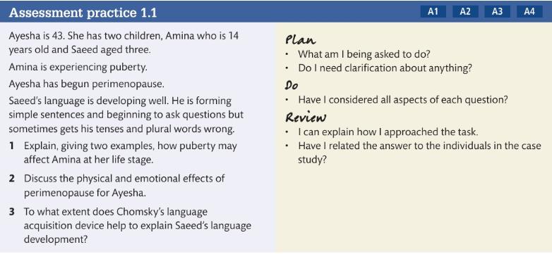

Exam Practice 3:

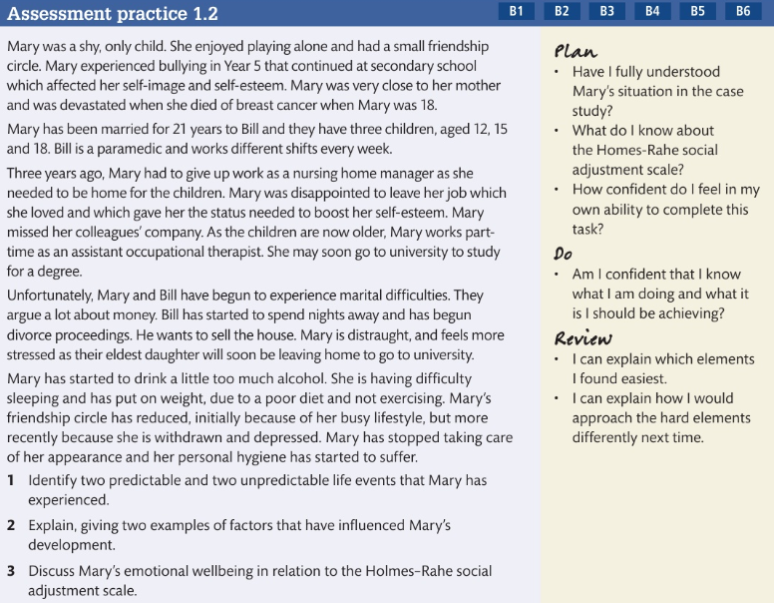

Exam Practice 4:

