Inspection of services
Activity
Sheet 2.19
Learning aim B4
Health and social care sectors are monitored and regulated by external organisations.

- Complete the following table by identifying the sector or sectors that each agency works in and outlining their role in monitoring services.

Agencies | Sector(s) | Role
Office for Standards in Education (Ofsted)

Care Quality Commission (CQC)

The National Institute for Health and Care Excellence (NICE)

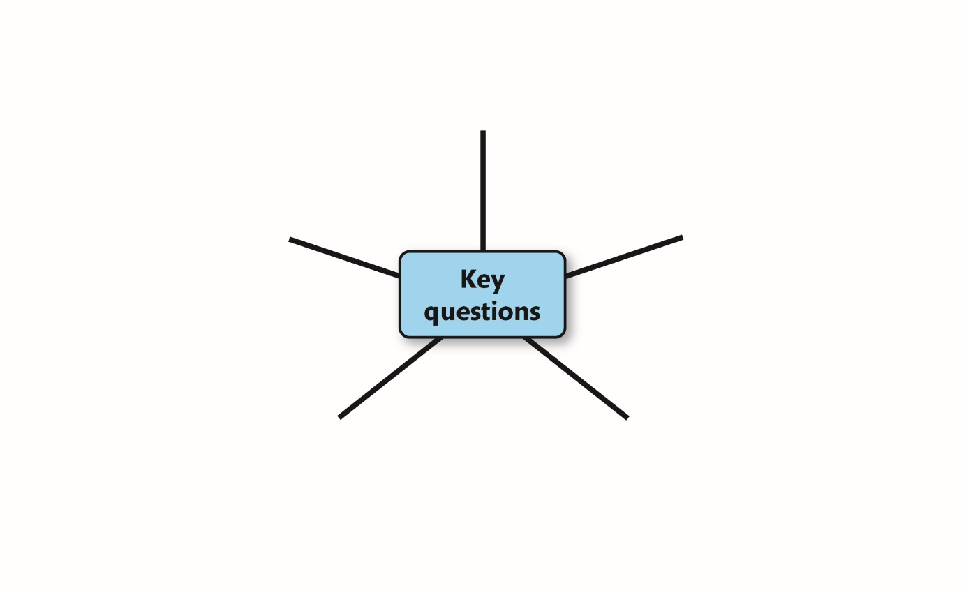
- Cliff Lodge residential care home is expecting a visit from the Care Quality Commission. Identify five key questions that inspectors will want to ask about the home’s provision and practice.

- Hollyvale primary school is expecting a visit from the Office for Standards in Education (Ofsted). Identify five key questions that inspectors will want to ask about the school’s provision and practice.
- Discuss ways in which services can be improved by regulation and inspection.

Pause point
What happens after an inspection? How do you find inspection reports?
Hint: Research the CQC and Ofsted websites: www.cqc.org.uk and www.gov.uk/find-ofsted-inspection-report.
Extension: Find a report from a local service or organisation. Identify strengths and any weaknesses of the service or organisation. Suggest ways that improvements could be made.

