Access to services
Activity
Sheet 2.17
Learning aim B2
Why might individuals need access to services?
People gain access to services through referral, assessment of needs or eligibility.

Read the scenarios, then answer the questions.

Scenario 1
Angie, 54, recently visited her GP because she was concerned about a lump in her breast. Her GP examined her and said that she would refer Angie for tests.
Angie gave up her job 10 years ago to become the main carer for her father. Six months ago her father died. When the GP asked Angie how she was coping now, she burst into tears saying that some days she found it difficult to get up in the morning. She admitted that she had started smoking again to help her relax.

- The GP will refer Angie to an oncologist. Identify two other services to which he should refer Angie.

__________________________________________________________________________________________________________________________________________________________________

Scenario 2
Grace, 62, has always been active but last month she had a stroke. She has now returned home but her recovery is slow. Her partner Frank helps a little but he has arthritis himself, so is struggling to cope.
Grace used to be proud of her appearance but gets down when she cannot dress herself without help or do her hair. She also worries that she cannot look after the house and support Frank in the ways that she used to.
Grace and Frank live in a small village eight miles from the nearest town. She can no longer drive so a cousin has been giving her lifts to the shops and takes her and Frank to appointments.

- A social worker is meeting with Grace. Explain four things that the social worker will need to consider in order to assess Grace’s needs.

____________________________________________________________________________________________________________________________________________________________________________________________________________________________________________________________________________________________________________________________________
__________________________________________________________________________________________________________________________________________________________________
_________________________________________________________________________________

Scenario 3
Jed, 38, has two children who are living with him. Jed has physical and mental health problems. He has had to give up his job and has been seen in the neighbourhood looking dishevelled. The school his children attend have reported concerns to social services about the children’s hygiene and their claim to teachers that they have to ‘cook and clean at home for Dad’.

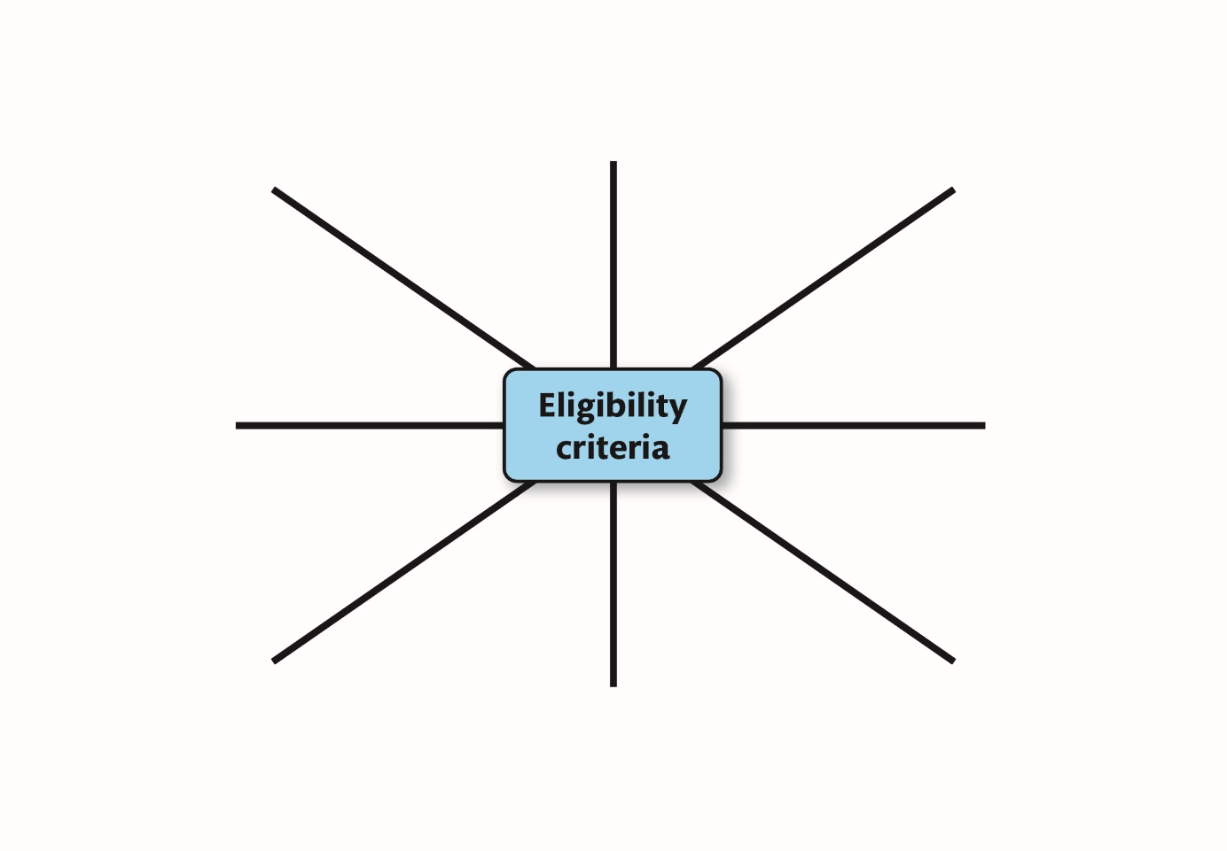
- On the diagram below, identify the eligibility criteria used by local authorities for people who need personal care.
b) Circle the criteria that Jed would meet in order to receive personal care.

Pause point
Identify why people may have difficulties in accessing services.
Hint: Consider physical, geographical, financial, social and cultural reasons.
Extend: Explain ways that individuals can be helped to overcome barriers to access.

