Holy Cross Sixth Form College
Health & Social Care

BTEC Level 3 National
Extended Certificate Handbook
2017-2018

Course outline

The Pearson BTEC Level 3 National Extended Certificate in Health and Social Care aims to provide an introduction the sector. This course will suit you if you see your future in working with people. The course covers topics related to the health and well-being of individuals and the wider community. It is equivalent in size to one A Level.

You can be awarded:
Grade | A level equivalent
Distinction* | A*
Distinction | A
Merit | C
Pass | E

What does this qualification cover?

Year 1: |  | Guided learning hours | Assessment
Unit 1: | Human Lifespan development | 90 | Exam: 1.5 hour, 90 marks
Unit 5: | Meeting individual care and support needs | 90 | Coursework: 2 Assignments
Year 2:
Unit 2: | Working in Health and Social Care | 120 | Exam: 1.5 hour, 80 marks
Unit 14: | Physiological Disorders and their Care | 60 | Coursework: 2 Assignments
Your assessment calendar and assignment briefs will give you all details of your exam dates and deadlines, which will also be posted in the Health classroom and on the Health website at www.hcchelath1.com

What will I study?
This Extended Certificate course will occupy one block or 4.5 hours of your timetable a week over two years. You are also required to do a minimum of 5 hours a week independent study as part of the course.

Year One Unit 1: Human Lifespan Development Health and social care practitioners need to develop a knowledge base for working with people in every stage of their lives, and they need to know how their own experiences relate to health and wellbeing. Although it is generally accepted that there may be deterioration in health with age following adulthood, medical intervention means people are living longer and have better life prospects.
You will explore the key aspects of growth and development, and the experience of health and wellbeing. You will learn about factors that can influence human growth, development and human health. Some of these are inherited and some are acquired through environmental, social or financial factors during our lifespan. You will learn about several theories and models to explain and interpret behaviour through the human lifespan. In this unit, you will explore the impact of both predictable and unpredictable life events, and recognise how they impact on individuals. You will study the interaction between the physical and psychological factors of the ageing process, and how this affects confidence and self-esteem, which in turn may determine how individuals will view their remaining years.

This unit is externally assessed in a 90-minute exam.

Year One Unit 5: Meeting Individual Care and Support Needs
For you to be able to provide the care and support that individual’s need, it is important that you have a good understanding of the principles behind providing quality care and support.
In this unit, you will learn about the values and principles of meeting care and support needs and look at some of the ethical issues that arise when personalising care. You will examine factors that can impact the professionals who provide the care and support, and the challenges that must be overcome to allow access to good quality care and health services. You will explore the different methods used by professionals across all care services. You will reflect on these methods when you consider the importance of multi-agency working in providing a package of care and support that meets all the needs of individuals. In this unit you will draw on your learning from across your programme to complete assessment tasks.

This unit is internally assessed coursework.
What support will I receive?
In the Health and Social Care department we want to support you in your studies as much as we can. We have developed our own department website and You Tube channel which contain our calendar, all resources and information about your course.
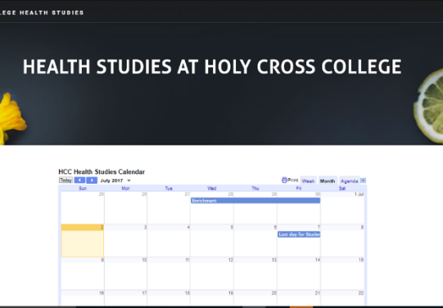
Health at Holy Cross website: www.hcchealth1.com

In class, we use the Pearson recommended textbook, which we strongly recommend you purchase for your studies.
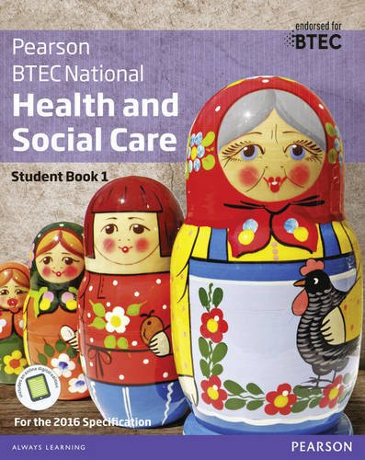
BTEC Nationals Health and Social Care Student Book 1 + ActiveBook: For the 2016 specifications (BTEC Nationals Health and Social Care 2016) Paperback – 24 Jun 2016
by Marilyn Billingham (Author), Pamela Davenport (Author),
Hilary Talman (Author), & 3 more
ISBN-10: 1292126019
ISBN-13: 978-1292126012

We run weekly support sessions – the days and times will be advertised in the classroom and on the website.
Staff are available by email or in the Health office:
Mrs Claire Prescott cap@holycross.ac.uk
Mrs Dianne Warwick dmw@holycross.ac.uk

Assignment Submission Policy

Assignment deadlines will be published on assignment briefs and on the Health website.
Assignment deadlines must be met.
Students may be granted an extension (only in exceptional circumstances) – these must be requested before the deadline.
Absence from college on the day of a deadline is not an excuse for missing a deadline
Your assignments must be your own work and not copied from other learners or the internet.
Any quotes must be referenced. Plagiarism checks will be made.
You must also submit your signed and dated learner declaration.

Failure to submit an assignment on time will result in the following:

1 | Parents will be notified and invited in for a case conference with you, your Senior Tutor and your BTEC teacher.
2 | You will be given 3 working days to submit your assignment.
3 | The maximum grade you can get for that assignment and therefore that unit is a Pass.
4 | You will not qualify for a re‐submission.
5 | Failure to meet this or any future deadlines will result in you being removed from the course. This could put your place at Holy Cross at risk.

NB. Plagiarised work will be considered as a non‐submission and the same steps will be taken.

Turnitin UK
All assignments must be submitted on Turnitin UK.
Turnitin checks work for plagiarism. It will be checked against published work and against other work submitted for the assignment.
Turnitin also helps to save the environment … all work will be submitted and assessed electronically.
Turnitin Setting up Account Instructions
Please follow the stages below in order to set up your Turnitin account.
Stage | Instruction | Tick
1 | Go onto your college e‐mails.
2 | You will have an e‐mail from TurnitinUK No Reply.
3 | Go into the e‐mail and click on the website address link.
4 | Enter your college e‐mail address and the password contained in the e‐mail.
5 | You will then be asked to change your password (this should be your surname followed by your date of birth e.g. Smith231099)
6 | Read the user agreement and select ‘I agree’.
7 | You will now be signed in to Turnitin UK and should have the class BTEC Health and Social Care, Instructor: Mrs. C Prescott appearing on your screen.

Submitting Work on Turnitin UK
- Log in to Turnitin UK (www.turnitinuk.com). Remember to use your college e‐mail address.
- Click on the correct course. The instructor name should be the same name as the teacher who has set you the assignment.
- Go to the correct assignment and click Submit.
- The Submission Title should be the assignment title (see assignment brief).
- Choose the file location of your assignment and click upload.
- Follow the instructions provided. An electronic receipt will be sent to your college e‐mail address.

OneDrive
Losing work will not be accepted as an excuse for missing a deadline and the loss of work cannot be a reason for requesting an extension. Therefore, we recommend the use of One Drive. You will automatically have an account set up through your college e‐mail system.

Instructions on how to use OneDrive
- Open up a word document as normal.
- Click ‘Save As’ click ‘One Drive – Holy Cross College’
- Click on ‘OneDrive –Holy Cross College’ and Windows box will appear where you can save (or create) files. (Once you have used a folder a couple of times it will appear for you to save in).
- To then access your work:
  - Open Word click ‘File’ ‘Open’ and then you will have the option to open any of your OneDrive documents.
  - OR, open up your e‐mails. Go to the top left hand corner and click on this icon:
You will then have the option to open your OneDrive and you will be able to
access all files saved in your OneDrive.
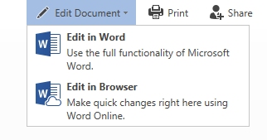
- When opening files direct from your OneDrive to edit your document. Click on ‘edit document’. You will have two options: (1) Edit in Word. This will open your document in Microsoft Word. You will then edit and save your document as you would when normally using Word. (2) Edit in Browser. This will allow you to edit work on Word Online and will save as you type. It does not have all the functions of the full Microsoft Word Software.

- You can access your OneDrive from any computer device connected to the internet. Type in ‘outlook.com/holycross.ac.uk’ you will then be required to enter your college e‐ mail address and password. Alternatively, you can download the OneDrive APP (ios and Android versions are available).
Unfortunately, you cannot upload directly from your OneDrive to Turnitin. Therefore, when you are ready to upload your work to Turnitin you will need to save your work on to the college computer or your desktop. This can be done by either downloading the document from your OneDrive or using the ‘Save As’ function in Word.

Learner Declaration
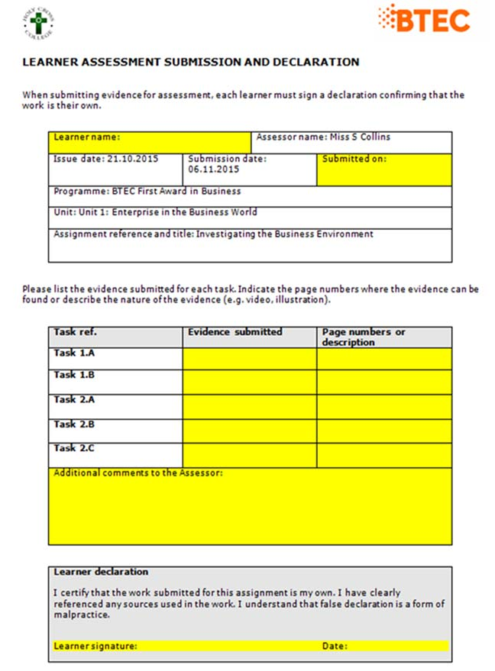
A completed learner declaration will be required for every assignment that you submit. Please see an example below:

- This will be e‐mailed to you at least one week before your assignment deadline.
- Your teacher will partially complete this document. You must complete the sections in yellow.
  - Submission date: the date you submitted on to Turnitin UK.
  - Evidence submitted e.g. Word, PowerPoint or Publisher.
  - Page numbers for each task.
  - Any websites or books used should be listed in “Additional Comments to the Assessor”.
  - Copy and paste your electronic signature and date.
- E‐mail to the teacher who set the assignment (Assessor Name) the same day you submit your work on to Turnitin UK.
- For resubmissions this form will be green.

Assignment Checklist
Before you submit your assignment, please ensure you have checked the following list and can answer all questions with a “Yes”.

 | Task | Tick
1. | Have you left enough time to submit the work before the deadline?
2. | Have you covered all the tasks set out in the assignment brief?
3. | If you have used any other sources have you “Quoted” them and referenced/said where this information is from?
4. | Have you proof-read your work to ensure there are no mistakes, it is formatted correctly and there are no grammar and spelling errors?
5. | Have you ensured that your work is saved on One Drive and you have the final, most up to date copy ready to submit?
6. | Have you read and filled in the sections in yellow (or green) of the assignment Learner Declaration and signed it with your electronic signature?
7. | Have you emailed the completed learner declaration to your teacher on the same day as you submit your assignment on to Turnitin UK?
8. | Once you have uploaded the assignment to Turnitin UK, have you checked that all pages have been successful uploaded.
9. | Finally have you checked your email for a receipt to show a successful submission?

How the course is delivered
The course is delivered through a range of methods and is often led by students following research in particular areas.
The course relies on group, paired and individual work depending on the activity and uses a range of teaching methods to enable both practical and theoretical learning including time in a variety of Health and Social Care settings.

Work experience
A major factor of the BTEC course and assignments is application of practice and so, where possible, we collaborate with professionals who work within the Health & Social Care sectors. This involves visits to settings, inviting professionals in to school to talk to students and you undertaking work experience or shadowing in a range of settings to build your knowledge and understanding of the varied sectors.
It is a vital part of your Health and Social Care course that you gain experience of working in the sector.
Use the Careers Moodle page to start your search for a place relevant to your Career goals:
https://moodle.holycross.ac.uk/course/view.php?id=7#workexperience

Your first task: Health and Social Care services

Deadline – Monday’s lesson.

This task will form the basis of your first lesson, as you will be discussing your findings; it will also get you researching along with working to a deadline.
Your task covers elements of the first unit you will be studying on the BTEC Health and Social Care course: Human Lifespan Development.
- What is good Health? What do we mean by being Healthy? Give your own explanation and find a quote. Give the course of your quote.
- What are the factors that affect Health? What things can make you more or less healthy? Brainstorm a list of all the factors you can think of.
- Do some further research into this question – make a note of your sources.
- Bring your list to the lesson and we will use it in our first activity.
Good luck!

