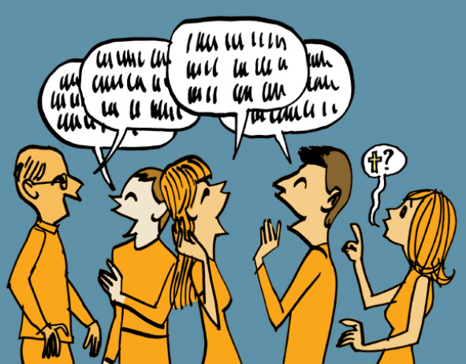
An advocate can build up a trusting relationship with a service user over a period of time, spending quality time, at a time that’s convenient. They can build up they sense of worth and value, encourage confidence and reassure them that what they say, is important.
Although this may appear an informal partnership, it is very much part of the multi-disciplinary team who will work together, as a team to ensure all their holistic needs are met.
It is a key opportunity to get a service user to feel comfortable enough to express their views so this can be taken to care planning meetings ensuring full support is given
Vulnerable service users feel:-
…they may not be believed or be taken seriously..
..are afraid, intimidated of negative consequences if they speak up..
..not confident enough or value themselves enough to speak..
..don’t have the vocabulary or cognitive ability to join in…
..don’t want to appear demanding or feel a burden….

Exam Practice; A defensive 15 year-old has moved to a children’s home out of her local area and requires support from a multidisciplinary team.
Who will co-ordinate the team to ensure everyone works together with her?

Who will specifically support her education?

How might a youth group help integrate her into the new area?

How could an advocate help support her and increase team-working with professionals?

Disciplinary action against a member of staff; line mangers job role
Struck off register or banned from care work for life

Court case & dismissal

Very serious or repeated serious misconduct

Final Warning

Serious dangerous inappropriate
Written Warning
Training

One-off
Minor
inappropriate
Verbal
Warning

A line managers duty and their line managers duty is to sort out disciplinary action for staff who are not maintaining the care values, policies and procedures of codes of conduct. Depending on the serious or nature of the misconduct, will affect what level of action will be taken. Repeated minor misconduct, following close monitoring and after further training will also lead to dismissal and evidence that will show on a DBS check, preventing them from working with vulnerable people ever again.
A professional may be deregistered by their professional organisation that regulates those who work in the UK. This however, is harder to monitor if a person then moves overseas to work. Care workers from overseas must be re-trained in UK legislation, policies, procedures and codes of practice before they start practicing.
http://www.communitycare.co.uk/2017/05/24/social-worker-lacked-basic-legal-knowledge-struck/

