Unit 2
Section 6 A3
Empowering Individuals

The importance of fostering and supporting the empowerment of service users can often be overlooked.

Empowerment:

Mind-map your ideas about how a care worker in a residential home could ensure a frail 86 year-old resident is empowered….

Empowerment can be achieved by …..

READING TASK: Empowering individuals

- Read the information below and answer the questions within each section. There are four questions and one think higher in total.

Promoting individualised care
Empowerment enables service users to understand the choices that they can make about their care, to contribute to the decision-making and to take control of their lives.

In health and care settings, particularly when service users are feeling unwell or anxious, there can be a tendency to allow service providers to take over and for the service user to just ‘do as they are told’.

In most situations, practitioners are required to gain their client’s consent before carrying out a care procedure, a treatment or making arrangements for a client’s care.
Q1: What could the outcome be if a service provider does not allow their service user to be active in decision making?
________________________________________________________________________________________________________________________________________________________________________
Q2: How could the empowerment of individuals and inclusion in decision making promote individualised care?
________________________________________________________________________________________________________________________________________________________________________

Promoting and supporting individuals’ rights to dignity and independence
Empowering service users means that they are more likely to be treated as individuals. Their needs and preferences will be known and respectfully considered.

Q3: If a person’s needs and preferences are known and considered with respect, what is likely to be the effect on the individual? Hint: consider Unit 1!
____________________________________________________________________________________________________________________

Providing active support consistent with the beliefs, cultures and preferences of service users
Health and care provision in a multi-cultural society must address the specific needs of people from diverse backgrounds.
A professional carer must be aware of individual differences and ensure, through discussion and planning, that the importance of these needs to the service user are fully respected and are not ignored.
Here at Holy Cross College Hospital, we are committed to the following, to provide active support for our service users:
- Translators will be provided if a service user does not speak English as a first language.
- We provide a multi-cultural appreciation week, which we encourage all of our colleagues and service users to get involved in, each year.

Foods offered must be culturally suitable... or... it would be discriminating!

Type of religion | Practice or restriction | Rationale
Buddhism | Refrain from meat, vegetarian diet is desirable, moderation in all foods. Fasting required of monks | Natural foods of the earth are considered most pure Monks avoid all solid food after noon
Hinduism | Beef prohibited, all other meat and fish restricted or avoided. Alcohol avoided and numerous fasting days | Cow is sacred and can't be eaten, but products of the "sacred" cow are pure and desirable. Fasting promotes spiritual growth
Islam | Pork and certain birds prohibited. Halal met only. Alcohol prohibited. Coffee/tea/stimulants avoided Fasting from all food and drink during specific periods, fasting has a cleansing effect of evil elements | Eating is for good health. Failure to eat correctly minimises spiritual awareness
Judaism | Pork and shellfish prohibited, kosher Meat and dairy at same meal prohibited Leavened food restricted. Fasting practiced at times | Land animals that do not have cloven hooves and that do not chew their cud are forbidden as unclean (e.g., hare, pig, camel)
Mormonism | Alcohol and beverages containing caffeine prohibited, moderation in all foods. Fasting practiced, self-control and honouring to God | Caffeine is addictive and leads to poor physical and emotional health.
Rastafarianism | Meat and fish restricted, vegetarian diets only, with salts, preservatives, and condiments prohibited. Herbal drinks permitted; alcohol, coffee, and soft drinks prohibited. Marijuana used extensively for religious and medicinal purposes | Pigs and shellfish are scavengers and are unclean. Foods grown with chemicals are unnatural and prohibited. Biblical texts support use of herbs (marijuana and other herbs)

Q4: Why is it important in your role, to recognise the multi-cultural society in which we live?
____________________________________________________________________________________________________________________________________________________________________________________
Think Higher: What else could Holy Cross College Hospital do to support our service users? Try to think of at least two additional things.
1._______________________________________________________________________________________________________________________
2._________________________________________________________________________________________________________________________________________________________________________________________________________________________________________________

Supporting individuals to express their needs and preferences
Not all of our service users will have the confidence or personal skills to participate fully in their care. Some may need specific support to participate in meetings or to enable them to explain their preferences.

Support mechanism | Provide an example of a service user that this could benefit and why
Translators and interpreters
Signers
Advocates
Family and friends

Care plan meetings and assessments can be intimidating and confusing for some vulnerable service users. An older person with dementia, a person with poor mental health or a child may not feel confident or able to contribute or give their honest open opinion, when asked directly in a group of professionals they don’t really know.

Advocacy is a support which must be offered under the Care Act. They are able to build trust and really get to know the person’s needs, wishes and preferences which can then be represented when the service user is unable to.
Research task: Make notes about the different types of advocacy.
Watch these YouTube clips; https://www.youtube.com/watch?v=eOSnDXgY0T4 and
https://www.youtube.com/watch?v=WBbNJp_1X-c
Visit the SCIE website
https://www.scie.org.uk/care-act-2014/advocacy-services/commissioning-independent-advocacy/inclusion-empowerment-human-rights/types.asp
Promoting the rights, choices and wellbeing of individuals and balancing their rights with those of other service users and staff
It will not always be straightforward to provide a service user with the care or treatment of their choice, even when their preferences are clear and apparently reasonable.

Watch the below videos; https://www.scie.org.uk/socialcaretv/topic.asp?t=mentalcapacity
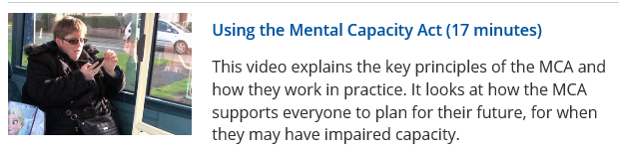
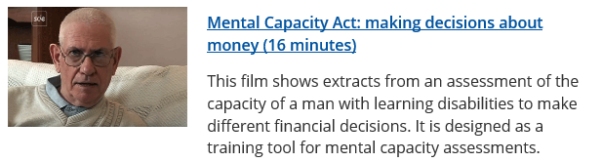
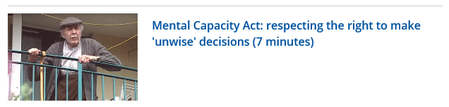
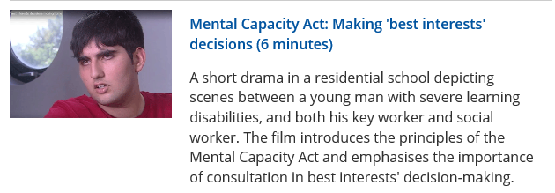

Dealing with conflict in health and social care settings
Allowing service users to make their own decisions sometimes leads to dilemmas and conflict. A service user has a right to smoke, but other service users have a right to not inhale side stream smoke. A Jehovah’s Witness parent’s belief is that their child should not receive a blood transfusion but then the child has the right to life, under the Human Rights Act. A mentally ill patient can be sectioned and kept in hospital against their will, if their deemed a suicide risk, which goes against the Human Rights Act – right to freedom.

In pairs; complete the case study Marjorie page 99 in the BTEC book
Key terminologies to use in exam answers…

Conflict
Challenging
Behaviour
Lone
Workers
Policy

Watch this video and then answer these two questions
https://youtu.be/f4qCP_NEYYU
